LUMINOUS: Studying, Measuring and Altering Consciousness through information theory in the electrical brain.

H2020-FETOPEN-2014-2015-RIA  
Grant agreement No686764

Work Package WP1: *Scientific framework*

**Deliverable D1.3: A computational model for EEG in consciousness studies**

**Issue 1 - Month 12**

Fabrice Wendling (INSERM)

Isabelle Merlet (INSERM)

Siouar Bensaid (INSERM)

Ricardo Salvador (STARLAB)

Jennifer Rizkallah (INSERM)

Pascal Benquet (INSERM)

Julien Modolo (INSERM)

Release date: March 10, 2017 – Final version (after QCB review)

Status: *confidential*

**Executive Summary**

In this deliverable D1.3 (issue 1, month 12), we report the progress that has been accomplished on a computational model for EEG in consciousness studies. The development of such a model is a tremendous challenge. Fortunately, it will benefit from the background, the results and the know-how acquired during a previous European project called HIVE (Hyper Interaction Viability Experiments, FP7-FET Open – 222079, 2008-13) that was coordinated by STARLAB and in which INSERM partner has led WP1 dedicated to biophysical and biological models of the brain under tCS conditions.

This available background explains why the first section (section 2: A computational model of EEG accounting for tCS effects: background from the “HIVE” project) provides a synthetic review on the main aspects and results obtained in the HIVE project. We preferred writing this summary instead of just referring to papers in order to i) gather the essential elements of modeling in the present document and ii) facilitate the reading of reviewers and colleagues. In addition, this section was intended to point at the limitations of models developed in HIVE and therefore the work to be done to build an even more insightful model that can be useful for consciousness studies, which is one of the ambitious goals of the LUMINOUS project.

From section 3 (Computational modeling of EEG for consciousness studies), we describe the work accomplished over the period spanning from April 2016 to February 2017.

Starting from the main advantages and current limitations of the existing model and considering the theoretical models of consciousness reported in D1.1, we performed a comprehensive literature review about the neurophysiological mechanisms that should be “ideally” integrated in the envisioned computational modeling of EEG for consciousness studies.

We then provide an update on recent (at M12) modeling advances regarding the cortical response to TMS and the Perturbational Complexity Index (PCI), based on the experimental work performed by UMIL (Milano, Italy). In brief, we have developed a model of local brain tissue activity, in response to brief (< 100 ms) pulses of stimulation, such as those used to calculate the PCI. Interestingly, preliminary results (M12) show that a neural field model composed of 10 populations, connected through a biologically plausible distribution of time delays, can capture the basic properties of TMS-evoked responses in humans. We then computed the PCI values for two states of consciousness and showed that they are consistent with PCI values measured for similar conditions.

We also provide an update regarding the progress we made on the thalamo-cortical model and the simulation of EEG in two different states of consciousness, i.e. wakefulness and sleep conditions. The key role of the thalamo-cortical (TC) circuitry as a neural correlate of consciousness has been reported in most theories of consciousness, including the Dynamic Core Hypothesis (DCH) and the Integrated Information Theory (IIT) (see D1.1). We have described the developed model, including a cortical module, a thalamic module, and a reticular module. The model was implemented in a user-friendly environment. At this stage, preliminary results indicate that it can simulate background activity, alpha waves and some rhythms associated with sleep (k-complexes and SWS).

Finally, one important objective of LUMINOUS is to develop novel metrics of consciousness. In section 4, we provided a first illustrative example of the approach we can follow to evaluate metrics of consciousness based on physiologically-relevant models of EEG. At this stage (M12), we simulated local field potentials from a simple neural mass model (mesoscopic level, similar to models envisioned in LUMINOUS) and computed various metrics based on the Hurst exponents on simulated signals. From this combination (model/signal processing), we could determine some specific conditions for which an insightful relationship can be derived regarding i) the values provided by considered metrics and ii) model parameters directly related to cortical excitability.

Deliverable Identification Sheet

|  |  |
| --- | --- |
| IST Project No. | **H2020-FETOPEN-2014-2015-RIA** Grant agreement No 686764 |
| Acronym | LUMINOUS |
| Full title | Studying, Measuring and Altering Consciousness through information theory in the electrical brain |
| Project URL | http://www.luminous-project.eu/ |
| EU Project Officer | Christiane Wilzeck |

|  |  |
| --- | --- |
| Deliverable | D1.3 **A computational model for EEG in consciousness studies**  **Issue 1 – M12** |
| Work package | WP1: Scientific framework |

|  |  |  |  |  |
| --- | --- | --- | --- | --- |
| Date of delivery | Contractual | M 12 | Actual | 10-03-2017 |
| Status | Version 1.0 | | final | |
| Nature | Report/Other | | | |
| Dissemination Level | **Confidential** | | | |

|  |  |  |  |  |
| --- | --- | --- | --- | --- |
| Authors (Partner) | Author1 (affiliation), Author2 (affiliation), | | | |
| Responsible Author | Fabrice WENDLING | | Email | Fabrice.wendling@inserm.fr |
| Partner | INSERM | Phone | +33223235605 |

|  |  |  |
| --- | --- | --- |
| Keywords |  |  |

|  |  |  |  |
| --- | --- | --- | --- |
| Version Log | | | |
| Issue Date  <dd-mm-yy> | Rev No.  <00n> | Author  <author name> | Change  <Description of the changes that were made to the preceding revision> |
|  |  |  |  |
|  |  |  |  |

**Table of Contents**

1 Introduction 13

1.1 LUMINOUS and its primary objectives 13

1.2 The work described in this deliverable 13

2 A computational model of EEG accounting for tCS effects: background from the “HIVE” project 14

2.1 Introduction 14

2.2 Context and model overview 14

2.3 Local level: a neural mass model for the cerebral cortex 15

2.3.1 Level of modeling 15

2.3.2 Model structure and equations 16

2.3.3 Time constants of glutamatergic and GABAergic postsynaptic potentials (PSPs) 18

2.3.4 Coupling between neuronal populations and externally-applied electric field 19

2.3.5 Experimental validation of modeling results 21

2.4 Global level: a computational model of brain activity and EEG generation under tCS conditions 21

2.4.1 Realistic modeling of the spatial features of neocortical sources 22

2.4.2 Realistic brain connectivity: couplings between cortical regions 23

2.4.3 Generation of scalp EEG signals under tCS conditions: application to alpha activity modulated by tACS 25

2.5 Conclusion 33

3 Computational modeling of EEG for consciousness studies 33

3.1 Main advantages and current limitations of the existing model. Required extensions for LUMINOUS 33

3.2 Assumptions on “horizontal” and “vertical” connectivity, thalamo-cortical loops and corresponding EEG rhythms 34

3.2.1 Horizontal cortico-cortical connectivity 34

3.2.2 Vertical thalamo-cortical connectivity 38

3.2.3 Thalamo-cortical switch from horizontal to vertical connectivity 41

3.2.4 Short- and long-term effects of NIBS on neuronal assemblies, cortical regions and whole brain 42

3.3 Physical modeling of electric fields induced by (multi)tCS 42

3.4 Update on recent advances (M12) at local level: cortical response to TMS and PCI 43

3.5 Update on recent advances (M12) at local level: thalamo-cortical model and simulation of awake and SWS EEG 50

3.5.1 Motivation 50

3.5.2 Model structure and equations 51

3.5.3 Simulation software: thalamo-cortical loop 55

3.5.4 Simulated electrophysiological signals 57

3.6 Conclusion 61

4 Toward novel metrics of consciousness: model-based evaluation of scale-free approaches 61

4.1 General context 61

4.2 Application to scale-free approaches 62

4.3.1 Background on scale-free approaches and rationale for LUMINOUS 62

4.3.2 A simple neural mass model of local field potentials 64

4.3.3 Preliminary results: assessment of cortical excitability 66

5 Conclusion and perspectives 69

A. Schematic diagrams of the different subpopulations in the thalamo-cortical loop model 71

6 References 75

**LIST OF FIGURES**

Figure 1: Background from the HIVE Project (FP7, 2008-12). The development of neuro-physiological models was divided into two main tasks: i) development of a neural mass model aimed at representing local field potentials (LFPs) generated at the level of single neuronal populations located in the cerebral cortex and ii) development of a brain model aimed at reproducing global field potentials (EEG signals) as recorded in humans. 15

Figure 2: structure of the neural mass model for the cerebral cortex. Thin lines (among interneurons) indicate that the connections are less numerous. 16

Figure 3: a) Structure of a generic neuronal population model representing a cluster of neurons composed of two subsets: main cells (i.e. pyramidal cells) and local interneurons (basket cells for instance). Pyramidal cells receive excitatory input from other pyramidal cells (collateral excitation) or inhibitory input from interneurons. These latter cells receive excitatory input only from pyramidal cells. b) Each subset is characterized by two functions, respectively named as the “pulse-to-wave function” and the “wave-to-pulse function”. The former changes presynaptic information (average density of afferent action potentials) into postsynaptic information (average excitatory or inhibitory postsynaptic membrane potential, respectively EPSP or IPSP). The latter relates the average level of membrane potential of the neurons to an average pulse density of potentials fired by these neurons. c) Impulse response of the “pulse-to-wave function” approximating actual average excitatory (dotted line) or inhibitory (solid line) postsynaptic potentials. d) Shape of the “wave-to-pulse” function. Nonlinear sigmoid shape accounts for the integrating action that takes place at the soma (threshold and saturation effects). From [11]. For this report, permission has not been requested. 18

Figure 4: Intracellular recordings performed in hippocampal slices in vitro (A) during application of an external electric field influence. A) The cell membrane polarization and B) action potential threshold vary (almost) linearly with the strength of the applied electric field. Adapted from [16]. For this report, permission has not been requested. 20

Figure 5: Coupling model between a subpopulation of neurons in the neural mass model and the electric field resulting from the externally-applied stimulation (tDCS). (A) The variation of the average membrane potential of a given subpopulation is proportional to the amplitude of the component of the electric field oriented along the main axis of the cells (Ey). A field aligned with the orthodromic direction (dendritic tuft to axon), will result in a positive (depolarizing or excitatory) perturbation of the soma membrane potential. The opposite effect is observed on dendritic tuft. (B) Schematic diagram showing a given subpopulation of cells, its input pulse-to-wave functions, output wave-to-pulse function, and the polarization effect of the electric field on soma membrane potential. 20

Figure 6: Comparison between real and simulated LFPs. Left: typical averaged evoked potentials (EPs) recorded in the rabbit in response to air-puffs under control condition where no tDCS current is applied (green), under anodal (red) and cathodal (dark blue) tDCS conditions, respectively. Right: Simulated EPs under control (green), anodal (light red), and cathodal (dark blue) tDCS. Here, tDCS effect affects all subpopulations (pyramidal cells and interneurons). In this case, simulated EPs actually reproduce observed modifications of peak amplitudes and latencies, as measured in the real EPs. 21

Figure 7: Spatio-temporal source model. A) T1-weighted 3D-MRI data were obtained from subject Colin Holmes, scanned 27 times at the Brain Imaging Center (MNI, Montreal, Canada). Scans were coregistered and averaged to get a high resolution (voxel size 1mm3) anatomical dataset. This average was then spatially normalized in the MNI Talairach space to create the MRI volume called “colin27", downloaded, for the purpose of our study, from http://imaging.mrccbu.cam.ac.uk/imaging/MniTalairach. These data were segmented and triangulated using the BrainVisa software (IFR49, SHFJ, Orsay, France). The resulting mesh (grey-white matter interface) is composed of 210054 elementary triangles with a mean surface of 1mm2. (B) Each triangle is assumed to represent a neuronal population. The electrical contribution of each neuronal population is represented by an elementary current dipole, placed at the barycentre of the triangle and oriented orthogonally to triangle surface. The moment of each current dipole is weighted by both the triangle area and the population time-varying field activity or “population dynamics” [20]. This field activity is obtained from the model of neuronal populations described in section 2.1. 23

Figure 8: Extraction of a Whole Brain Structural Connectivity Network. (1) High-resolution T1 weighted and diffusion spectrum MRI (DSI) is acquired. DSI is represented with a zoom on the axial slice of the reconstructed diffusion map, showing an orientation distribution function at each position represented by a deformed sphere whose radius codes for diffusion intensity. Blue codes for the head-feet, red for left-right, and green for anterior-posterior orientations. (2) White and gray matter segmentation is performed from the T1-weighted image. (3a) 66 cortical regions with clear anatomical landmarks are created and then (3b) individually subdivided into small regions of interest (ROIs) resulting in 998 ROIs. (4) Whole brain tractography is performed providing an estimate of axonal trajectories across the entire white matter. (5) ROIs identified in step (3b) are combined with result of step (4) in order to compute the connection weight between each pair of ROIs. The result is a weighted network of structural connectivity across the entire brain. [24]. For this report, permission has not been requested. 24

Figure 9: Average Regional Connection Matrix, Network Layout, and Connectivity Backbone. (A) Matrix of inter-regional fiber densities between pairs of anatomical subregions, obtained by averaging over fiber densities for all pairs of ROIs within the regions, and averaging across all five participants. Connection weights are symmetric and are plotted on a logarithmic scale. (B) Network layout. (C) Dorsal and medial views of the connectivity backbone in anatomical coordinates [24]. For this report, permission has not been requested. 25

Figure 10: Simulation pipeline. 3D T1 MRI images are segmented into binary masks of the different head tissues in order to get meshes of the scalp, skull and brain surface (realistic head model) as well as of the white matter (WM) / grey matter (GM) interface. Unit dipoles are located at the barycenter of the triangles of this WM/GM mesh and set perpendicular to the triangle surface. This dipole layer over the cortex defines the source space. The forward problem is computed for each dipole using the Boundary Element Method (BEM) in order to get the leadfield matrix *A* that represents the contribution of each unit dipole of the mesh at each of the 19 scalp electrodes considered in our simulations (orange arrows in the pipeline). In order to get a physical model of the current distribution after tCS stimulation, surface meshes representing the boundaries between the different head tissues are transformed into volume meshes. In addition, virtual tCS electrodes are also represented into the model and can be placed at any scalp location (in our simulation protocol, we used PO9-PO10 location of the international 10-10 system). The electric field is calculated using the Finite Element Method (FEM) and the normal component of the field is mapped on the surface mesh of the WM/GM interface. values are then averaged over 66 macro-regions to get the 66 coefficients representing the mean field effect during tCS. We then used a model of coupled neuronal populations, with parameters of each population being adjusted to generate alpha-like activity, and connectivity between populations being defined in order to account for the thalamic input. coefficients can be added to the average membrane potential of pyramidal cells of each cortical neuronal population in order to i) mimic the de- or hyper-polarizing effect of the electric field and ii) get the resulting time-varying activities at the level of each cortical macro-region (green arrows in the pipeline)*.* The resulting spatio-temporal source matrix *S* is multiplied by the leadfield matrix *A* to obtain the simulatedEEG data under tCS condition. 26

Figure 11: Physical model for current propagation. A: Finite element mesh of the scalp and of the stimulation electrodes B: Finite element mesh of the interface between GM and WM. C: Spatial distribution of the magnitude of the electric field induced by the injection of a current through the anode. In this stimulation configuration, the anode and cathode virtual electrodes are centred over both occipital cortices, and the amplitude of the injected current is set to 1.12 mA. 27

Figure 12: Generation of alpha-like cortical activity in the neuronal population model. A: Typical alpha-like signal (alpha peak around 10 Hz) produced by the model at the level of a single population for appropriate setting of parameters (see table 1) B: An example of signals obtained in the model with *N* populations (same set of parameters as in A) when no connectivity is present among populations. Alpha-like activity is generated at the level of each population. This activity is desynchronized among populations. C: An example of signals obtained in the model with *N* populations (same set of parameters as in A) when a “vertical” connectivity pattern is used. In that case, an additional population (N+1th) is added as a common synchronizer. This population called “subcortical” is unidirectionally coupled with the *N* other populations in order to mimic the thalamic input. The “subcortical” population also receives a direct low frequency input in order to mimic the synchronizing effect of cortical delta oscillations on the thalamus. Under these conditions, alpha-like activity is synchronized among the N populations. 29

Figure 13: Simulation of EEG under no-stimulation condition. A: Typical signals simulated in the absence of tACS stimulation (19 scalp electrodes, international 10-20 standard system). B: Real alpha activity recorded in a healthy subject during wakefulness with eyes closed. 31

Figure 14: Simulation of scalp EEG signals under tACS stimulation. A: Calibration of the Λparameter. Scalp EEG signals were simulated for 13 values of parameter involved in the computation of the coefficients. Λ = 0corresponds to the no-stimulation condition, and Λ = {1,2,4,6,10,12,14,16,18,20} correspond to the 10Hz-tACS stimulation condition. Boxplot are obtained after averaging the mean alpha power at the POZ scalp electrode from 20 trials of simulated EEG for each condition. During tACS stimulation the alpha power at posterior electrode POZ gradually increases with the calibration factor Λ. For Λ = 8, a significant increase of 14% is observed and corresponds to the percentage reported in real data at the same electrode [5]. This Λ = 8 value was chosen for simulations. B: Typical simulated EEG signals obtained in the no stimulation (left) or during tACS at the model peak frequency (10 Hz). C: Mean alpha power, averaged from 20 trials at each of the 19 scalp electrodes in the no stimulation vs. 10Hz-tACS condition. Significant increase in alpha PSD is observed during tACS stimulation at most left and right channels (except for fronto-polar electrodes) as well as at posterior midline channels POZ and OZ. 32

Figure 15: Basic network involved in gamma oscillation generation. BC: Basket cells (somatic-projecting GABAergic interneuron). Sst: Somatostatin expressing interneurons (dendritic-projecting GABAergic interneuron). Both types on interneurons received excitatory input from thalamo-cortical glutamatergic synapses (blue lines) and pyramidal cells (not illustrated). 35

Figure 16: Connectivity between distinct neural mass models will be implemented. This type of connectivity was already developed in HIVE’s project and will be updated according to the most recent experimental literature. 36

Figure 17: Left: Surrounding inhibition (green halo) is provided through both somatic-projecting interneurons (BC) and dendritic interneurons (Sst). Right: This inhibition maintains a synaptic barrage in order to decrease functional connectivity. Connectivity between distant neuronal groups could appear only if the surrounding inhibition decreases. 36

Figure 18: Communication of two distant neuronal groups blocked through disynaptic lateral inhibition. A subpopulation of pyramidal cells (P1) should be configured in order to be able to inhibit two distant other pyramidal cells populations (P2, P3) through the activation (synaptic excitation) of dendritic-targeting interneurons (Sst). 37

Figure 19: Up: Cortical VIP interneurons target dendritic-projecting GABAergic interneurons. Down: Distant activation of VIP coming from P4 glutamatergic input disinhibits population P2, allowing for excitation of P2 pyramidal cells. 37

Figure 20: The updated computational cortical model should implement physiological mechanisms of alpha / gamma oscillations for each population. Right: Excitatory input coming from a distant population of pyramidal cell (P4) targets both pyramidal cells of population P2 and disinhibits the somatostatin-expressing interneurons that create transient “holes” in the inhibitory blanket extended by dendritic-projecting GABAergic cells. Once disinhibited, BC-BC mutual inhibition and consequent BC-PC communication should be able to generate gamma oscillations (based on Scanziani et al. [65]). 38

Figure 21: Former computational model developed in HIVE’s Project. A population of thalamic cells was used to synchronize different population of cortical neurons. 39

Figure 22: General architecture of the thalamo-cortical loop that will be adapted for the computational model of EEG for consciousness studies. At the cortical level, two populations of GABAergic interneurons (dendritic- and somatic- projecting) target pyramidal cells. At the thalamic level, two populations of GABAergic interneurons of the reticular nucleus inhibit thalamo-cortical cells (TC cells). 39

Figure 23: Simulation of distinct sleep cortical rhythms depending on the level of thalamo-cortical cells inhibition (adapted from Hauri P. Current Concepts: The Sleep Disorders, 2nd Edition, Kalamazoo, MI: Upjohn Company; 1982, link, reproduced without permission). As the firing of the GABAergic thalamic reticular nucleus interneurons increase, the inhibition of TC cells increases. This progressive inhibition is thought to be responsible for the transition from the awake state (associated to cortical alpha-beta-gamma oscillations) to NREM sleep (cortical delta waves). 40

Figure 24: Identification of the basic cellular connectivity within the envisioned model of the thalamo-cortical loop. 41

Figure 25: Overall view of the connectivity patterns in the envisioned computational model aimed to generate horizontal (cortico-cortical connectivity), vertical (thalamo-cortical) connectivity. Depending on the degree of TC cell inhibition, this model is expected to generate cortical awake-like EEG patterns with high cortico-cortical connectivity to several sleep–like EEG patterns until pronounced thalamic up and down activity associated with high thalamo-cortical connectivity and low cortico-cortical connectivity. 42

Figure 26: Distribution of the E-field in the cortical surface: (a) magnitude of the E-field; (b) component of the E-field perpendicular to the surface; (c) component of the E-field parallel to the surface. The current (1 mA) was injected via a pair of saline soaked sponge electrodes (rectangular shape, area of ) placed over the left motor cortex and the contralateral supra-orbital region. Figure adapted from [88]. For this report, permission has not been requested. 43

Figure 27: Illustration of the parameters used for each neuronal population within the local cortical model (excitation, slow/fast inhibition, connectivity parameters between subpopulations…). 44

Figure 28: Synaptic connectivity and conduction delay matrices. Left: connectivity coefficients between the 10 populations forming the local cortical model. Right: conduction delays of action potentials between neuronal populations within the local cortical model. 45

Figure 29: Example of simulated TMS-evoked EEG response using our neural field model, during a time interval of 5 seconds, with a TMS pulse triggered every 2 seconds. Upper panel: Field response as it would be measured by an EEG electrode, consisting in the average response between the simulated neuronal populations. Middle panel: TMS-evoked response for each individual population, illustrating the sequential activation depending on the time delays and on the activation of each neuronal population. Lower panel: power spectrum of the simulated EEG response. 46

Figure 30: Instability in model response after an initial TMS pulse (10 seconds simulation). Despite the short duration of the TMS pulse (5 ms) applied to the model, a response exceeding 10 seconds is induced in the local cortical model (upper panel: simulated field response, middle panel: individual population activity, lower panel: power spectrum of the simulated field response). 47

Figure 31: Comparison of an experimentally recorded TMS-evoked EEG response in humans (upper panel A for a single subject, lower panel C for the group response [97]) with an example of simulated TMS-evoked EEG response (B). 48

Figure 32: Individual population responses and field responses in the “wakefulness” and “sleep” conditions. Upper left panel: individual TMS-evoked responses in the “wakefulness” condition. Upper right panel: corresponding TMS-evoked field response, which can be compared to an experimentally recorded EEG signal. Lower left panel: individual TMS-evoked responses in the “sleep” condition. Lower right panel: corresponding TMS-evoked field response, which can be compared to an experimentally recorded EEG. 49

Figure 33: Comparison of stimulated TMS-evoked response with experimentally-recorded data from [91] and simulated TMS-evoked responses in different states of consciousness. Upper panel, left: experimentally recorded TMS-evoked response in wakefulness. Upper panel, right: experimentally recorded TMS-evoked response in sleep. Lower panel, left: simulated TMS-evoked response in a “wakefulness” state. Lower panel, right: simulated TMS-evoked response in a “sleep” state, involving an increase in GABAB [55]. 49

Figure 34: Comparison of PCI values for TMS-evoked responses corresponding to “wakefulness” and “sleep” conditions, respectively. 50

Figure 35: Modeling the thalamo-cortical loop. (A) The tri-modular model architecture inspired from the literature of thalamo-cortical models and in conformity with (B) the corresponding physiological representation (PMC: premotor cortex, CMN: centromedian thalamic nucleus, FSI: fast somatic inhibitory, SDI: slow dendritic inhibitory) (reprinted with permission from [109]). 53

Figure 36: Simulation software. The main window giving access to the principal functionalities implemented to simulate thalamo-cortical activity. 55

Figure 37: Simulation software. Graphical user interface giving access to edit the parameters associated with each population of neurons instantiated for the simulation purpose. 56

Figure 38: Simulation software. The oscilloscope object adapted to display the local field potential at the level of pyramidal cells (top), firing rates and local field potential at the level of all subpopulations and TC cells, respectively (middle), and the power spectrum of the first signal (bottom). 57

Figure 39: Simulated background activity. 57

Figure 40: A) Simulated (red) and real (black) alpha waves in human extracted from Atlas of Electroencephalography: EEG Awake and Sleep EEG Activation Procedures and Artifacts, Vol.1. B) The parameter values used to generate alpha waves in the thalamo-cortical model. C) The oscilloscope displaying EEG (top), firing rates (middle) and power spectrum density of EEG (bottom). 58

Figure 41: Simulated local field potentials of N2 sleep stage (A1) and slow waves sleep (SWS)/delta waves (A2) are compared to real signals (D) illustrated from Hauri P. Current Concepts: The Sleep Disorders, 2nd Edition, Kalamazoo, MI: Upjohn Company; 1982, link, reproduced without permission. (B1 & B2) present firing rates of *TC* cells, inhibitory fast and slow TRN interneurons in N2 sleep stage and SWS, respectively. Notice the up (depolarized) and down (hyperpolarized) state. (C1 & C2) report graphical interfaces corresponding to the underlying parameters as well as zooms from figures (B1) and (B2) highlighting the delay of firing between *TC* cells and TRN interneurons. Notice that the more the sleep deepens, the more important the delay between *TC* cells and TRN interneurons firings is, and the more the latter are engaged, which corresponds to the real signals in (D) (blue and green). To switch from N2 sleep stage to SWS, two key parameters were tuned: the thalamic excitatory gain that was increased from 4.1 to 5 mV and the time constant of slow GABAergic TRN interneurons $1/aTh$ that was increased from 0.05 to 0.0833 seconds. 60

Figure 42: General approach to model-based evaluation of consciousness metrics. 62

Figure 43: Rhythmic vs. arrhythmic neural activity. MEG signal is presented in time (middle left) and frequency (middle right) domains. The oscillatory patterns present in the signal are presented in time (top left) and frequency (top right) domains. The infraslow activity was shown scale-free (bottom left) which entails the presence of a power-law in the power spectrum (1/*fβ* spectrum) (bottom right) (adapted from [117] without permission). 63

Figure 44: Self-similarity vs. Multifractality. The multifractality spectrum *D* describes the distribution of Hölder exponent *h* in the signal (right). Its maximum coincides with the Hurst exponent *H*. In the self-similarity scheme (left), *D* is reduced to one value that corresponds to the Hurst exponent *H* (adapted from [117] without permission). 64

Figure 45: Spontaneous vs Stimulated activities. A generic neural mass model composed of pyramidal cells (PC) and inhibitory interneurons (IN) was implemented and used in passive and active paradigms (1st column). Local field potentials of 10 minute duration each were generated in four excitability states (“Low”, “Intermediate1”, “Intermediate 2”, and “High”). The underlying temporal and spectral presentations were seemingly equivalent (2nd & 3rd columns). 65

Figure 46: Boxplots of scale-free metrics *c1*, *c2* and *c3*, computed by WLBMF algorithm in the passive and active (*T*stim= 5 s) paradigms and for sliding windows of 20 and 40 seconds. 67

Figure 47 : Boxplots of scale-free metrics *H* and *M*, computed by MFDFA algorithm in the passive and active (*T*stim= 5 s) paradigms and for sliding windows of 20 and 40 seconds. 68

Figure 48: Schematic diagram of pyramidal cells P and P’ sub-block where $hact$ is the impulse response of the input transfer function in the cortical module for the AMPAergic transmissions. 71

Figure 49: Schematic diagram of inhibitory GABA fast cortical interneurons $I1c$ sub-block where $hgct$ is the impulse response of the input transfer function in the cortical module for the fast GABAergic transmissions. 72

Figure 50: Schematic diagram of inhibitory GABA slow cortical interneurons $I2c$ sub-block where $hbct$ is the impulse response of the input transfer function in the cortical module for the slow GABAergic transmissions. 72

Figure 51: Schematic diagram of thalamic cells TC sub-block where $haTht$ is the impulse response of the input transfer function in the thalamic module for the AMPAergic transmissions. 73

Figure 52: Schematic diagram of inhibitory GABA fast reticular thalamic nuclei interneurons $I1Rt$ sub-block where $hgTht$ is the impulse response of the input transfer function in the reticular nuclei module for the fast GABAergic transmissions. 73

Figure 53: Schematic diagram of inhibitory GABA slow reticular thalamic nuclei interneurons $I2Rt$ sub-block where $hbTht$ is the impulse response of the input transfer function in the reticular nuclei module for the slow GABAergic transmissions. 74

**LIST OF TABLES**

Table 1: Standard values for the amplitude of average post-synapytic potentials and decay time constants used in the model. 19

Table 2: Parameters values for which alpha-like activity is obtained. 28

Table 3: Thalamo-cortical model: model parameters, values and interpretation 55

Table 4: Model parameters and values used to produce LFPs in four excitability states 66

**A computational model for EEG in consciousness studies**

# Introduction

## LUMINOUS and its primary objectives

The LUMINOUS project aims at studying, measuring, and altering consciousness through the exploitation of information theoretic principles. Supported by computational neuroscience models, the project aims at creating non-invasive consciousness-probing technologies based on electroencephalography (EEG), magnetoencephalography (MEG) and peripheral and non-invasive electromagnetic brain stimulation (NIBS). Computational neuroscience models will be developed in parallel with human studies in sleep, anesthesia, locked-in syndrome, disorders of consciousness, and in utero.

The general objectives of the project are:

O1. To provide a scientific, theoretical framework of consciousness for modelling, definition of metrics, and planning of experiments.

O2. To develop a physiologically plausible computational neuroscience model to possibly derive the mechanisms of loss and recovery of consciousness and to predict the effects of NIBS on brain activity.

O3. To develop practical and clinically useful metrics for measuring consciousness in different physiological and pathological conditions and during non-invasive neuromodulation.

O4. To develop open- as well as closed-loop non-invasive technology to monitor and alter consciousness in research and medical applications.

O5. To validate and refine the measurement of consciousness in order to optimize diagnosis, prognosis, and treatment monitoring of patients with disorders of consciousness.

O6. To evaluate the ethical implications of these methodologies in view of their application in a clinical environment.

O7. To disseminate and exploit the project results via events, publications and, if applicable, protection of IPR.

## The work described in this deliverable

In the present report, we describe the progress accomplished so far on physiologically-plausible computational models developed in WP1 (Objective 2). These models should be able to account for non-invasive brain stimulation (NIBS) effects and are intended to be used for consciousness studies.

This report is the first deliverable submitted by INSERM at month 12. A second deliverable will complement this first edition and will be prepared for month 39.

The content is organized according to three main sections. The first section (section 2) provides a synthetic background on an already-available computational model of EEG accounting for transcranial stimulation (tCS). For the purpose of LUMINOUS, this model should be viewed as a starting point. It will be extended to specifically respond to the project objectives, typically on the effects of NIBS i) on possible transitions between states of consciousness, ii) on related changes at the EEG level and iii) on the assessment of consciousness metrics computed from EEG.

The second section (section 3) provides an update on the modeling work achieved at M12. First, we describe the extensions to the former model that are required in the context of LUMINOUS. We then present the assumptions we will start from to make these necessary extensions. Most of these assumptions stem from the literature review on consciousness models we performed with UMIL and STARLAB. This review was reported in Deliverable D1.1 (*Consciousness: models, metrics & intervention in the electric brain*). In section 3, we also provide preliminary results we obtained at local level regarding the cortical response to Transcranial Magnetic Stimulation (TMS) and the explanation of Perturbational Complexity Index (PCI) measures and regarding simulation results of awake and SWS EEG obtained through a novel thalamo-cortical model.

In the third section (section 4), we show how models can be used to investigate the relationship between metrics computed from EEG and underlying neuronal mechanisms. This work is exemplified using scale-free approaches applied to local field potentials recorded under periodic pulse stimulation as a novel method to probe brain excitability, typically near critical states.

# A computational model of EEG accounting for tCS effects: background from the “HIVE” project

## Introduction

From Sept. 2008 to Mar. 2013, we (INSERM partner) participated to a European collaborative research project named “HIVE” (Hyper Interaction Viability Experiments, FP7-FET Open - 222079) that was coordinated by STARLAB (who is also the coordinator of the present LUMINOUS Project, H2020-FET Open-RIA). In the context of HIVE, we developed models describing the impact of electrical currents on neocortical tissue and on brain neurodynamics in WP1 (Biophysical models of stimulation).

These generic models provide a solid basis for those that will be developed in the context of LUMINOUS and which are intended to specifically help consciousness studies. In this section, we provide a synthetic overview of the modeling work accomplished in HIVE. The reader may refer to the HIVE D1.3 deliverable [[1](#_ENREF_1)] for more exhaustive information. This section ends with a discussion of the advantages but also the limitations of these former models and introduces the extensions that need to be added (at small and large sale) in order to build new models from which we can get insights on EEG in consciousness studies.

## Context and model overview

Based on computational modeling of electromagnetic currents and of their impacts on neuronal systems, coupled with experimentation in animals and humans, the HIVE project (2008-12) was intended to explore advanced multi-site transcranial current (tCS) and magnetic stimulation (TMS) targeting different applications (sleep, direct communication, motor and cognitive learning). Let us remind that tCS can involve, in terms of stimulation modality, either transcranial direct current stimulation (tDCS) or transcranial alternating current stimulation (tACS).

To reach this objective, we developed models of brain activity at two different scales, local and global (sections 2.3 and 2.4). A first task consisted in the development of a neural mass model aimed at representing the effects of tDCS or tACS at the level of a single neuronal population located in the cerebral cortex. As this model can generate local field potentials (LFPs), parameters could be identified from the comparison with real data (actual LFPs) recorded in the cortex of the rabbit in a well-controled protocol of electrical stimulation. A second task was devoted to the development of a brain model aimed at reproducing global field potentials (EEG signals) as recorded in humans.

At both levels (local and global), proposed models take into account the effects of applied electrical fields.

|  |  |
| --- | --- |
|  |  |



Figure 1: Background from the HIVE Project (FP7, 2008-12). The development of neuro-physiological models was divided into two main tasks: i) development of a neural mass model aimed at representing local field potentials (LFPs) generated at the level of single neuronal populations located in the cerebral cortex and ii) development of a brain model aimed at reproducing global field potentials (EEG signals) as recorded in humans.

## Local level: a neural mass model for the cerebral cortex



### Level of modeling

In order to simulate local field potentials (LFPs) generated in the cerebral cortex under the influence of an externally-applied electrical field, we designed a physiologically-plausible computational model. According to the chosen level of modeling, which is that of the neuronal assembly, we considered the average activity of interconnected subpopulations of principal neurons and interneurons without explicit representation of mechanisms lying at the level of single cells (conversely to detailed models). Although macroscopic, these models still rely on neurophysiological data and have two essential features. First, their parameters relate to excitatory and inhibitory processes taking place in the considered neuronal tissue. Second, the temporal dynamics of their output (analogous to a local field activity) can be directly compared to those reflected in real signals recorded with electrodes located in the cerebral cortex. Indeed, it can be assumed that field potentials reflect overall dynamics rising from synaptically interconnected populations of principal neurons and interneurons.

This macroscopic modeling approach required a description of the different subpopulations of cells present in the cerebral cortex as well as a description of synaptic interactions between these subpopulations. This type of approach was first described theoretically by Wilson and Cowan [[2](#_ENREF_2)] and first used by Freeman [[3](#_ENREF_3)] and Lopes Da Silva [[4](#_ENREF_4), [5](#_ENREF_5)] for electrophysiological data interpretation. More recently, this class of models was exploited in various neurophysiological or clinical studies. Jansen et al. [[6](#_ENREF_6), [7](#_ENREF_7)] proposed a lumped-parameter model of the visual cortex to study the generation of evoked potentials. Wendling et al. [[8](#_ENREF_8)] elaborated a model for the hippocampus. Suffczynski et al. [[9](#_ENREF_9)] investigated the mechanisms of transition between normal EEG activity and epileptiform paroxysmal activity using a computational macroscopic model of thalamo-cortical circuits. Bojak and Liley [[10](#_ENREF_10)] also proposed a model of the same type for cortical activity and simulated realistic EEG signals in response to specific and quantifiable physiological changes related to different anesthetic agents.

### Model structure and equations

In order to design the model, we started from neurophysiological data about neuronal organization and connectivity of the cerebral cortex. A schematic diagram of the model is proposed in Figure 2. The main features were obtained from the literature.

In this macroscopic class of models, a population of cells is considered. This population is composed of different subpopulations of cells (typically principal cells and interneurons) that interact via synaptic connections. Our model accounts for the main types of cells present in the cerebral cortex:

* pyramidal cells,
* axon-, soma- and proximal dendrite-targeting cells: basket cells and chandelier cells (type 1 interneurons mediating GABAa,fast currents),
* dendrite-targeting cells: bitufted, bipolar and double bouquet cells (type 2 interneurons mediating GABAa,fast currents),
* dendrite-targeting cells: neurogliaform cells (type 3 interneurons mediating GABAa,slow and GABAb currents),

and for the main synaptic interactions (glutamatergic and GABAergic) described in the previous section. Therefore, the contribution of stellate cells and Martinotti cells to the network activity is neglected in the model. This assumption is reasonable with regards to the lesser representation of these cells in the neocortex. The model structure is summarized in Figure 2.

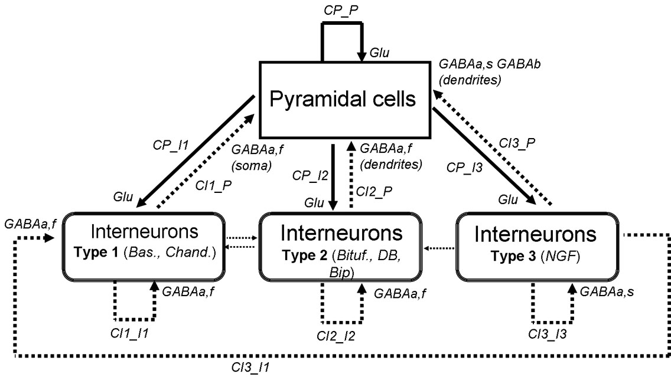

Figure 2: structure of the neural mass model for the cerebral cortex. Thin lines (among interneurons) indicate that the connections are less numerous.

As shown in the simple example shown in Figure 3, at each subpopulation, a pulse-to-wave function transforms the average presynaptic pulse density of afferent action potentials (input) into an average postsynaptic membrane potential (output) whereas a wave-to-pulse function relates the average postsynaptic potential to an average pulse density of potentials fired by the neurons. The pulse-to-wave function is represented by a 2nd order linear transfer function impulse response



where  is the amplitude of the average receptor-mediated postsynaptic potential, and where  represent the time rate constants of this postsynaptic potential. In the above equation,  can be one of the  ,  and  parameters which show time rate constants of glutamate, GABAA,slow , GABAA,fast and GABAB receptors. Accordingly,  may be one of , ,  and  parameters. denotes the Heaviside function.  is a normalizing constant value which is given by the following equation:



To have more information about the morphology of *h*(*t*), we can obtain the time (*t1*) at which *h*(*t*) is maximal and the time (*t2*) at which the value of *h*(*t*) become 0.707 of its maximum value.



The wave-to-pulse function is modeled by a static nonlinear function of sigmoid shape  to represent saturation and threshold effects taking place at the soma.  refers to one of the sub-populations shown in Figure 2 (i.e., *P, I1, I2, I3*). ,  and  represent maximum firing rate, inflection point of the sigmoid function, and the slope at the inflection point, respectively. Beside  which has a cortical origin, sub-cortical structures can also send some deriving inputs to cortical structure. To distinguish between cortical and sub-cortical firing rates we will use subscripts ‘c’ and ‘s’ to express firing rate quantities. This means that the above-mentioned  parameter is expressed by , and sub-cortical firing rates are expressed by .  refers to the target subpopulation in the cortex (contrary to , which refers to the source subpopulation). All sub-cortical inputs in the model are excitatory. This means that sub-cortical inputs target pyramidal cells and interneurons populations via glutamatergic synapses. Those sub-cortical inputs that target interneurons can have an inhibitory effect on pyramidal cells population, a phenomenon called as “feed-forward inhibition”.

Besides synaptic transmission, interactions between neuronal subsets are also characterized in the model by connectivity constants (*CP\_Ix*, *CP\_P*, *CIx\_Ix*, *CIx\_P* where *x* is 1, 2 or 3) that account for the average number of synaptic contacts or “degree of connection”.

The nonspecific influence from neighboring or distant populations is represented by a Gaussian input noise corresponding to an excitatory input *p(t)* that globally describes the average density of afferent action potentials.

One model output corresponds to the postsynaptic activity of principal neurons (summated postsynaptic potentials) and can be interpreted as a field potential. Others possible model outputs correspond to the postsynaptic activity of subpopulations, allowing to assess the participation of each cellular type in the observed field activity.

Finally, model equations are derived from functions *h(t)* which introduce a pair of first order ordinary differential equations of the form



where *x(t)* and *z1(t)* are the respective input (afferent pulse density) and output (average postsynaptic membrane potential) signals, and where the ’ symbol denotes the first derivative wrt time. For a given model, the set of first order nonlinear ordinary differential equations obtained for all synaptic interactions present in the model is numerically solved using standard integration algorithms (fixed step Euler method) to simulate signals.

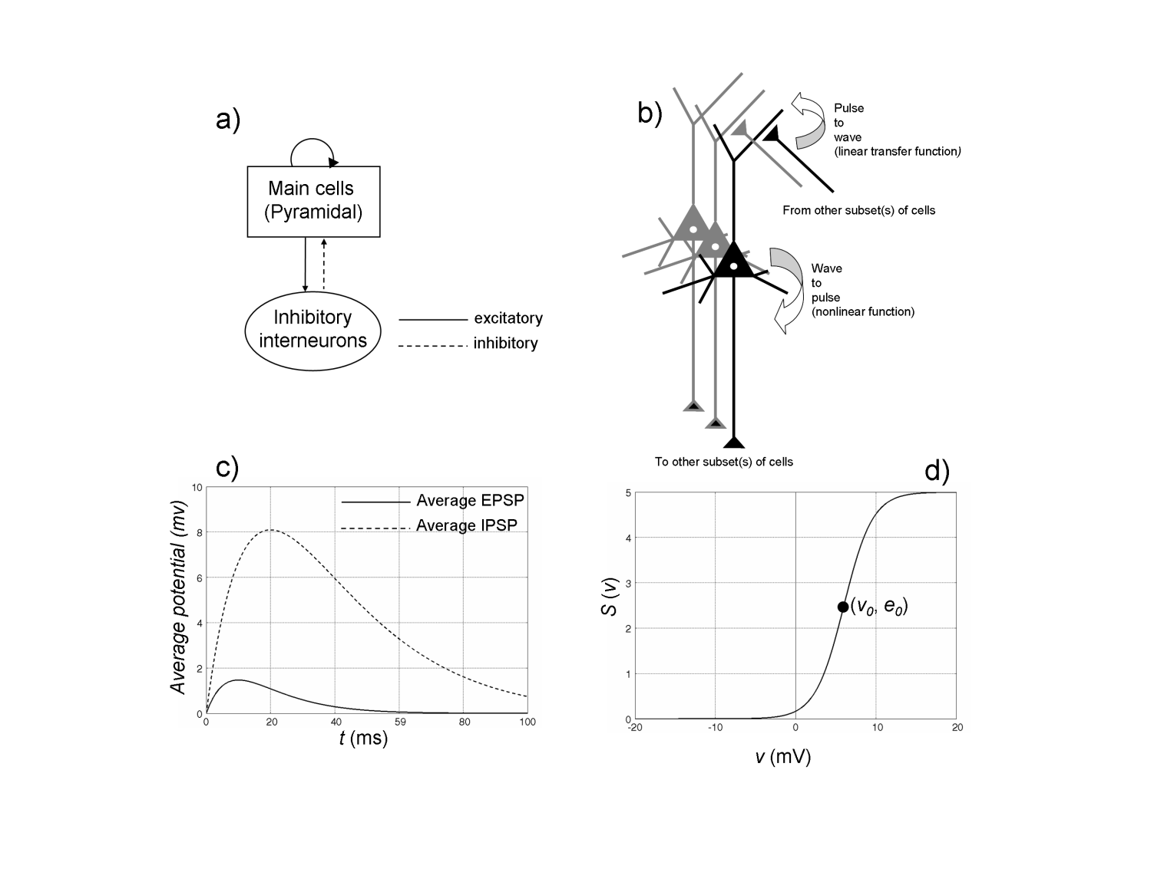

Figure 3: a) Structure of a generic neuronal population model representing a cluster of neurons composed of two subsets: main cells (i.e. pyramidal cells) and local interneurons (basket cells for instance). Pyramidal cells receive excitatory input from other pyramidal cells (collateral excitation) or inhibitory input from interneurons. These latter cells receive excitatory input only from pyramidal cells. b) Each subset is characterized by two functions, respectively named as the “pulse-to-wave function” and the “wave-to-pulse function”. The former changes presynaptic information (average density of afferent action potentials) into postsynaptic information (average excitatory or inhibitory postsynaptic membrane potential, respectively EPSP or IPSP). The latter relates the average level of membrane potential of the neurons to an average pulse density of potentials fired by these neurons. c) Impulse response of the “pulse-to-wave function” approximating actual average excitatory (dotted line) or inhibitory (solid line) postsynaptic potentials. d) Shape of the sigmoid“wave-to-pulse” function. Nonlinear sigmoid shape accounts for the integrating action that takes place at the soma (threshold and saturation effects). From [[11](#_ENREF_11)]. For this report, permission has not been requested.

### Time constants of glutamatergic and GABAergic postsynaptic potentials (PSPs)

Regarding glutamatergic currents, Kidd et al. [[12](#_ENREF_12)] showed that the EPSC decays were best fitted by the sum of two exponentials ( fast= 5.9 +/- 0.5 ms,  slow = 169.2 +/- 16.7 ms). The fast component of the EPSC was mediated by AMPA receptors. According to this value, we will adjust the value of  at about 6 ms (4.5 – 7.5ms).  and in general a  parameter takes a value between 100 to 400 s-1.

For GABAergic currents, monosynaptic GABAa fast-mediated IPSCs were recorded in pyramidal neurons. Decay times were estimated to vary in the range of 3-8 ms. For GABAa slow synapses, falling time constants of 50 +/- 20 ms are commonly used [[13](#_ENREF_13)]. Finally, for GABAb-mediated IPSCs, based on current recordings performed under paired-pulse technique, the study reported in [[14](#_ENREF_14)] showed time constants ranging approximately from 200 to 400 ms in neocortical neurons of the rat in vitro. Therefore, the value of  can be adjusted in this range of values. Table 1 provides a summary of time constants to be used in the model.

|  |  |  |
| --- | --- | --- |
|  | Average amplitude (mV) | Decay time (ms) |
| Excitatory PSP (Glutamate) | *A:* 3 -8 | a : 4.5 - 7.5 |
| Inhibitory PSP (GABAa, slow) | *B:* 1 – 40 | b : 30 - 70 |
| Inhibitory PSP (GABAa, fast) | *G:* 1 – 40 | g : 3 - 8 |
| Inhibitory PSP (GABAb) | *D:* 1 – 5 | d : 200 - 400 |

Table 1: Standard values for the amplitude of average post-synapytic potentials and decay time constants used in the model.

### Coupling between neuronal populations and externally-applied electric field

In order to account for the influence of the electric field resulting from the externally-applied stimulation in our neuronal mass model, we have to introduce a model for the coupling between the neuronal population and the stimulation effects.

From the literature review we performed in the HIVE project (reported in HIVE D1.1 *REVIEW OF STATE-OF-THE-ART IN CURRENTS DISTRIBUTION AND EFFECTS,* *Release date: 09 June, 2009*), it can be assumed that, within a certain range of intensity, the applied electric field linearly modifies the average membrane potential at the level of the different sub-populations. This polarization effect is also described and discussed in a recent literature review about animal models of transcranial direct current stimulation [[15](#_ENREF_15)].

An example obtained from experimental data obtained in vitro is provided in Figure 4. From intracellular recordings (effects on single pyramidal cells of CA1), authors [[16](#_ENREF_16)] confirmed that application of exogenous uniform electric fields parallel to the soma–dendritic axis results in changes in transmembrane potential (all recorded neurons): positive (respectively negative) fields resulted in somatic hyperpolarization (respectively depolarization).

|  |  |
| --- | --- |
|  | Figure 4: Intracellular recordings performed in hippocampal slices in vitro (A) during application of an external electric field influence. A) The cell membrane polarization and B) action potential threshold vary (almost) linearly with the strength of the applied electric field. Adapted from [[16](#_ENREF_16)]. For this report, permission has not been requested. |

In this section, we summarize the main aspects of this model. As shown in many studies reported in D1.1, neurons are sensitive to the externally-applied electric field component that oriented along their somato-dendritic axis. As illustrated in Figure 5-A, this component (blue) can be obtained by computing the **dot product between the electric field (red) and a unit vector along the somato-dendritic axis y of the cells**. This component (weighted by a scalar lambda determined from experimental data) is then added to the average membrane potential of the different subpopulations of neurons (pyramidal cells and interneurons) represented in the neuronal mass model. When positive (respectively negative), it will have a depolarizing (respectively polarizing) effect.

**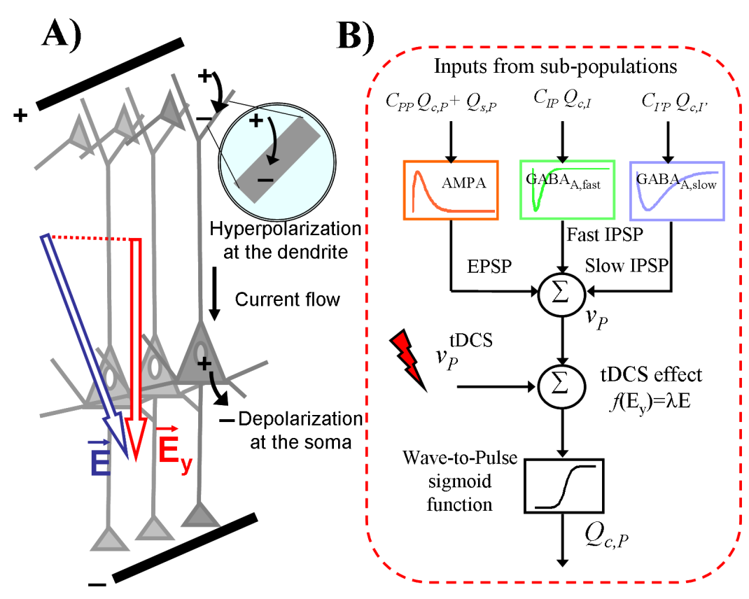**

Figure 5: Coupling model between a subpopulation of neurons in the neural mass model and the electric field resulting from the externally-applied stimulation (tDCS). (A) The variation of the average membrane potential of a given subpopulation is proportional to the amplitude of the component of the electric field oriented along the main axis of the cells (Ey). A field aligned with the orthodromic direction (dendritic tuft to axon), will result in a positive (depolarizing or excitatory) perturbation of the soma membrane potential. The opposite effect is observed on dendritic tuft. (B) Schematic diagram showing a given subpopulation of cells, its input pulse-to-wave functions, output wave-to-pulse function, and the polarization effect of the electric field on soma membrane potential.

### Experimental validation of modeling results

In order to evaluate the performance of the above-described computational model, we made use of somatosensory evoked potentials recorded in the rabbit under control and tDCS effects. Our objective was to reproduce the time-course of actual cortical responses in control condition as well as under anodal and cathodal tDCS. In this section, we provide a short summary of performed studies. Readers may refer to [[17](#_ENREF_17)] and [[18](#_ENREF_18)] for detailed description.

In brief, it is now well-admitted that transcranial Direct Current Stimulation (tDCS) allows for interacting with brain endogenous rhythms. However, the exact mechanisms by which externally-applied fields modulate the activity of neurons remain elusive. Based on the above-described computational model (a neural mass model including subpopulations of pyramidal cells and inhibitory interneurons mediating synaptic currents with either slow or fast kinetics) of the cerebral cortex, we investigated the local effects of tDCS in an *in vivo* experimental model. Computational model parameters were adjusted to reproduce evoked potentials (EPs) recorded from the somatosensory cortex of the rabbit in response to air-puffs applied on the whiskers. EPs were simulated under control condition (no tDCS) as well as under anodal and cathodal tDCS fields (Figure 6). Results first revealed that a feed-forward inhibition mechanism must be included in the model for accurate simulation of actual EPs (peaks and latencies). Interestingly, results revealed that externally-applied fields are also likely to affect interneurons. Indeed, when interneurons get polarized then the characteristics of simulated EPs become closer to those of real EPs. In particular, under anodal tDCS condition, more realistic EPs could be obtained when pyramidal cells were depolarized and, simultaneously, slow (resp. fast) interneurons became de- (resp. hyper-) polarized. Geometrical characteristics of interneurons might provide some explanations for this effect.

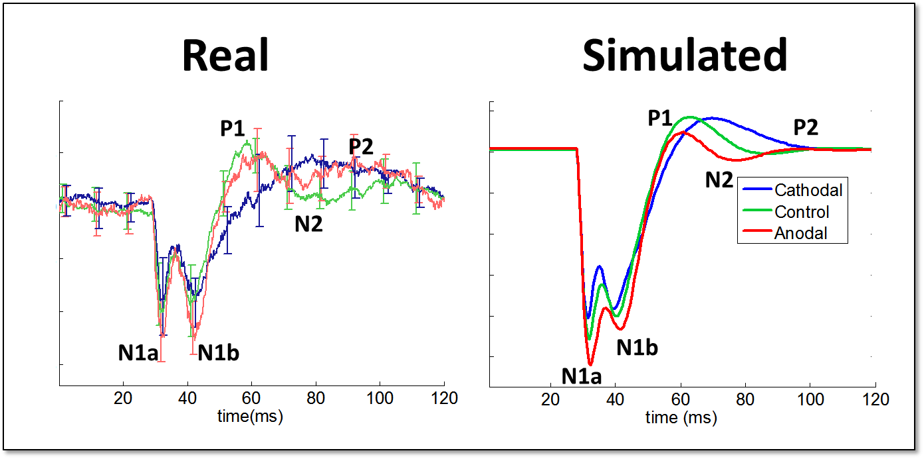

Figure 6: Comparison between real and simulated LFPs. Left: typical averaged evoked potentials (EPs) recorded in the rabbit in response to air-puffs under control condition where no tDCS current is applied (green), under anodal (red) and cathodal (dark blue) tDCS conditions, respectively. Right: Simulated EPs under control (green), anodal (light red), and cathodal (dark blue) tDCS. Here, tDCS effect affects all subpopulations (pyramidal cells and interneurons). In this case, simulated EPs actually reproduce observed modifications of peak amplitudes and latencies, as measured in the real EPs.

## Global level: a computational model of brain activity and EEG generation under tCS conditions

In this section, we summarize the second step of the computational model that was developed in HIVE and that will be extended for the purpose of LUMINOUS. Here, the objective was to develop a brain model that can reproduce global field potentials (EEG signals) as recorded in human subjects. In particular, we focused on alpha EEG activity recorded during rest (eyes closed).

This global model was aimed at helping us to interpret EEG data recorded under “normal” and “stimulation” conditions. It makes use of the neuronal population model presented in the previous section (2.3) that describes the activity generated at the level of the cerebral cortex, under “normal” conditions or under application of external electric fields, as induced by tCS. This model combines 1) a distributed dipole source model that describes the spatial features of the sources as defined by the folded surface of human neocortex and 2) a model of coupled neuronal populations that simulates the time-courses associated to the dipole sources and referred to as the “temporal dynamics” in the following.



### Realistic modeling of the spatial features of neocortical sources

In this model, it is assumed that the neocortex consists in a network of neuronal populations. The electrical activity of each population (i.e. the local cortical activity) is represented by a current dipole (characterized by its location, orientation and intensity). In order to constrain the dipole locations and orientations, a realistic mesh of the cortical surface (grey matter/white matter interface) is built from the segmentation of a T1-weighted 3D-MRI, using the BrainVisa software (SHFJ, Orsay, France). This mesh is made of 210054 elementary triangles (mean surface 1mm2) that precisely describe the circumvolutions of the cortical surface (see Figure 7A), and defines our source space. One dipole is located at the barycenter of each triangle and oriented normally to its surface (Figure 7B). At each 3D location *x*, the dipole intensity *I(x,t)*, function of space and time, is written as the product of two terms:

*I(x,t) = q(x) .α(t)*

where *q(x)* denotes the dipole moment (function of space) and *α(t)* represents the neuronal activity(function of time). The dipole moment *q(x)* is obtained by multiplying the corresponding triangle surface bythe dipole moment (current density of the cerebral cortex). Thisdensity is the product of the neocortical thickness (set toa constant value of 3 mm) and the cortical current surface density(100 nA/mm2 for a normal background activity, see [[19](#_ENREF_19)]).The weighting coefficient *α(t)* represents time-course of thedipole intensity and is provided by the output of the neuronal population model described in 2.3.

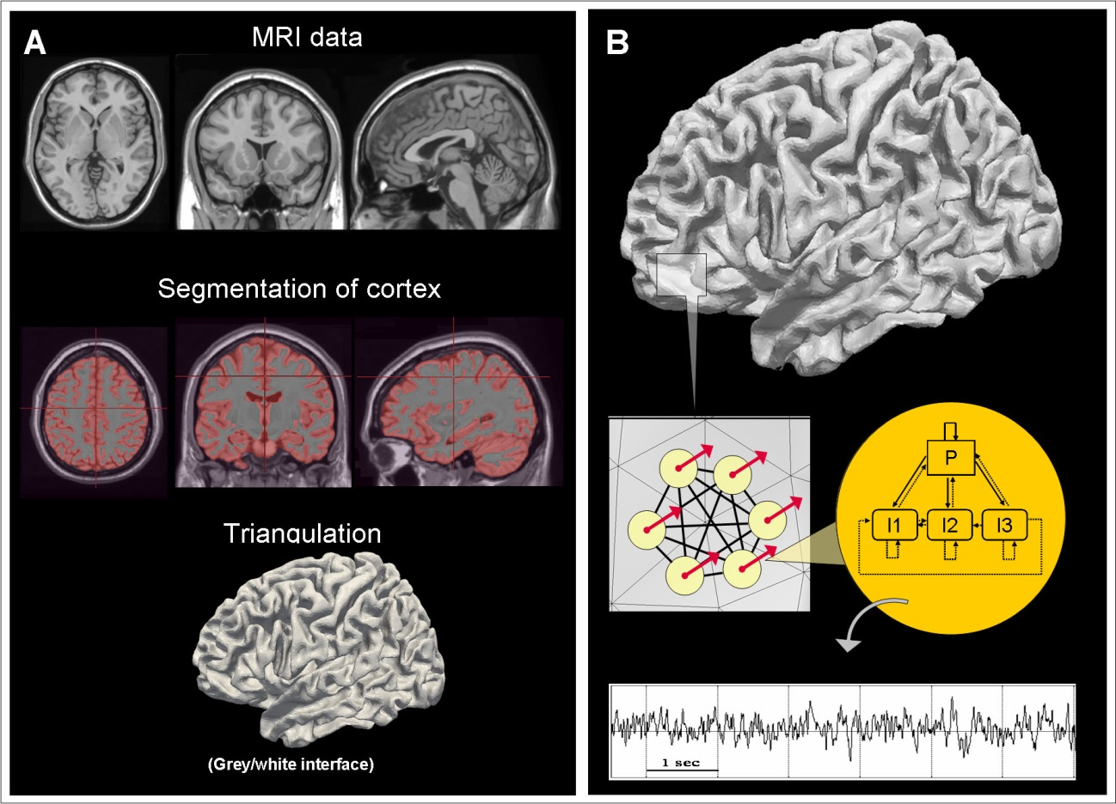

Figure 7: Spatio-temporal source model. A) T1-weighted 3D-MRI data were obtained from subject Colin Holmes, scanned 27 times at the Brain Imaging Center (MNI, Montreal, Canada). Scans were coregistered and averaged to get a high resolution (voxel size 1mm3) anatomical dataset. This average was then spatially normalized in the MNI Talairach space to create the MRI volume called “colin27", downloaded, for the purpose of our study, from <http://imaging.mrccbu.cam.ac.uk/imaging/MniTalairach>. These data were segmented and triangulated using the BrainVisa software (IFR49, SHFJ, Orsay, France). The resulting mesh (grey-white matter interface) is composed of 210054 elementary triangles with a mean surface of 1mm2. (B) Each triangle is assumed to represent a neuronal population. The electrical contribution of each neuronal population is represented by an elementary current dipole, placed at the barycentre of the triangle and oriented orthogonally to triangle surface. The moment of each current dipole is weighted by both the triangle area and the population time-varying field activity or “population dynamics” [[20](#_ENREF_20)]. This field activity is obtained from the model of neuronal populations described in section 2.1.

### Realistic brain connectivity: couplings between cortical regions

In our model, the neuronal populations placed all over the cortical surface are coupled via excitatory connections between pyramidal cells. Indeed, neocortical pyramidal cells are extensively interconnected [[21](#_ENREF_21)]. The majority of the connections made by pyramidal axons are with spiny postsynaptic dendrites, indicating that many of their targets are other pyramidal cells (Kisvárday *et al.*, 1986; Elhanany and White, 1990; White and Czeiger, 1991; Kisvárday and Eysel, 1992; Czeiger and White, 1993; Keller, 1993; Keller and Asanuma, 1993; Johnson and Burkhalter, 1996).

These couplings should reflect the anatomical connections between cortical regions. Obviously, these connections are not distributed homogeneously in the brain, and follow a complex topology. This aspect is a key point as short- or long-range connections (even for distant anatomical regions) constitute the substrate of physiological EEG rhythms. Accordingly, the realistic simulation of EEG signals implies that some of these rhythms can be reproduced, i.e., that a realistic coupling scheme between populations can be established.

A large scale study called “Human Connectome” was initiated at the Indiana University [[22](#_ENREF_22)] with the collaboration of the Department of Radiology at the University Hospital Center and University of Lausanne. As a result, the authors provided a map of anatomical connections linking human brain regions, called “connection matrix” [[23](#_ENREF_23), [24](#_ENREF_24)].

In brief this matrix was obtained from analysing anatomical data in 5 normal subjects. The procedure they followed is detailed in Figure 8. For each subject, the MRI data are segmented, and processed with sulci-recognition and automatic regional labelling algorithms to get a set of 66 anatomical regions covering both hemispheres. This partition is refined afterwards into about 1000 regions of interest (ROIs) that are combined with the axonal trajectories across the entire white matter, estimated from whole brain tractography.

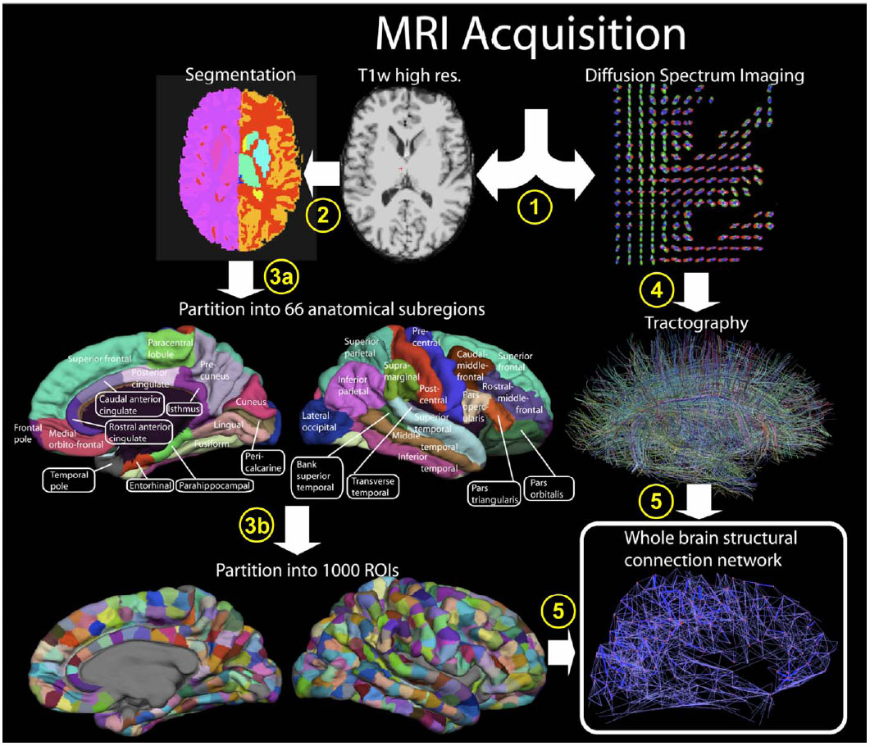

Figure 8: Extraction of a Whole Brain Structural Connectivity Network. (1) High-resolution T1 weighted and diffusion spectrum MRI (DSI) is acquired. DSI is represented with a zoom on the axial slice of the reconstructed diffusion map, showing an orientation distribution function at each position represented by a deformed sphere whose radius codes for diffusion intensity. Blue codes for the head-feet, red for left-right, and green for anterior-posterior orientations. (2) White and gray matter segmentation is performed from the T1-weighted image. (3a) 66 cortical regions with clear anatomical landmarks are created and then (3b) individually subdivided into small regions of interest (ROIs) resulting in 998 ROIs. (4) Whole brain tractography is performed providing an estimate of axonal trajectories across the entire white matter. (5) ROIs identified in step (3b) are combined with result of step (4) in order to compute the connection weight between each pair of ROIs. The result is a weighted network of structural connectivity across the entire brain. [[24](#_ENREF_24)]. For this report, permission has not been requested.

As a next step, fiber densities for all pairs of ROIs are first averaged within each subregion and then across all five participants (see Figure 9). The obtained matrix represents the *connection weights* between the 66 regions defined according to anatomical landmarks.

4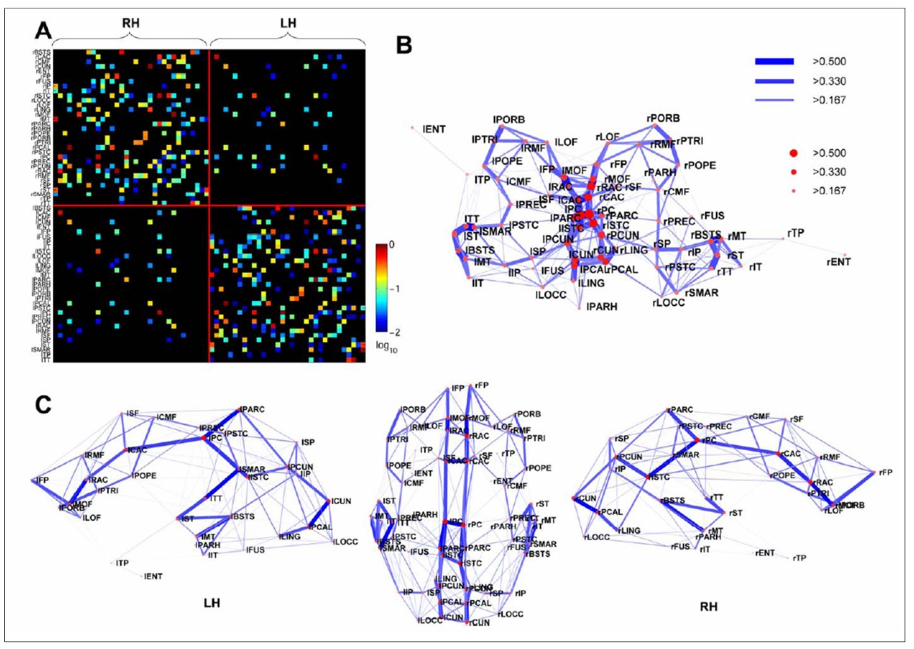

Figure 9: Average Regional Connection Matrix, Network Layout, and Connectivity Backbone. (A) Matrix of inter-regional fiber densities between pairs of anatomical subregions, obtained by averaging over fiber densities for all pairs of ROIs within the regions, and averaging across all five participants. Connection weights are symmetric and are plotted on a logarithmic scale. (B) Network layout. (C) Dorsal and medial views of the connectivity backbone in anatomical coordinates [[24](#_ENREF_24)]. For this report, permission has not been requested.

The connection matrix provided in [[24](#_ENREF_24)] constitute one key element providing a “plausible” basis for coupling cerebral regions in our human brain model.

In order to make use of this connection matrix for our data, we first defined on our mesh a similar set of 66 regions (33 per hemisphere) as those used in the “human connectome” study. To proceed, we used the Paraview software (version 3.4.0, [www.paraview.org](http://www.paraview.org)) to manually outline these regions on the grey/white interface mesh. Contiguous triangles belonging to each of the 66 regions were referenced in individual ROI files (see section 2.4.2).

### Generation of scalp EEG signals under tCS conditions: application to alpha activity modulated by tACS

In this section, we describe the simulation pipeline and illustrate the model performance in a concrete application: the simulation of scalp EEG during alpha activity, under control condition and under tACS stimulation. Detailed information regarding this study was reported in [[25](#_ENREF_25)]. Here, we provide a synthesis of the main points that remain relevant in the context of Luminous.

**a) Simulation pipeline: general overview**

The proposed pipeline to simulate EEG data under tCS is summarized in Figure 10. The three main steps (physical modeling of electric fields, neurophysiological modeling of brain activity in response to applied fields and simulation of EEG signals) are then summarized in the paragraphs (b, c and d) that follow.

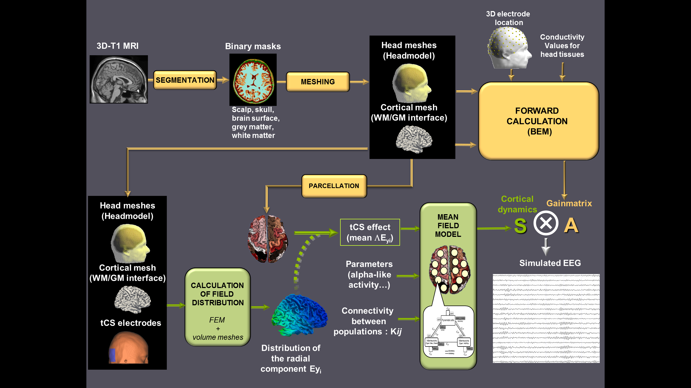

Figure 10: Simulation pipeline. 3D T1 MRI images are segmented into binary masks of the different head tissues in order to get meshes of the scalp, skull and brain surface (realistic head model) as well as of the white matter (WM) / grey matter (GM) interface. Unit dipoles are located at the barycenter of the triangles of this WM/GM mesh and set perpendicular to the triangle surface. This dipole layer over the cortex defines the source space. The forward problem is computed for each dipole using the Boundary Element Method (BEM) in order to get the leadfield matrix *A* that represents the contribution of each unit dipole of the mesh at each of the 19 scalp electrodes considered in our simulations (orange arrows in the pipeline). In order to get a physical model of the current distribution after tCS stimulation, surface meshes representing the boundaries between the different head tissues are transformed into volume meshes. In addition, virtual tCS electrodes are also represented into the model and can be placed at any scalp location (in our simulation protocol, we used PO9-PO10 location of the international 10-10 system). The electric field is calculated using the Finite Element Method (FEM) and the normal component of the field is mapped on the surface mesh of the WM/GM interface. values are then averaged over 66 macro-regions to get the 66 coefficients representing the mean field effect during tCS. We then used a model of coupled neuronal populations, with parameters of each population being adjusted to generate alpha-like activity, and connectivity between populations being defined in order to account for the thalamic input. coefficients can be added to the average membrane potential of pyramidal cells of each cortical neuronal population in order to i) mimic the de- or hyper-polarizing effect of the electric field and ii) get the resulting time-varying activities at the level of each cortical macro-region (green arrows in the pipeline)*.* The resulting spatio-temporal source matrix *S* is multiplied by the leadfield matrix *A* to obtain the simulatedEEG data under tCS condition.

**b) Simulation pipeline: physical modeling of current propagation and resulting tCS-induced electric fields**

In order to map the spatial distribution of the electric field on the cortical surface, we built a physical model for current propagation using a three-step approach. First, MR images were segmented. For this purpose, we used T1 and Proton Density (PD) phantom images based on the Colin27 template (http://www.bic.mni.mcgill.ca/brainweb). Segmentation was performed using the BrainSuite software (http://www.loni.ucla.edu/Software/BrainSuite, [[26-29](#_ENREF_26)]). White matter (WM), gray matter (GM) and cerebrospinal fluid (CSF) were segmented from the T1 images whereas the skull and scalp were obtained from the PD images. The resulting masks were used to generate surface meshes representing the boundaries between the different tissues. The mesh of WM-GM interface had 189494 triangles and 94743 vertices (average area of triangles 1.036 mm2, maximum 3.832 mm2, and minimum 0.008 mm2) and is shown in Figure11B. Secondly, a volume mesh representing the whole head was generated from the surface meshes using MIMICS (<http://www.materialise.com/>). At this stage, virtual tDCS electrodes were also incorporated into the model. The anode and the cathode could be placed at any of the positions defined in the 10-10 International System. The resultant mesh comprised more than 1.9×106 tetrahedral second order Lagrange elements (Figure11A).



Figure 11: Physical model for current propagation. A: Finite element mesh of the scalp and of the stimulation electrodes B: Finite element mesh of the interface between GM and WM. C: Spatial distribution of the magnitude of the electric field induced by the injection of a current through the anode. In this stimulation configuration, the anode and cathode virtual electrodes are centred over both occipital cortices, and the amplitude of the injected current is set to 1.12 mA.

Thirdly, the volume mesh was imported into a finite element program to calculate the electric field (Comsol 3.5a, [www.comsol.com](http://www.comsol.com)). The upper surface of each electrode was set to uniform electrical potential and the potential difference between them was adjusted to reach the desired custom amplitude of injected current through the anode. All the remaining outer boundaries of the model were considered to be insulating (), and continuity of the normal component of the current density was imposed on all the inner boundaries. The electric field induced in the brain was obtained by solving Laplace’s equation:

,

(where  denotes the electrostatic scalar potential and  the electrical conductivity) and taking the gradient of the scalar potential. This procedure assumes that the quasi-static approximation [[30](#_ENREF_30)] is valid for the low stimulation frequencies used in tCS. In this approximation, the tissues are considered to be purely resistive with no capacitive components. The different tissues in the head model were modeled as having electrical conductivities with values close to the average ones reported in the literature for the DC / low frequency range [[20](#_ENREF_20), [31](#_ENREF_31), [32](#_ENREF_32)]: 0.33 S/m, 0.008 S/m, 1.79 S/m, 0.33 S/m and 0.15 S/m for the scalp, skull, CSF, GM and WM, respectively. The electrodes were modeled as having a conductivity value arbitrarily taken to be equal to that of the scalp. All media were modeled as having isotropic conductivities and, as such, the current density could be found simply by multiplying the scalar electrical conductivity by the electric field.

All calculations were performed in Comsol, using its Conductive Media DC package. Given the large number of degrees of freedom in the model (more than 5×106), an iterative linear system solver (GMRES) was chosen. This iterative solver required that a preconditioner be used (Incomplete LU with a drop tolerance of 0.005). The calculation took less than 3 hours to complete in a workstation with a quad-core i7-860 processor running at 2.8 GHz and 16 GB of RAM memory.

Following this calculation, both normal and tangential components of the electric field were mapped on the WM mesh. The magnitude of the electric field on the WM surface is shown in (Figure 11C). The radial component of the electric field is discontinuous across the WM-GM boundary. Here, we have always used the values obtained in the WM side of this interface.

**c) Simulation pipeline: neurophysiological modeling for cortical activity from a mean-field model**

The model shown in Figure 2 was used in this study, configured to produce alpha activity. At the level of a single population, and when model parameters are properly adjusted, oscillations around 10 Hz become prominent in the model signal output [[33](#_ENREF_33)]. These oscillations closely resemble real alpha activity (Figure 12A).

Model parameters used to simulate this alpha-like activity are provided in

Table 2. Besides parameters controlling the kinetics of PSPs, the ratios between connectivity parameters (average number of synaptic contacts between sub-populations) were set according to physiology. In brief, the number of synaptic contacts among pyramidal cells and from pyramidal cells to interneurons was set to be greater than the number of synaptic contacts among interneurons and from interneurons to pyramidal cells.

|  |  |
| --- | --- |
| **Synaptic gains** |  |
| **PSP rate constants** |  |
| **Connectivity parameters** |  |
| **Sigmoid functions** |  |
| **tCS effect (gain ratios)** |  |

Table 2: Parameters values for which alpha-like activity is obtained.

As reported in [[34](#_ENREF_34), [35](#_ENREF_35)], a number *N* of neuronal populations can be coupled to model the activity over *N* interconnected brain structures. We followed this approach to obtain a “realistic” (i.e. relatively correlated) alpha-like activity over the entire neocortex (see Section 2.3.4 for practical details). Indeed, in the absence of any connectivity pattern, we could verify as expected that the *N* populations of the model generate uncorrelated alpha activity (Figure 12 B), which is not compatible with experimental data. A way to overcome this difficulty is to account for the influence of the thalamic system which intervenes both in the generation and control of alpha/spindles observed in EEG signals [[36](#_ENREF_36)]. It is noteworthy that our intent was not to develop a complex thalamo-cortical model, but instead to increase the “realism” of the simulated alpha-like neocortical activity. To proceed, in the model, we introduced an *N+1*th population, referred to as the “sub-cortical population” that was unidirectionally connected to the *N* neocortical populations. Using this “vertical connectivity”pattern, the model could include a common input (mimicking, to some extent, the thalamic input) to neocortical populations. In addition, it has been reported that slow delta oscillations, generated in the neocortex, can synchronize the thalamus leading to the generation of high-amplitude alpha oscillations [[36](#_ENREF_36), [37](#_ENREF_37)]. In order to also account for this effect, a direct glutamatergic input was added to the sub-cortical population (periodic trapezoid pulse, 2.5 s period, i.e. 0.4 Hz). Under these conditions, we could qualitatively verify that the model generates “more realistic” alpha-like activity, as illustrated in Figure 12C.



Figure 12: Generation of alpha-like cortical activity in the neuronal population model. A: Typical alpha-like signal (alpha peak around 10 Hz) produced by the model at the level of a single population for appropriate setting of parameters (see table 1) B: An example of signals obtained in the model with *N* populations (same set of parameters as in A) when no connectivity is present among populations. Alpha-like activity is generated at the level of each population. This activity is desynchronized among populations. C: An example of signals obtained in the model with *N* populations (same set of parameters as in A) when a “vertical” connectivity pattern is used. In that case, an additional population (N+1th) is added as a common synchronizer. This population called “subcortical” is unidirectionally coupled with the *N* other populations in order to mimic the thalamic input. The “subcortical” population also receives a direct low frequency input in order to mimic the synchronizing effect of cortical delta oscillations on the thalamus. Under these conditions, alpha-like activity is synchronized among the N populations.

Regarding the impact of tCS at neuronal population level, we simulated membrane polarisation effects as described in section 2.3.4. Neurons are sensitive to externally-applied electric fields in a geometry-dependent manner [[16](#_ENREF_16), [38](#_ENREF_38)]. Their response depends on the orientation of the electric field with respect to the somato-dendritic axis of neuronal cells. More particularly, the electric field effects are maximal when the field orientation is parallel to the cells’ main (somato-dendritic) axis. Conversely, electric field effects are null for orthogonal orientation. In addition to the orientation, it has been shown that the direction is also an essential factor. A field aligned with the orthodromic direction (dendritic tuft to axon) would result in a positive (depolarizing or excitatory) perturbation of the membrane potential at the soma. Conversely, a field in the antidromic direction would have a negative influence (hyperpolarizing or inhibitory). In accordance with these considerations, the influence of tCS was represented in the neuronal population model as a perturbation of the mean membrane potential. Two main assumptions were made at this level. First, based on results reported in ([Bikson et al. 2004](#_ENREF_2)), it can be reasonably hypothesized that this perturbation is linear and direction-dependent within a certain range of magnitude. Second, we recently showed that the electric field induced by tCS has an impact on both pyramidal cells and interneurons [[17](#_ENREF_17)]. Nevertheless, for the purpose of this study and in order to limit the number of free parameters, we neglected the electric field effects on interneurons since the impact is lower compared that on pyramidal cells [[17](#_ENREF_17)].

Formally, we added a DC-offset voltage to the mean membrane potential  where . This DC-offset may have either a depolarizing or a hyperpolarizing effect on the sub-population of pyramidal cells, depending on its polarity. As a consequence, the firing rate of the corresponding sub-population described by the wave-to-pulse sigmoid function directly increases or decreases accordingly, resulting in a non-linear perturbation. It is worth mentioning that this effect on the firing rate is also consistent with results reported experimentally [[16](#_ENREF_16)], as the applied field also modifies the action potential threshold.

**d) Simulation pipeline: generation of EEG Signals**

In the model, EEG sources are represented as a dipole layer distributed over the neocortical surface. The geometrical description of this cortical surface can be achieved by using the same surface mesh (obtained from the segmented WM/GM interface) as the one used to map the electric field distribution. To simulate EEG signals at the level of scalp electrodes, each mesh triangle was associated to an elementary current dipole, placed at the barycentre of the triangle and oriented perpendicular to its surface. The magnitude of the moment of each dipole was proportional to the area of the corresponding triangle. In addition, each dipole was assumed to correspond to a distinct cortical neuronal population. Its time course, which represents the time-varying dynamics of the associated population, was provided by the output of a neuronal population model described in section 2.3.

From this setup, we built a spatio-temporal source matrix containing the time-varying activities of all cortical dipoles of the source space. Simulated EEG signals were generated using a realistic head model made of three nested surface meshes modeling the brain, the skull and the scalp with a conductivity of each medium fixed to 0*.*33 S/m, 0*.*008 S/m and 0.33 S/m, respectively [[31](#_ENREF_31)]. The inter-medium surfaces were extracted from the segmentation of the same T1-weighted 3D-MRI as for the source space and meshed by 2440 triangles each (ASA, ANT, and Netherlands). From this head model, the forward problem was then numerically calculated for each triangle using the boundary element method (BEM) implemented in ASA, to obtain the lead-field matrix***.*** This matrix gives the contribution of each dipole ofthe mesh at the level of scalp electrodes. The spatio-temporal matrix of simulatedEEG data was given by



**e) Illustrative example: simulation of EEG signals during tACS at alpha frequency**

An example of simulated EEG in the no-stimulation condition is displayed on Figure 13A. In the absence of tACS-like stimulation, simulated EEG signals display alpha-like activity. These rhythms are organised as spindles, synchronized over most of scalp EEG channels. This aspect is similar to that observed on real EEG alpha activity (Figure 13B). However, regarding experimental data, one can notice that the amplitude of the bursts of alpha activity is higher on parietal (P3, Pz, P4) and occipital channels (O1, O2) than on frontal electrodes while this specific topography does not appear on simulated data.



Figure 13: Simulation of EEG under no-stimulation condition. A: Typical signals simulated in the absence of tACS stimulation (19 scalp electrodes, international 10-20 standard system). B: Real alpha activity recorded in a healthy subject during wakefulness with eyes closed.

When applied at the alpha-peak frequency of the model (10 Hz), the tACS-like stimulation induced an elevation of the alpha power at posterior electrode POZ. This elevation gradually increased when the calibration factor was augmented (Figure 14A). In the reference study [5], an elevation of 14% in the alpha power was observed at POZ electrode. In our simulation study, this percentage value corresponded to. Therefore, the following simulations were calibrated by fixing.

At the level of all scalp electrodes, the increase in alpha power was clearly visible on left and right central, parietal temporal and occipital contacts, while only subtle changes occurred on midline electrodes (Figure 14B). As illustrated on (Figure 14C), the quantitative analysis revealed that under 10Hz-tACS simulated stimulation, the alpha power was significantly increased on most left and right channels. The significant increase was larger on central and posterior channels and was maximal at the level of temporo-parietal electrodes (T5 or T6). Contrarily, the increase in alpha power remained non-significant at frontopolar contacts (Fp1, Fp2) and at the level of most anterior midline electrodes (Fz, Cz, and Pz).



Figure 14: Simulation of scalp EEG signals under tACS stimulation. A: Calibration of the Λparameter. Scalp EEG signals were simulated for 13 values of parameter involved in the computation of the coefficients. Λ = 0 corresponds to the no-stimulation condition, and Λ = {1,2,4,6,10,12,14,16,18,20} correspond to the 10Hz-tACS stimulation condition. Boxplot are obtained after averaging the mean alpha power at the POZ scalp electrode from 20 trials of simulated EEG for each condition. During tACS stimulation the alpha power at posterior electrode POZ gradually increases with the calibration factor Λ. For Λ = 8, a significant increase of 14% is observed and corresponds to the percentage reported in real data at the same electrode [5]. This Λ = 8 value was chosen for simulations. B: Typical simulated EEG signals obtained in the no stimulation (left) or during tACS at the model peak frequency (10 Hz). C: Mean alpha power, averaged from 20 trials at each of the 19 scalp electrodes in the no stimulation vs. 10Hz-tACS condition. Significant increase in alpha PSD is observed during tACS stimulation at most left and right channels (except for fronto-polar electrodes) as well as at posterior midline channels POZ and OZ.

**f) Discussion**

In order to evaluate the above-described modeling approach, we chose to start from a study conducted in humans that examined the effects of tACS on EEG alpha activity [[39](#_ENREF_39)]. This choice was motivated by both the small number of studies reporting quantified EEG changes in response to tACS and the relative ease with which oscillations in the alpha frequency band can be simulated with neural mass models. In the present study, multiple neural masses are used in order to account for brain dynamics at a global level. Typically, the use of a common synchronizing population accounting for thalamo-cortical interactions promotes pacemaking synchronized alpha oscillations over multiple cortical regions. Yet, our connectivity pattern is not sufficient to obtain a realistic topography of EEG alpha activity, in particular with respect to the parieto-occipital distribution of alpha waves during wakefulness. This can be explained by the fact that not only thalamo-cortical but also long-range cortico-cortical interactions are involved in the genesis of alpha activity [[40](#_ENREF_40)]. Defining a connectivity pattern between cortical regions in our multiple population model is unfortunately a difficult task. While very interesting breakthroughs have been made in humans in particular with the use of Diffusion Tensor Imaging (DTI) data [[24](#_ENREF_24)], it appears that directionality in the connectivity pattern, which is not yet available in humans, is essential for the realism of simulated dynamics in large-scale networks [[41](#_ENREF_41)].

Despite the absence of cortico-cortical connectivity patterns, insights could be gained from our modeling approach into the effect of tACS stimulation on EEG alpha rhythms. Firstly, our modeling results are in accordance with the study by Zaehle and collaborators [[39](#_ENREF_39)]. Indeed, the increase in alpha power observed by these authors on posterior midline scalp electrodes (POz, Pz and Oz) was also reproduced in the model. In turn, the quantification of this increase on real data provided a method to calibrate the model. Interestingly, the value defined by the calibration process (Λ=8) also corresponded to the first value of Λ for which significant changes occurred at the posterior electrode POz.

## Conclusion

In the former FP7-Fet-Open **HIVE** project (2008-12), a computational model was proposed and developed, allowing for the simulation of EEG signals based on i) a realistic description of the volume conductor features, ii) an accurate representation of the distribution of the electric field inside this volume conductor and iii) a model of electric field effects on neuronal assemblies in the neocortex. To the best of our knowledge, the use of such a pipeline had never been proposed before and still remains now very advanced.

Based on this background, our intent is to develop a new model for the purpose of the **LUMINOUS** project (H2020-Fet-Open-RIA, 2016-20).

# Computational modeling of EEG for consciousness studies

## Main advantages and current limitations of the existing model. Required extensions for LUMINOUS

The motivation to start from the background presented in the previous section is justified by the **main advantages** offered by the chosen modeling approach:

1. The existing model can simulate electrophysiological signals under both control (i.e. no stimulation) and tCS conditions.

2. For the tCS condition, the model accounts for the impact, at cortical level, of the electric field induced by injected currents. The computation of the electric field distribution is based on biophysics (electrode size, geometry and position, head model, tCS parameters, etc.).

3. At the global level, the model is able to produce EEG signals that qualitatively and quantitatively (to a large extent) match the features of actual EEG signals.

4. At the local level, both the type (neural mass) and the level of modeling (mesoscopic) provide access to neurophysiologically-grounded parameters (excitation, inhibition, firing rates and membrane potential of sub-populations of glutamatergic and GABAergic neurons).

Nevertheless, in order to develop a new model that can be used in consciousness studies, a number of **strong limitations** must be overcome:

1. A more physiologically-realistic representation of the **thalamus** should be added to the model.

2. The connectivity between the thalamic and cortical modules (“vertical connectivity”) should be modified. So far, the model only includes a “synchronizing” input to neocortical populations of neurons. This phenomenological mechanism should be removed and replaced by a neurophysiologically-grounded representation of the **thalamo-cortical loop** which plays a key role in consciousness states.

3. Along the same line, the **cortico-cortical connectivity** (“horizontal connectivity” among brain areas) should also be enhanced. In the existing model, both short- and long-range connections were defined as excitatory only (i.e. interconnecting glutamatergic neurons). Although this type of connectivity is present in the brain, it should be complemented by another type of connectivity, referred to as “lateral inhibition”, which involves connections made to and from interneurons within the neocortex [[42](#_ENREF_42)] [[43](#_ENREF_43)] [[44](#_ENREF_44)] [[45](#_ENREF_45)].

4. It is well established that tCS is sub-threshold and induces not only immediate effects but also lasting effects, on the short and long-term. Acute effects are likely related to membrane polarization mechanisms which are already included in the existing model. Nevertheless, lasting effects which are likely related to **plasticity-related changes** in target brain circuits are not represented yet. Some mechanisms at the origin of these changes should be included in the model to be developed in the LUMINOUS project.

## Assumptions on “horizontal” and “vertical” connectivity, thalamo-cortical loops and corresponding EEG rhythms

During this year (at M12), we performed a comprehensive literature review about brain connectivity in order to determine which neurophysiological mechanisms should be “**ideally**” integrated in the envisioned computational modeling of EEG for consciousness studies. In the following section, we provide a synthesis about these mechanisms. This synthesis should be viewed as a “**modeling** **roadmap**” we would like to follow in order to reach the general objective. However, it is worth mentioning that, at this early stage (M12), there is no guarantee that all these mechanisms can actually be converted into mathematical equations and then integrated in the new model.

### Horizontal cortico-cortical connectivity

It is well established that the two fundamental components of consciousness, awareness and wakefulness, are related to brain functional connectivity. There is now a large body of evidence supporting the idea that functional connectivity studies can shed light on functional networks involved in various conscious states [[46](#_ENREF_46)]. In brief, during general anesthesia-induced loss of consciousness, there is a breakdown in cortical effective connectivity [[47-49](#_ENREF_47)]. In patients in vegetative state, impaired consciousness is also associated with an altered effective connectivity [[50](#_ENREF_50), [51](#_ENREF_51)]. Along this line, a TMS protocol triggering a simple, local response indicated a breakdown of effective connectivity, similar to the one previously observed in unconscious sleeping or anaesthetized subjects [[52](#_ENREF_52)]. During dreamless sleep, there is a dramatic reduction of both wakefulness and awareness. During the transition from wakefulness to slow wave sleep, the firing rate in the cortex remains relatively unchanged during depolarizing phases of the slow sleep oscillation [[53](#_ENREF_53)], while effective connectivity changes dramatically [[54](#_ENREF_54), [55](#_ENREF_55)]. More precisely, upon falling into NREM sleep, cortical activations became more **local** and **stereotypical**, **impairing effective cortical connectivity** [[56](#_ENREF_56)].

**a) Cellular processes involved in cortico-cortical connectivity**

Neuronal communication trough coherence of activity involves a rhythmic synchronization between distant neuronal groups, creating sequences of excitation and inhibition that focus both spike output and sensitivity to synaptic inputs to short temporal windows [[57](#_ENREF_57)]. All activated neuronal groups (belonging to the same module) can oscillate at a given frequency. Functional connectivity requires resonant oscillations between networks modules. Anatomical connections are dynamically rendered effective or ineffective through the presence or absence of rhythmic synchronization, in particular in the gamma band (30–90 Hz). Based on this connectivity pattern, generation of gamma oscillations in specific neuronal populations should create rhythmic sequences of excitation and inhibition forming a temporal window to bind the activity of distant networks.

**b) Local gamma oscillations within distant cortical neuronal groups**

To produce gamma oscillations (Figure 15), at least three main types of neurophysiological connections should be present in the model [[58](#_ENREF_58)]:

- **Feed-back inhibition** from somatic-projecting GABAergic interneurons to pyramidal cells

- **Mutual inhibition of somatic-projecting** GABAergic interneurons to themselves.

- **Thalamo-cortical feedforward inhibition** through thalamic activation of cortical somatic-projecting GABAergic interneurons to pyramidal cells.

|  |  |
| --- | --- |
|  | Figure 15: Basic network involved in gamma oscillation generation. BC: Basket cells (somatic-projecting GABAergic interneuron). Sst: Somatostatin expressing interneurons (dendritic-projecting GABAergic interneuron). Both types on interneurons received excitatory input from thalamo-cortical glutamatergic synapses (blue lines) and pyramidal cells (not illustrated). |

Note that mutual inhibition of somatic-projecting GABAergic interneurons (fast-spiking interneurons) through electrical gap-junctions are involved in gamma oscillations but, in a neural mass model, gap junctions are not considered since interneurons in each population are intrinsically synchronized.

**c) Connectivity: Isolated or communicating cortical neuronal groups**

In order to achieve effective long-range communication, distant pyramidal cells groups need to be phase-locked. Therefore, long-range excitatory connections (Excitatory P🡪P) are required to allow for the interconnection of several distinct cortical neuronal populations. The type (strength, convergence, divergence) should be tuned according to neurophysiological data available in the literature.

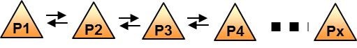

Figure 16: Connectivity between distinct neural mass models will be implemented. This type of connectivity was already developed in HIVE’s project and will be updated according to the most recent experimental literature.

**d) Surrounding inhibition of cortical populations**

In order to avoid an undesirable spatial widespread of activity from one excited neural population to any other connected neocortical neural population, local inhibition through GABAergic inhibitory interneurons (INs) is needed to provide a synaptic barrage, representing a crucial element of neocortical information processing.

Both the dendritic-targeting INs (Sst-type) and the somatic-targeting INs (basket cells, BC) have a broad connectivity, generating a blanket of inhibition of principal cells in their local neighborhood [[59](#_ENREF_59)].

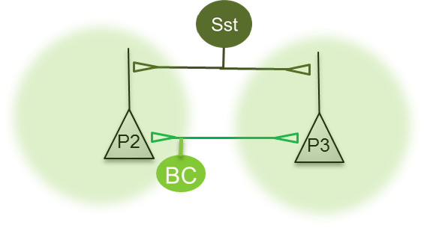 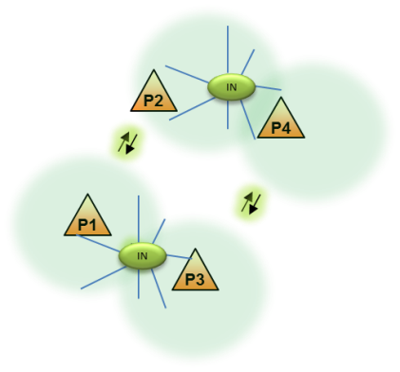

Figure 17: Left: Surrounding inhibition (green halo) is provided through both somatic-projecting interneurons (BC) and dendritic interneurons (Sst). Right: This inhibition maintains a synaptic barrage in order to decrease functional connectivity. Connectivity between distant neuronal groups could appear only if the surrounding inhibition decreases.

The dense and unspecific innervation of local PCs by INs generates a surrounding inhibition that supposedly suppresses uncontrolled propagation of excitatory activity in the neocortex. Parvalbumin interneurons (PVs) are specialized in **fast and transient inhibition** while somatostatin interneurons (Sst) deliver **slow-onset, lasting inhibition**.

**e) Lateral inhibition**

Lateral inhibition and competition shapes the spatial integration of cortical activity [[60](#_ENREF_60), [61](#_ENREF_61)]. Horizontal interactions between cortical domains enable information to be processed in a context-dependent manner. In terms of mechanisms, activation of layer 2/3 pyramidal cells involves disynaptic lateral inhibition between nearby pyramidal cells (PCs), likely through somatostatin-expressing interneurons (Sst).

Sst interneurons have been implicated in behaviour-dependent control of dendritic integration, as well as in lateral inhibition [[62](#_ENREF_62)]. They target the tuft dendrites of principal cells, and also inhibit other interneurons. Horizontal projections suppress activity in superficial layers, and therefore generate lateral competition while simultaneously activating deeper cortical output layers [[61](#_ENREF_61)].

**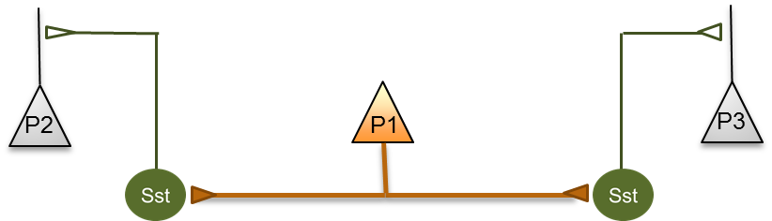**

Figure 18: Communication of two distant neuronal groups blocked through disynaptic lateral inhibition. A subpopulation of pyramidal cells (P1) should be configured in order to be able to inhibit two distant other pyramidal cells populations (P2, P3) through the activation (synaptic excitation) of dendritic-targeting interneurons (Sst).

**f) Breakdown of surrounding inhibition to allow distant communication**

Allowing connectivity between distant neocortical neural groups requires to transiently suppress surrounding inhibition.

Vasoactive intestinal polypeptide (VIP) GABAergic interneurons mediate disinhibitory control in multiple neocortical areas and are recruited by reinforcement signals [[63](#_ENREF_63)]. VIP interneurons are responsible for disynaptic lateral disinhibition, and have narrow axons inhibiting nearby somatostatin interneurons, which themselves inhibit pyramidal cells. Through this lateral disinhibition, VIP cells make local and transient “holes” in the inhibitory blanket extended by SOM cells [[64](#_ENREF_64)]. Therefore, VIPs can have a highly localized disinhibitory effect on the surrounding network.

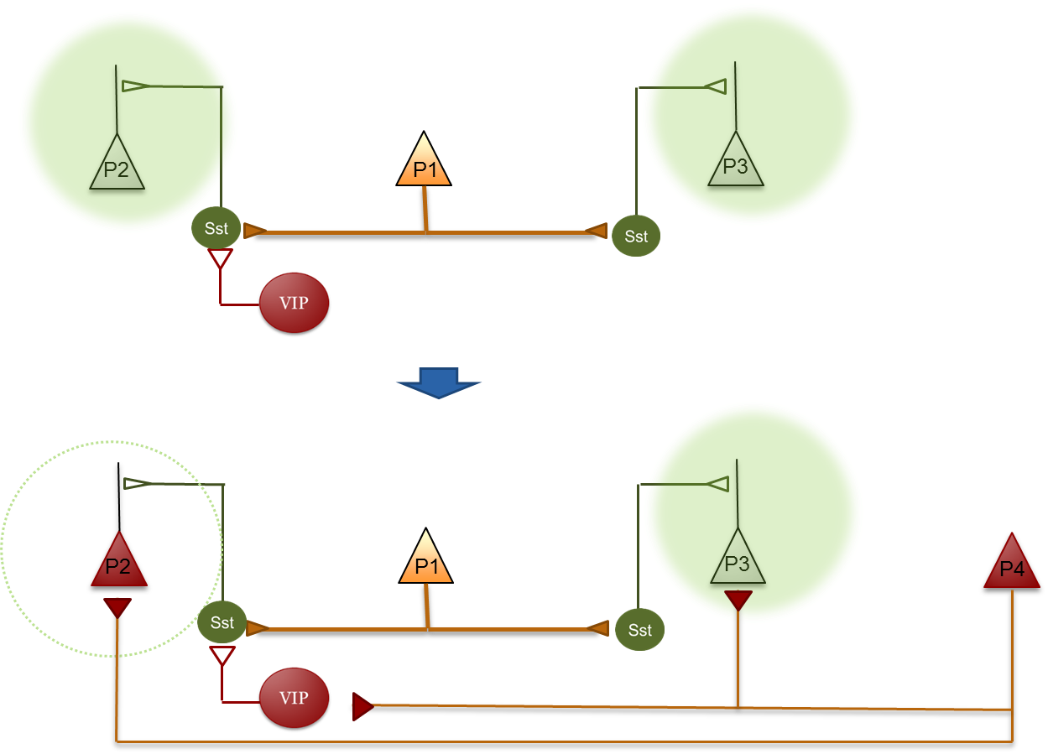

Figure 19: Up: Cortical VIP interneurons target dendritic-projecting GABAergic interneurons. Down: Distant activation of VIP coming from P4 glutamatergic input disinhibits population P2, allowing for excitation of P2 pyramidal cells.

In summary, the computational model should account for the main architecture of GABAergic inhibition illustrated in Figure 20.

|  |  |
| --- | --- |
|  |  |

Figure 20: The updated computational cortical model should implement physiological mechanisms of alpha / gamma oscillations for each population. Right: Excitatory input coming from a distant population of pyramidal cell (P4) targets both pyramidal cells of population P2 and disinhibits the somatostatin-expressing interneurons that create transient “holes” in the inhibitory blanket extended by dendritic-projecting GABAergic cells. Once disinhibited, BC-BC mutual inhibition and consequent BC-PC communication should be able to generate gamma oscillations (based on Scanziani et al. [[65](#_ENREF_65)]).

### Vertical thalamo-cortical connectivity

As reported in Deliverable D1.1 (*Consciousness: models, metrics & intervention in the electric brain*) and according to Tononi’s and Massimini’s theory (IIT, Integrated Information Theory [[66-68](#_ENREF_66)]), consciousness is not explained by the degree of cortical neurons excitability *per se,* but rather depends on the brain's ability to integrate information, depending itself on the effective connectivity among functionally specialized regions of the thalamo-cortical system. Effective connectivity is defined by the ability of a neuronal group to causally affect the firing of other neuronal groups [[69](#_ENREF_69)].

The rhythm of thalamo-cortical cells is indeed able to modify the excitability of cortical subpopulations and modulate cortico-cortical connectivity. Thalamic-mediated synchronization mechanism of distant cortical areas may give rise to large-scale integration of information across multiple cortical circuits, consequently influencing the level of arousal and consciousness [[70](#_ENREF_70)].

Conversely, during sleep or anesthesia-induced transitions in consciousness, thalamo-cortical and intra-thalamic functional connectivity is modified [[71](#_ENREF_71), [72](#_ENREF_72)]. On the other hand, thalamo-cortical rhythms are able to modify cortico-cortical connectivity. Upon falling into NREM sleep (during the establishment of the rhythmic thalamo-cortical up and down state), cortical activations become more local and stereotypical, pointing at a significant impairment of cortico-cortical connectivity [[55](#_ENREF_55), [56](#_ENREF_56), [73](#_ENREF_73)]. It has been shown recently that direct optogenetic tonic activation of the GABAergic interneurons of the thalamic reticular nucleus (TRN) induces spatially restricted cortical slow wave activity [[74](#_ENREF_74)]. This activity is reminiscent of sleep rhythms, while animals exhibit behavioural changes consistent with decreased arousal.

A very basic and phenomenological model of the thalamo-cortical connectivity has been developed in the HIVE project. As already mentioned, this aspect must be enhanced: a more realistic thalamo-cortical loop has to be implemented in the model developed in LUMINOUS (see preliminary results in section 3.5).

|  |  |
| --- | --- |
|  | Figure 21: Former computational model developed in HIVE’s Project. A population of thalamic cells was used to synchronize different population of cortical neurons. |

As reviewed in [[36](#_ENREF_36)], the thalamo-cortical loop is therefore essential to generate and maintain several brain rhythms.

**a) Thalamus**

The model to be developed will include the thalamic reticular nucleus (TRN), consisting of a population of GABAergic interneurons targeting TC cells. These reticular interneurons will receive inputs from the cortex, from TC cells and from brainstem. The TC cells receive input from brainstem, TRN and cortex, and project onto cortical layer 4.

We have already started to develop such a model of the thalamo-cortical loop for the purpose of LUMINOUS, based on our previous work regarding the modulation of epileptic activity by deep brain stimulation [[75](#_ENREF_75)]. A detailed description is provided in section 3.5 (*update on recent advances at local level: thalamo-cortical model and simulation of awake and SWS EEG*).

|  |  |
| --- | --- |
|  | Figure 22: General architecture of the thalamo-cortical loop that will be adapted for the computational model of EEG for consciousness studies. At the cortical level, two populations of GABAergic interneurons (dendritic- and somatic- projecting) target pyramidal cells. At the thalamic level, two populations of GABAergic interneurons of the reticular nucleus inhibit thalamo-cortical cells (TC cells).  The TC cells target both cortical pyramidal cells and GABAergic interneurons (accounting for thalamo-cortical feed forward inhibition). |

This model has to be upgraded to be able to produce the “**up and down” state**, depending on the **degree of inhibition** coming from the TRN (and therefore the firing rate of interneurons). Once upgraded, if the activity of inhibitory TRN interneurons is set to be more pronounced, the amplitude of the up and down activity of TC cells should increase producing slow waves at the cortical level. Ideally, the model should mimic different rhythms reminiscent of distinct sleep stages.

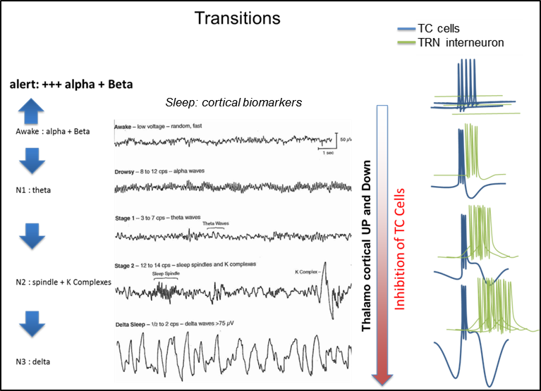

Figure 23: Simulation of distinct sleep cortical rhythms depending on the level of thalamo-cortical cells inhibition (adapted from Hauri P. Current Concepts: The Sleep Disorders, 2nd Edition, Kalamazoo, MI: Upjohn Company; 1982, [link](http://sleepdisorders.sleepfoundation.org/chapter-1-normal-sleep/stages-of-human-sleep/), reproduced without permission). As the firing of the GABAergic thalamic reticular nucleus interneurons increase, the inhibition of TC cells increases. This progressive inhibition is thought to be responsible for the transition from the awake state (associated to cortical alpha-beta-gamma oscillations) to NREM sleep (cortical delta waves).

The computational model should be able to simulate different electrophysiological markers at the cortical level, namely, alpha/beta rhythm (wake stage W), theta rhythm (N1), Spindle + K complex (N2), and delta waves (N3). The shift between the different stages of wakefulness should be dependent on the degree of inhibition of TC cells, and thereby on the level of TRN interneurons firing rate which is controlled by the brainstem activity. A sensory input should be also able to induce a switch from sleep to an awake state.

**b) Thalamo-cortical projections**

Thalamo-cortical feedforward inhibition (FFI) is one of the most fundamental organizational processes in the brain. Empirical and modeling work suggests that, within a generic FFI motif, a normalizing function selects synchronous inputs and facilitates their propagation. One of the functions of the FFI motif is to regulate circuits information transfer between the thalamus and cortical layer 4, but also to modulate cortico-cortical inter-regional interactions [[58](#_ENREF_58)] [[76](#_ENREF_76)] [[77](#_ENREF_77)].

The key components of the dynamic FFI pattern are: (1) strong excitatory connections to inhibitory neurons with (less) excitation of principal cells from the same source and (2) an inhibitory forward connection to principal cells with a time constant that imposes a temporal structure on the FFI motif. This type of inhibition is also involved in the generation of the cortical gamma rhythm.

Parvalbumine positive somatic-projecting GABAergic interneurons (BC) indeed participate in generating cortical gamma oscillation through: 1) thalamo-cortical feedforward inhibition in layer 4, 2) feedback inhibition in layer 2/3, and 3) direct BC-BC coupling through electrical gap-junctions [[58](#_ENREF_58)]. This scheme efficiently extracts population-coded information among concomitant asynchronous inputs in situations when this input is oscillatory. Therefore FFI represent a key element of consciousness regarding its role in gamma oscillation generation, inter-area communication, sensory integration and cortical inhibition.

Each cortical population contains excitatory glutamatergic pyramidal cells, and at least 2 types of GABAergic interneurons (e.g. somatic-projecting interneuron- GABA fast- and dendritic projecting interneurons –GABA slow-). TC cells project onto several populations of cortical neurons. Glutamatergic projections coming from TC cells target both cortical pyramidal cells (feed forward excitation) and perisomatic-targeting PV+ interneurons (BC, feed forward inhibition).

### Thalamo-cortical switch from horizontal to vertical connectivity

1. **Gamma oscillations and Inter-area functional connectivity (in the “awake mode”)**

At the cortical level, several neural populations should be able to oscillate in the gamma range (30–90 Hz). Several distinct cortical neuronal populations have to be interconnected. Connectivity between different populations of cortical neurons should allow phase-locking of gamma oscillations. These oscillations should emerge when the thalamo-cortical loop is tuned in the “awake” mode (e.g. phasic/tonic discharge).

**b) No functional connectivity during the up and down state (sleep mode)**

When the thalamo-cortical input is a slow, synchronized bursting discharge (as occurs during the up and down state), strong FFI combined to lateral inhibition between cortical populations should result in a spot of excited pyramidal cell surrounded by inhibited pyramidal cells (surrounding inhibition), along with a decrease of inter-area communication and therefore a decrease of functional connectivity.

Ideally, the model should be able to promote different sleep-awake stages (depending on thalamic output).

In the sleep mode, large and slow discharges of cortical populations surrounded by a large inhibitory barrage should result in specific biomarkers on the simulated EEG, such as slow waves. In this case, functional connectivity is expected to be low.

In the awake mode, distinct type of TC cells discharges should be associated with normal (physiological) background frequency content in the simulated EEG and the spontaneous emergence of gamma oscillations. The decrease of FFI and lateral inhibition might favor functional connectivity between distinct neuronal groups.

Therefore, we propose, in a first step, to construct the model presented in Figure 24 for one population:

|  |  |
| --- | --- |
|  | Figure 24: Identification of the basic cellular connectivity within the envisioned model of the thalamo-cortical loop. |

Finally, we aim to build a more complex and realistic thalamo-cortical model with several cortical populations able to simulate, and switch from a dominant cortical functional connectivity (horizontal connectivity) to dominant thalamo-cortical connectivity (vertical connectivity), depending on the degree of inhibition of the TC cells.

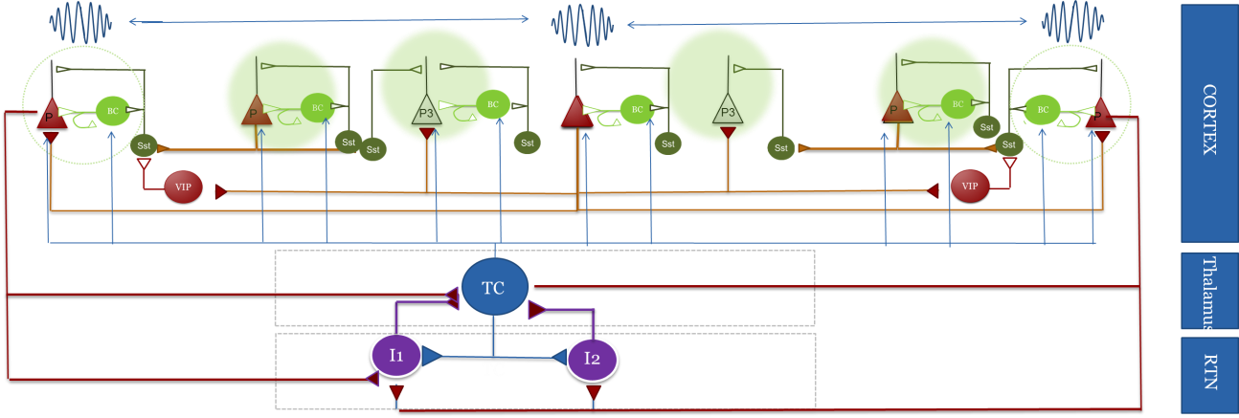

Figure 25: Overall view of the connectivity patterns in the envisioned computational model aimed to generate horizontal (cortico-cortical connectivity), vertical (thalamo-cortical) connectivity. Depending on the degree of TC cell inhibition, this model is expected to generate cortical awake-like EEG patterns with high cortico-cortical connectivity to several sleep–like EEG patterns until pronounced thalamic up and down activity associated with high thalamo-cortical connectivity and low cortico-cortical connectivity.

### Short- and long-term effects of NIBS on neuronal assemblies, cortical regions and whole brain

As mentioned above, the existing model accounts for **acute effects** of NIBS (tCS, TMS, multisite-tCS) by assuming that NIBS mainly results in neuron membrane polarization. We have already developed biophysical models to represent such mechanisms at the level of neuronal assemblies (see section 2.3.4) and of the whole brain (see section 2.4.3-b).

Nevertheless, NIBS techniques were also shown to produce lasting effects which are likely related to **plasticity-related changes** in target brain circuits. These plasticity-related effects are not represented yet in the model. Therefore, a bibliographic effort will be made on this topic in the coming months to determine how these lasting effects can be added.

## Physical modeling of electric fields induced by (multi)tCS

Despite recent developments in *in vivo* measurements [[78](#_ENREF_78)] of the electric field (E-field) distribution in the head during tCS, computational modeling remains the only viable solution to predict a high-resolution distribution of the E-field induced in the brain. These models employ powerful numerical techniques to solve the physical equations that yield the E-field distribution, i.e. Laplace equation:

|  |  |  |
| --- | --- | --- |
|  | $$∇^{2}ϕ=0$$ |  |

where $ϕ$ is the electric potential function (Volts, V) and the E-field can be calculated by taking the gradient of this function: $\vec{E}=-\vec{∇}ϕ$ (Volts per meter, V/m). This equation only yields the spatial distribution of the E-field. In the case of tACS or tRNS, the temporal variation of the E-field must also be taken into account. However, it is usually assumed that for the frequencies employed in these forms of stimulation, the temporal variation of the E-field follows that of the injected current (quasi-static approximation, [[79](#_ENREF_79)]).

One commonly employed numerical method to solve Laplace equation is the finite element (FE) method. In this method, the geometry of the head is discretized into simple geometrical shapes (such as tetrahedral), called elements. These elements comprise the FE mesh. Within each element, $ϕ$ is approximated by a linear combination of simple shape functions. With this approximation, a solution can be found for the potential at the vertex of each element (the nodes of the mesh) by solving a system of linear equations [[80](#_ENREF_80)].

The geometry of the head used in these models is obtained from segmentation of MR images into different masks for each tissue. Most recent models include masks for the scalp, skull, cerebrospinal fluid (CSF), gray matter (GM) and white-matter (WM). In the case of tCS, an accurate representation of the electrodes must be included in the geometry as well. It is important that the modelled electrodes are similar to the ones used in the experimental protocols both in terms of geometry and materials that comprise it [[81](#_ENREF_81)].

Another important set of parameters in these models is the conductivities ( $σ$ in Siemens per meter, S/m) of the tissues in the DC (tDCS) to low frequency range (tACS). These are usually based on literature data based on measurements of *ex vivo* human or animal tissue (for a review see [[82](#_ENREF_82)]). Despite the wide availability of such studies, the values reported span a wide range and are often contradictory. This is a current limitation of these studies, especially since the calculated E-field distribution can be very sensitive to changes in the conductivities [[83](#_ENREF_83), [84](#_ENREF_84)]. It is also possible to model the tissues’ conductivities as anisotropic, using data obtained from DT-MR imaging [[85](#_ENREF_85)]. The inclusion of anisotropic conductivity data does not seem to have an important impact on the distribution of the E-field on the cortex, but it may influence it in sub-cortical regions [[86](#_ENREF_86)].

The results of the calculations are usually presented as surface plots of either the norm of the electric field ($E$) or the components of the field perpendicular ($nE$) and tangential ($tE$) to the surface (see Figure 26). The $nE$ component seems to be especially important since cortical pyramidal cells tend to align themselves perpendicularly to the cortical sheet [[87](#_ENREF_87)]. These models have been used to study the E-field distribution in traditional electrode montages [[88](#_ENREF_88)], study alternative electrode design alternatives [[89](#_ENREF_89)] or optimize montage design for stimulating more effectively specific target regions in the brain [[87](#_ENREF_87)]. Alternatively, the E-field distribution can be used to study the effects of stimulation on models of neural populations (like in the study presented before), or to study the mechanisms of interaction of the E-field with highly detailed individual neuron models [[90](#_ENREF_90)].

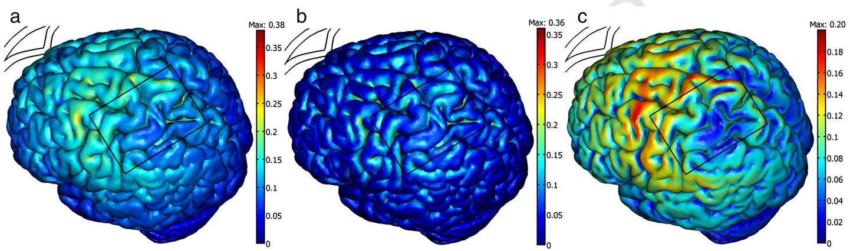

Figure 26: Distribution of the E-field in the cortical surface: (a) magnitude of the E-field; (b) component of the E-field perpendicular to the surface; (c) component of the E-field parallel to the surface. The current (1 mA) was injected via a pair of saline soaked sponge electrodes (rectangular shape, area of ) placed over the left motor cortex and the contralateral supra-orbital region. Figure adapted from [[88](#_ENREF_88)]. For this report, permission has not been requested.

## Update on recent advances (M12) at local level: cortical response to TMS and PCI

In order to describe the mechanisms of existing brain stimulation-based consciousness metrics, and also enable the *in silico* design and testing of novel metrics, a reasonable first step consists in simulating the local response of brain tissue to an electrical stimulation. Therefore, we aimed to develop a model of local brain tissue activity, in response to brief (< 100 ms) pulses of stimulation, such as those in the Perturbational Complexity Index (PCI, see [[91](#_ENREF_91)]). This first step appears a necessary pre-requisite before moving on to simulating brain-scale networks. In fact, working on local models involving a small number of parameters can provide a first overview of the model’s dynamical regimes as a function of the stimulation protocol and targets.

To reach this objective, we have built upon the computational model that was developed in HIVE project (see Section 2.4). This modular computational model can describe the activity of an arbitrary number of neural populations or “masses”, each neural mass being composed of subpopulations such as glutamatergic neurons (pyramidal cells) and GABAergic interneurons. Each neural mass involves a specific connectivity pattern between neuronal subpopulations, which is found commonly in the cortex. The basic neural mass model that is used in this computational model has been extensively used and validated in a number of studies in the field of epilepsy for example [[8](#_ENREF_8), [34](#_ENREF_34), [92](#_ENREF_92)]. In the model, the transition between different activity patterns (background activity, sporadic spiking, alpha activity) is controlled by the excitation to inhibition ratio (EIR), i.e. the EIR acts as a bifurcation parameter in the model, as evidenced by [[33](#_ENREF_33)]. The neurophysiological parameters used for each simulated population are presented in Figure 27 below.

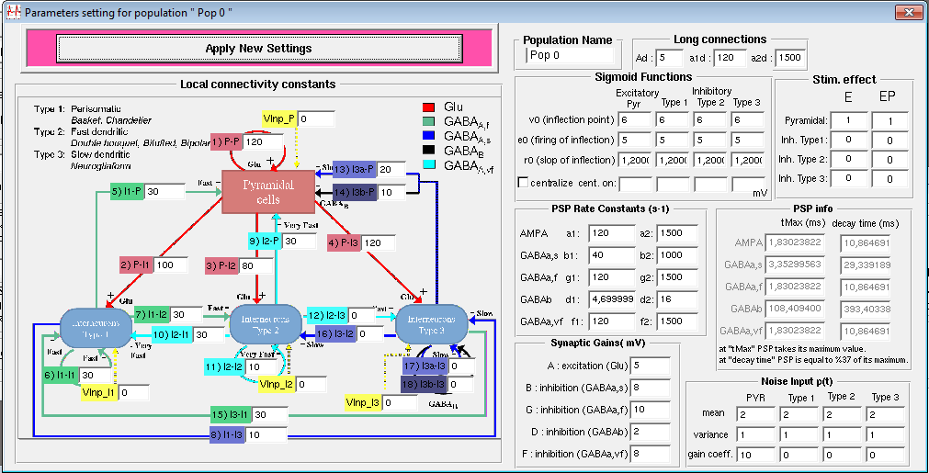

Figure 27: Illustration of the parameters used for each neuronal population within the local cortical model (excitation, slow/fast inhibition, connectivity parameters between subpopulations…).

First, in order to simulate the spontaneous activity of a local cortical patch (e.g., a single brain region with a size on the order of the square centimeter), we have chosen to develop a neural field model composed of 10 neural masses, connected through a random connectivity pattern and including the contribution of the time delays involved with action potentials conduction along axons. The random connectivity between neural masses is a reasonable approximation at a local scale, while, at a larger scale, a realistic brain-scale connectivity architecture has to be followed, which is already planned for the brain-scale model that will be developed in the next steps of the LUMINOUS project as discussed in the present deliverable. The coupling between neuronal populations was made through glutamatergic, excitatory projections from the pyramidal neurons from the source population to the pyramidal neurons of the target population. Synaptic projections between populations were not necessarily bidirectional, since they were randomly generated.

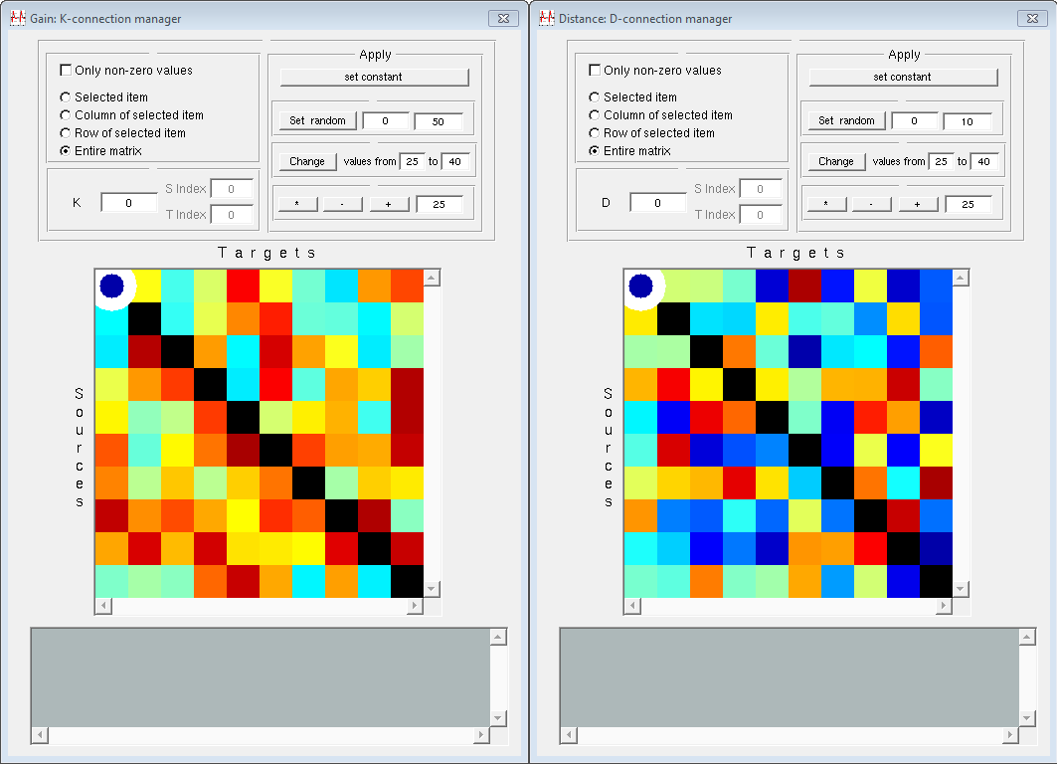

Figure 28: Synaptic connectivity and conduction delay matrices. Left: connectivity coefficients between the 10 populations forming the local cortical model. Right: conduction delays of action potentials between neuronal populations within the local cortical model.

Second, it was required to simulate the impact of transcranial stimulation on local brain networks. More precisely, we have chosen to simulate the impact of transcranial magnetic stimulation (TMS) on cortical dynamics, since this stimulation modality has been successfully used by [[91](#_ENREF_91)] quantify the level of consciousness in Disorders of Consciousness (DOC) patients. TMS involves the use of high-amplitude (> 1.5 Tesla), short-duration (on the order of 100 μs) magnetic pulses, generated using a coil in which flows a strong electric current. These time-varying magnetic pulses induce, according to Maxwell-Faraday’s law (one of the four Maxwell equations summarizing electromagnetism theory), an electric field in cortical tissue:

$$∇×E= - \frac{∂B}{∂t}$$

This electric field is the variable of interest that induces an effect on cortical tissue, since the magnetic field by itself does not induce any effects on neurons. TMS induces a massive neuronal response, since the induced electric field is strong enough to induce action potentials in neurons. Therefore, we used the “EP stimulation” mode of our neural field model software, which simulates incoming glutamatergic post-synaptic potentials on the targeted type of neurons. Due to the flexibility of the simulation software, we were able to determine the type of neurons receiving these TMS-evoked glutamatergic synaptic inputs. In the model, this is done by attributing a specific coupling coefficient scaling the amplitude of the TMS-evoked input on the membrane potential of the targeted neurons. As a first step, and in order to gradually increase the complexity of our simulations, we considered that pyramidal neurons only received this TMS-evoked input. Since the volume of cortical tissue considered was small (on the order of the square centimeter), we made a reasonable assumption of “uniform field” throughout the simulated cortical tissue: this consists in assuming that the TMS-evoked magnetic field is homogeneous in amplitude throughout the simulated cortical tissue, resulting in similar levels of activation for each modeled neuronal population, as the level of each targeted sub-population (i.e., in this first step, pyramidal neurons of each population). This “quasi-uniform” assumption is common in the field of neurostimulation research, and is being considered as realistic according to a recent review [[15](#_ENREF_15)]. That being said, assuming a quasi-uniform electric field at the level of the considered cortical tissue does not mean that all neuronal types are being impacted, with the possibility to impact specific neuronal subtypes in the model using the appropriate coupling coefficients, as aforementioned.

The effect of TMS was simulated using a biphasic, period pulse of period T = 2 s (0.5 Hz), with a pulse width of 5 ms per phase and a stimulus amplitude of 200 mV. While the pulse width appears significantly larger than a TMS pulse (100 µs), it should be kept in mind that the time step used to solve the integro-differential equations of the neural field models is typically on the order of the millisecond, therefore a few integration steps are required in order to account for the impact of TMS. In order to verify this, we decreased the time step (at the level of 100 µs), and checked that similar results were achieved by compensating the small time step by an increase in amplitude. A time step of 1 ms, sufficient for a resolution of neural field equations exempt of numerical instabilities, was kept in order to ensure a reasonable computation time. We illustrate in Figure 29 an example of simulated TMS-evoked response obtained using our local cortical model.

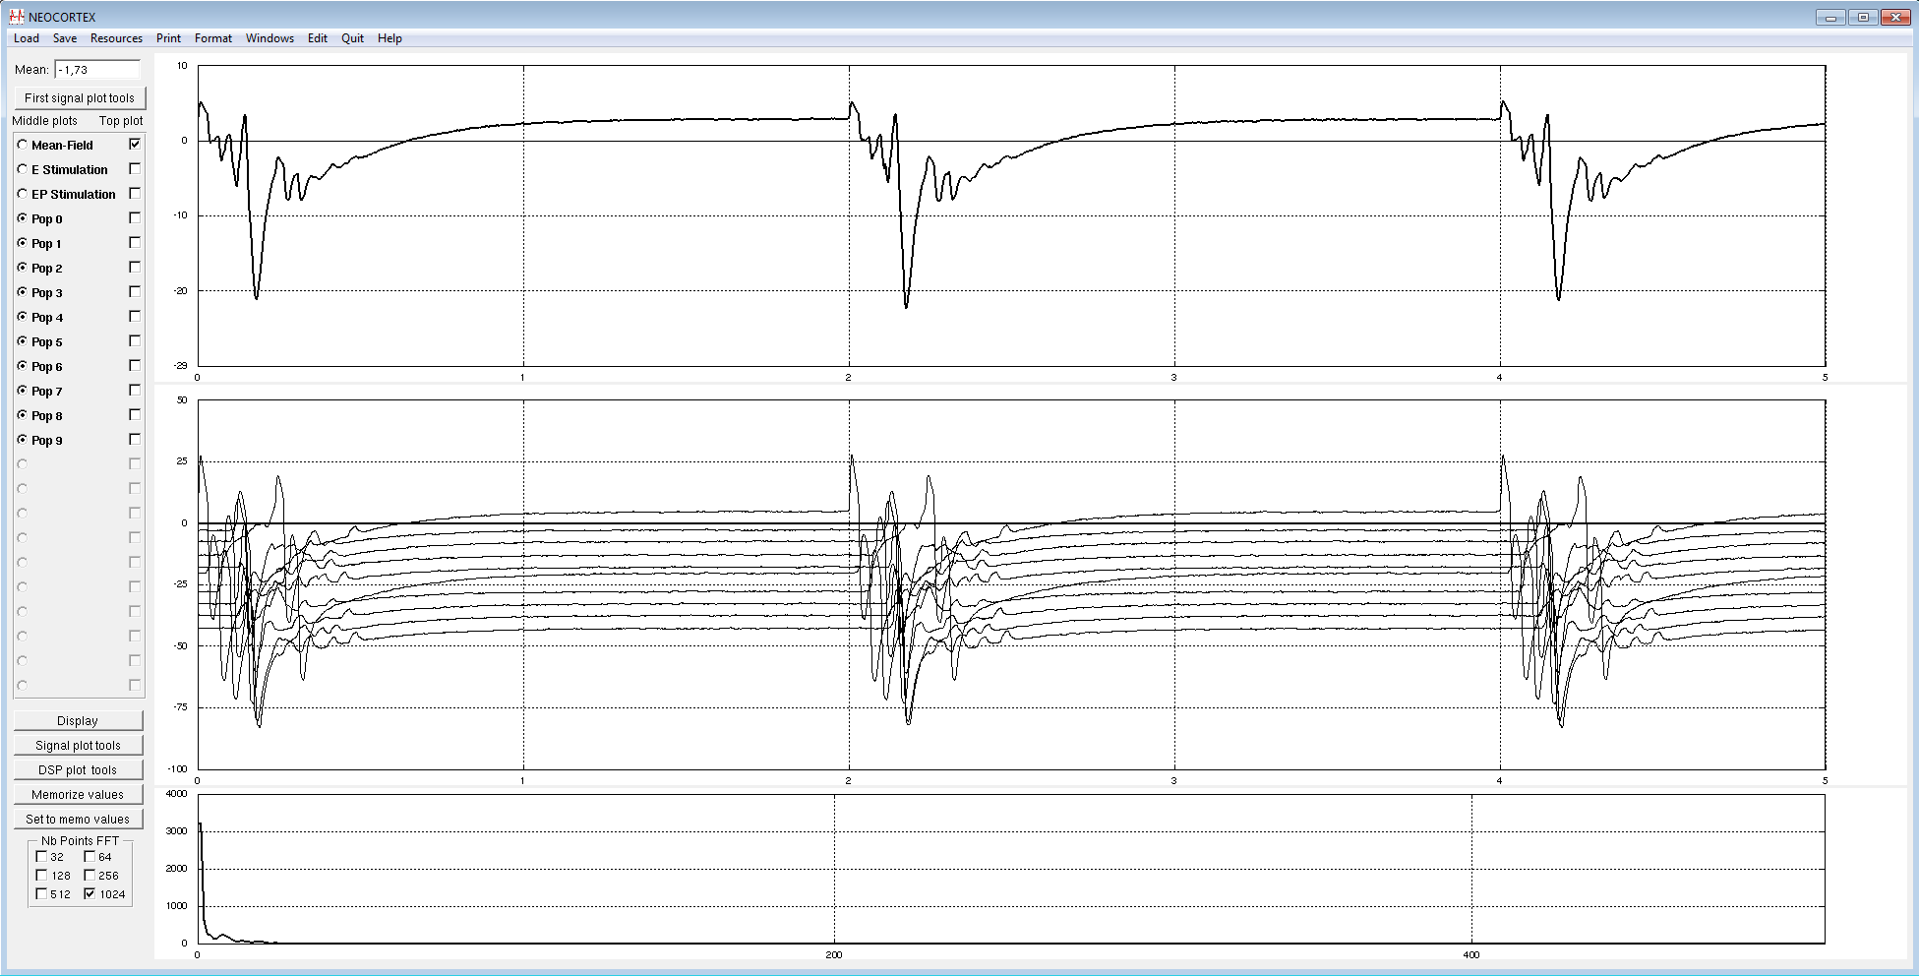

Figure 29: Example of simulated TMS-evoked EEG response using our neural field model, during a time interval of 5 seconds, with a TMS pulse triggered every 2 seconds. Upper panel: Field response as it would be measured by an EEG electrode, consisting in the average response between the simulated neuronal populations. Middle panel: TMS-evoked response for each individual population, illustrating the sequential activation depending on the time delays and on the activation of each neuronal population. Lower panel: power spectrum of the simulated EEG response.

The impact of the action potential propagation delays from one population to another on the evoked TMS response was investigated, since delays have been shown to be a key parameter in the stability of neural systems and evoked responses [[93](#_ENREF_93), [94](#_ENREF_94)]. The following ranges of time delays were investigated: [1-3] ms, [1-5] ms, [1-10] ms, [1-20] ms, and [1-30] ms. As can be seen in Figure 30, for time delays distributions involving an upper limit greater than 20 ms, a single pulse of TMS could induce an instability in the evoked response, i.e. the evoked response triggers neuronal activity remaining sustained for a significant time after that the pulse is delivered (which could correspond, for example, to seizure-like activity evoked by TMS). From the dynamical systems point of view, this suggests that the system is near a bifurcation, and that the TMS pulse enables crossing this bifurcation to move towards another attractor that corresponds to a qualitatively different dynamical state. Since such observations are not consistent with experimentally-recorded TMS-evoked responses (seizure-like activity evoked by TMS remains an extremely rare phenomenon [[95](#_ENREF_95)]), we used a range for time delays that resulted in TMS-evoked responses that vanished before a return to the pre-TMS activity pattern. Therefore, from the results of these simulated TMS-evoked responses, and in accordance with experimentally measured time delays in local brain networks (typically up to 10 ms [[55](#_ENREF_55)]), we have used a range of time delays of 1-10 ms.

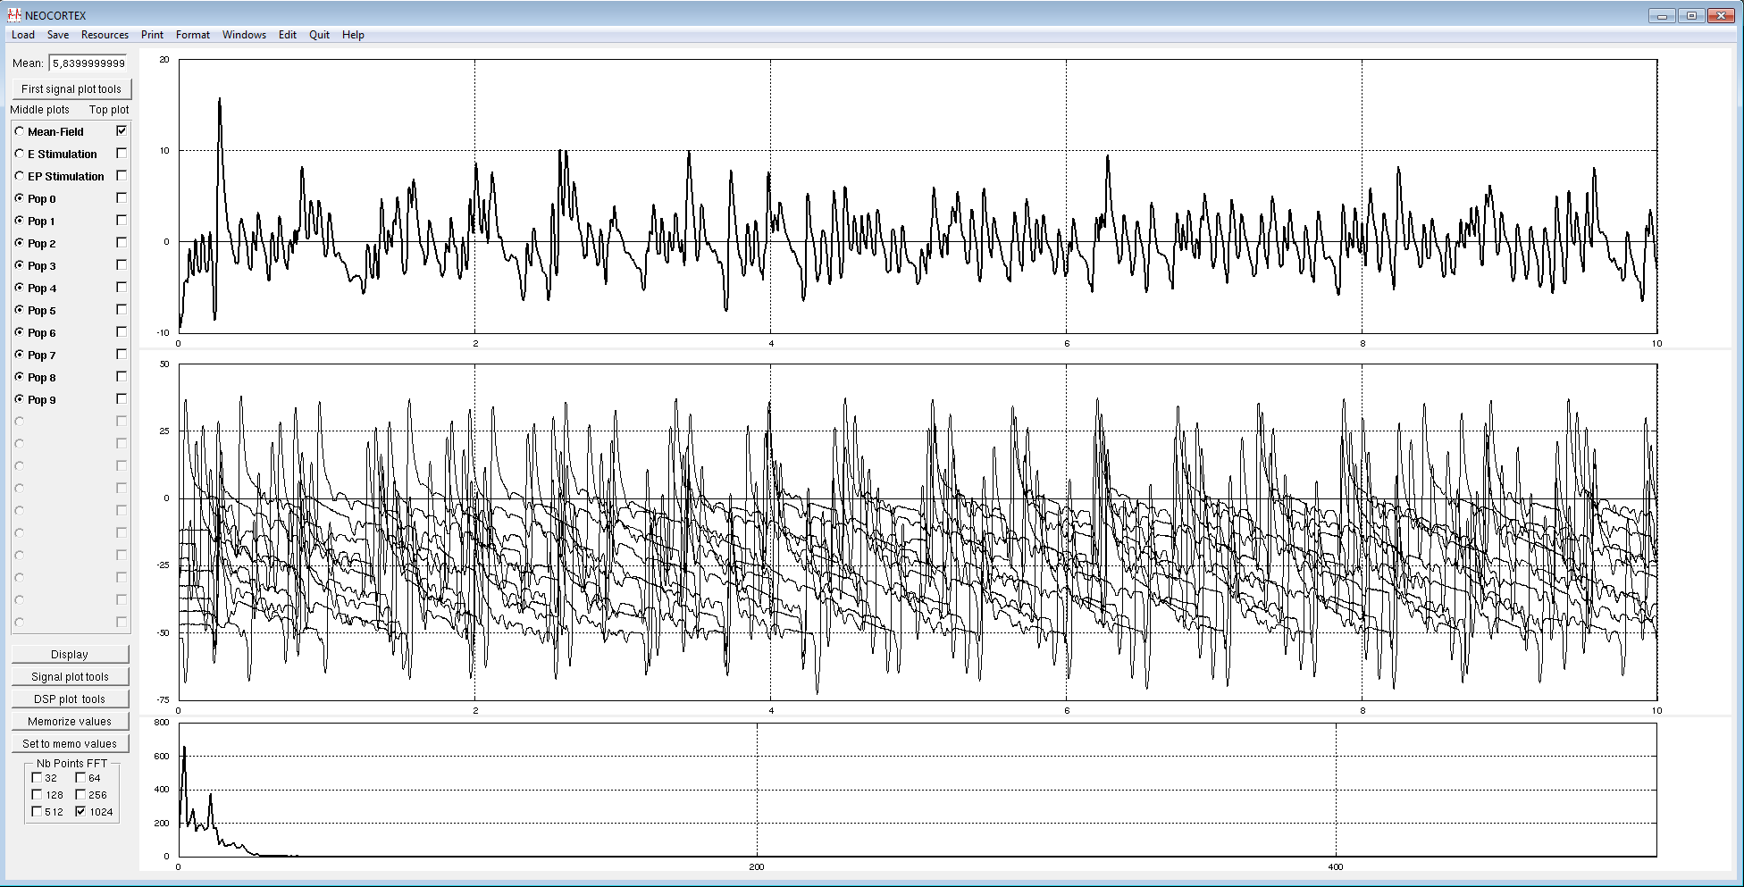

Figure 30: Instability in model response after an initial TMS pulse (10 seconds simulation). Despite the short duration of the TMS pulse (5 ms) applied to the model, a response exceeding 10 seconds is induced in the local cortical model (upper panel: simulated field response, middle panel: individual population activity, lower panel: power spectrum of the simulated field response).

Based on this range of time delays values, we then focused on the TMS-evoked response, and more specifically on their frequency content and latencies, since these are important characteristics of the evoked response that will enable a comparison of simulated TMS-evoked responses with experimentally recorded TMS-evoked responses.

|  |  |
| --- | --- |
| Macintosh HD:Users:julien:Desktop:Capture d’écran 2017-02-17 à 15.57.12.png | Figure 31: Comparison of an experimentally recorded TMS-evoked EEG response in humans (upper panel A for a single subject, lower panel C for the group response [[96](#_ENREF_96)]) with an example of simulated TMS-evoked EEG response (B). |

The simulated TMS-evoked response presented in Figure 31 illustrates that the response duration is comparable to experimentally recorded TMS-evoked responses, i.e. on the order of 500 ms, with a return to baseline, pre-TMS activity. In addition, we calculated the frequency of the evoked response, which was 14.3 Hz, i.e. an oscillation in the β range. A TMS-evoked response in the β range (albeit at a slightly higher frequency, 20 Hz) was also found in human EEG recordings during repetitive TMS in the motor cortex [[97](#_ENREF_97)]. Interestingly, this result shows that a neural field model composed of 10 populations, connected through a biologically plausible distribution of time delays, can capture the basic properties of TMS-evoked responses in humans. Furthermore, the latencies in the simulated response are relatively similar in terms of number (number of peaks) and values (timing for each maximum/minimum).

We present below in Figure 32 the simulated individual and field TMS-evoked responses in two different conditions, i.e. one corresponding to a “wakefulness” state with background activity, and one with increased GABAB conductance, corresponding to a “sleep” state.

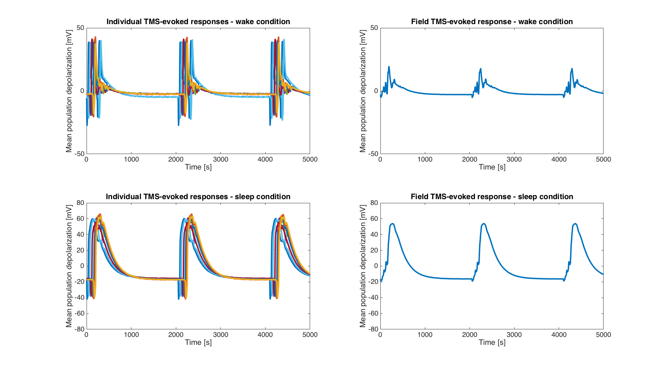

Figure 32: Individual population responses and field responses in the “wakefulness” and “sleep” conditions. Upper left panel: individual TMS-evoked responses in the “wakefulness” condition. Upper right panel: corresponding TMS-evoked field response, which can be compared to an experimentally recorded EEG signal. Lower left panel: individual TMS-evoked responses in the “sleep” condition. Lower right panel: corresponding TMS-evoked field response, which can be compared to an experimentally recorded EEG.

The next step was a qualitative comparison between the TMS-evoked responses recorded in humans by [[91](#_ENREF_91)] and the simulated responses obtained with the model and illustrated in Figure 32. Once these simulated TMS-evoked responses were obtained, we then extracted single responses in order to calculate the Perturbational Complexity Index (PCI) in each condition. We present in Figure 33 the experimentally-recorded TMS-evoked responses in wakefulness and in sleep, along with the corresponding responses simulated using the model that have been used to calculate an *in silico* value of the PCI.

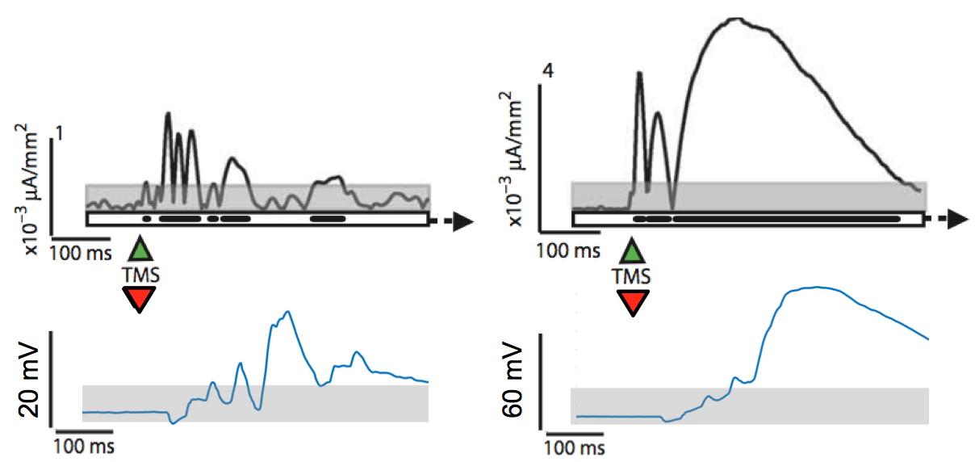

Figure 33: Comparison of stimulated TMS-evoked response with experimentally-recorded data from [[91](#_ENREF_91)] and simulated TMS-evoked responses in different states of consciousness. Upper panel, left: experimentally recorded TMS-evoked response in wakefulness. Upper panel, right: experimentally recorded TMS-evoked response in sleep. Lower panel, left: simulated TMS-evoked response in a “wakefulness” state. Lower panel, right: simulated TMS-evoked response in a “sleep” state, involving an increase in GABAB [[55](#_ENREF_55)].

As performed in [[91](#_ENREF_91)], we first constructed from the simulated signals a binary source activation matrix *SS(x,t)*. Basically, this matrix contains, for each time point of source activity, a value of “1” if the signal is greater than a statistical threshold; and “0” otherwise. Once this source activation matrix was obtained, we then computed the PCI value from the *SS(x,t)* matrix, as described in [[91](#_ENREF_91)], by integrating the PCI calculation script provided by our partner UMIL (Marcello Massimini’s group, University of Milan, Italy). The PCI values obtained in both conditions (“wakefulness” and “sleep”) are presented in Figure 34.

|  |  |
| --- | --- |
| Macintosh HD:Users:julien:Dropbox:Ltsi:Projects:Luminous - 2016-2019:reporting:PCI_wake_sleep.png | Figure 34: Comparison of PCI values for TMS-evoked responses corresponding to “wakefulness” and “sleep” conditions, respectively. |

As illustrated in Figure 34, in the model, the “wake” PCI value is more than 4-fold higher than for the “sleep” value, which is consistent with PCI values measured during wakefulness and sleep in humans [[91](#_ENREF_91)]. This is encouraging that, at this stage of the model advancement, simulated TMS-evoked responses are qualitatively similar to the ones obtained in humans, and that the PCI values from the simulated signals correspond to what would be expected in two different states of consciousness, i.e. sleep and wakefulness.

Obviously, one limitation of this local model is the imperfect agreement between the latencies of the TMS-evoked responses simulated and the ones measured in humans. This is however not surprising, since, as shown by [[91](#_ENREF_91)], TMS induces a significant activation of several distant brain regions, with involved time delays and possibly feedback through bidirectional connections. Therefore, extending this model, as planned in LUMINOUS using the large-scale architecture based on the human connectome matrix, should lead to an improved agreement between simulated and experimental data. Furthermore, our model did not aim at simulating a specific brain region (e.g., motor cortex, occipital cortex), but rather at capturing the basic properties of the cortical response to a TMS pulse. Consequently, this objective has been achieved and provides the required bases in order to move further to detailed modeling of the thalamo-cortical loop on the one hand, and on the other hand to modeling of tCS-evoked responses at the brain-scale level.

## Update on recent advances (M12) at local level: thalamo-cortical model and simulation of awake and SWS EEG



### Motivation

The thalamus is considered as a very sophisticated sensory relay endowed with dense loops into and out of the cortex, as well as the most subcortical areas. This privileged physiology makes it of vital importance to several mental functions including perception, attention, memory and consciousness so that a small damage in the thalamus block can have dire consequences for all the aforementioned functionalities [[98](#_ENREF_98)]. The role of the thalamo-cortical circuitry as a neural correlate of consciousness has been evoked by consciousness theories, namely the Dynamic Core Hypothesis (DCH) and the Integrated Information Theory (IIT) discussed in deliverable D1.1 of LUMINOUS project (D1.1: *Consciousness: models, metrics & intervention in the electric brain*). More evidence of this role was provided by a study analyzing the metabolic activity of posterior midline cortical areas driven by the thalamic nuclei, across different altered consciousness states [[99](#_ENREF_99)]. The authors reported therein that vegetative patients can be differentiated from minimally conscious ones by a difference in glucose metabolism in these areas, and that the latter are the first to show increases in glucose metabolism during the recovery trajectory from coma through vegetative state to minimal or full consciousness.

Recently, several studies have also shed light on the role of the thalamo-cortical loop in the generation of slow wave oscillations. In fact, the pervading corticocentric view claiming that these oscillations are entirely generated in cortical regions is no longer taken for granted. An alternative view conjectures that the full expression of these EEG waves of natural sleep requires a dynamic interplay of cortical and thalamic oscillators [[100-102](#_ENREF_100)]. In [[100](#_ENREF_100)], David et al. experimentally demonstrated that the thalamus finely tunes the frequency of slow waves during NREM sleep and anesthesia. They showed that the block of the thalamic output to the neocortex markedly (up to 50%) decreases the frequency of slow waves recorded during NREM sleep in freely moving, naturally sleeping-waking rats, and that selective excitation of thalamo-cortical neurons strongly entrains infraslow EEG activities (0.75–1.5 Hz) only when thalamic T-type calcium channels (in thalamo-cortical cells - or TC cells - and in thalamic reticular nuclei cells - or TRN cells -) are functionally active. The pivotal role of thalamo-cortical loop in the generation of slow waves and the “up and down” state was also appraised in the review of Crunelli et al. [[102](#_ENREF_102)] where they enumerated the main lines of evidence supporting this assertion including the strong interconnection between TC and neocortical layers involved in slow waves suggesting that thalamic nuclei can control up and down state dynamics in neocortical circuits, the early TC firing in relation to the initiation of cortical UP states, the rhythmic up and down state generated by TC neurons and TRN in isolated conditions, and the neocortical UP states readily induced in head-restrained mice by selective optogenetic activation of TC neurons proving the stimuli role of the latter.

The previously reported conclusions motivated the conception of thalamo-cortical-based models that simulate the communications between the cortex and the thalamus at a mesoscopic (neural mass) level [[9](#_ENREF_9), [103-108](#_ENREF_103)]. While some models were basically conceived to generate alpha rhythm (8-12 Hz) [[103-105](#_ENREF_103)], other ones were used to simulate the sleep-wake cycle [[9](#_ENREF_9), [106](#_ENREF_106), [107](#_ENREF_107)].

Since amongst the primary objectives of LUMINOUS project is to implement a computational model able to mimic the real physiological transitions across the different consciousness states (e.g. sleep-wake cycle), the thalamo-cortical loop seems to be a crucial block to include in the design of such model as planned in section 3.2. Our strategy consists in starting from an existing model that implements a part from the functionalities described in section 3.2 (i.e. in Figure 15) and adapt it progressively to reach to the sought “full” model depicted in Figure 25. A detailed description of the existing TC model is introduced in the following section.

### Model structure and equations

We started from the neural mass model of the thalamo-cortical loop developed in our team (INSERM) by Mina et al. in the framework of epileptic activity analysis [[108](#_ENREF_108)]. In line with already-existing models [[9](#_ENREF_9), [109-111](#_ENREF_109)], this model was built of three interconnected compartments: a cortical compartment, a thalamic compartment, and a reticular compartment simulating the dynamics of a cortical neuronal population, a nonspecific thalamic nucleus and the thalamic reticular nucleus, respectively (see Figure 35). Subpopulations of neurons and interneurons located in these three structures interact via excitatory and/or inhibitory synaptic connections. The novelty, however, consisted of three main adaptations: **i)** a modified cortical module aiming to better approximate the temporal dynamics of specific pathological (epileptic) signals, **ii)** subcortical stimulation inputs, and **iii)** inclusion of two well-known mechanisms at the cortical level: feed-forward inhibition (FFI) and short-term depression (STD). The purpose was to investigate frequency-dependent effects of electrical stimulation performed in the thalamus and aimed at modulating the neocortical activity. Note that this model corresponds to the basic cellular connectivity introduced in Figure 24 but without the VIP interneurons and the inhibitory feedback loop of BC.

Though STD is very important for implementing short-term plasticity, as a first step in the project, this mechanism was removed from the model. Plasticity mechanisms will be considered and integrated later on in a fashion that fits more to LUMINOUS project requirements. We aligned with the neural mass modeling approach based on pulse-to-wave and wave-to-pulse functions and connectivity constants to characterize the synaptic transmissions and interactions, respectively, between the different neuronal subpopulations (see section 2.3.2). Model differential equations were derived accordingly and according to the description of modules given thereafter. Detailed schematic diagrams of the sub-blocks in the model are summarized in Appendix A, supported by the underlying equations.

*The cortical module.* The cortical module is composed of a subpopulation of pyramidal principle cells (*P,* Figure 48), and two inhibitory subpopulations representing the soma- and proximal-dendrite targeting interneurons ($I_{1}^{c}$, GABAA,fast, Figure 49), and the dendrite-targeting interneurons ($I_{2}^{c}$, GABAA,slow, Figure 50). The three cortical subpopulations receive excitatory inputs from the thalamic module. Pyramidal collateral excitation was also implemented via the integration of an excitatory feedback loop passed by a supplementary excitatory population (*P’,* Figure 48); analogous to *P*,except that it establishes exclusive synaptic projections from and to the subpopulation *P.* The integration of cortical inhibition is the first novelty of this model, compared to the existing ones. Nonspecific influence from neighboring and distant populations was represented by a Gaussian input noise corresponding to excitatory input $n_{c}\left(t\right)$ that globally describes the average density of afferent action potentials.

*The thalamic module.* The thalamic module is composed of one population of excitatory neurons, known as glutamatergic thalamo-cortical cells (*TC*, Figure 51 ), which innervate the cerebral cortex. They receive glutamatergic EPSPs from cortical pyramidal cells (*P*), and send back excitatory inputs to the three aforementioned cortical subpopulations. They also receive GABAergic IPSPs with slow and fast kinetics from the reticular thalamic nuclei (TRN) module. The thalamic compartment implements the FFI (third novelty of the model), since it induces first an EPSP (pyramidal cells activation) followed later on by an IPSP (cortical interneurons activation) on cortical pyramidal cells. In the context of LUMINOUS project, the thalamic module was modified by adding an input modeling the average PSPs from the brainstem arousal system which plays a key role, in combination with TRN, in tuning the thalamo-cortical synchronization frequencies (40 Hz -gamma- for wakefulness and 2-3 Hz range for sleep) [[112](#_ENREF_112)]. As in the cortical module, a Gaussian input noise corresponding to excitatory input $n_{Th}(t)$ was used to represent nonspecific inputs on thalamo-cortical cells subpopulation.

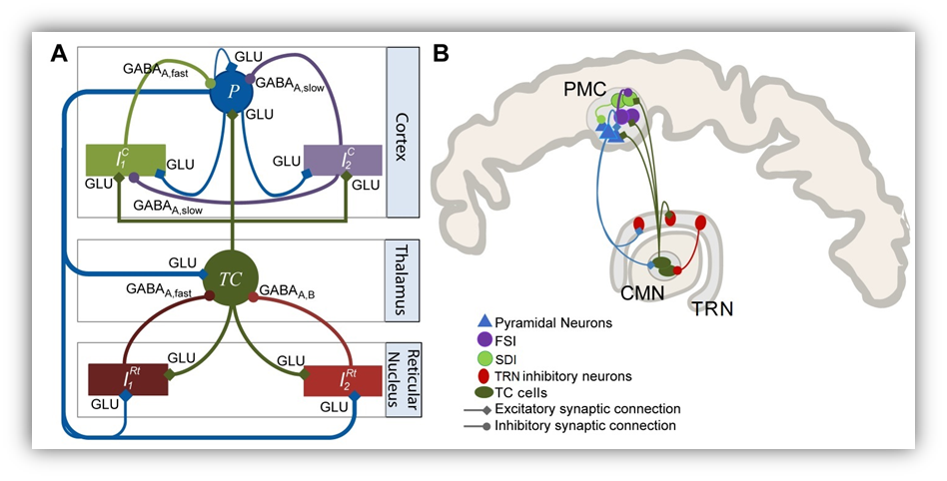

Figure 35: Modeling the thalamo-cortical loop. (A) The tri-modular model architecture inspired from the literature of thalamo-cortical models and in conformity with (B) the corresponding physiological representation (PMC: premotor cortex, CMN: centromedian thalamic nucleus, FSI: fast somatic inhibitory, SDI: slow dendritic inhibitory) (reprinted with permission from [[108](#_ENREF_108)]).

*The reticular module.* The reticular module is composed of two inhibitory interneurons $I_{1}^{Rt}$ and $I_{2}^{Rt}$ which account for fast (Figure 52) and slow (Figure 53) GABAergic IPSPs, respectively, and project exclusively to the *TC* cells. They receive excitatory inputs from both cortical and thalamic modules. Due to the anatomical connections between the TRN and brainstem cells that control the subject’s wakefulness and vigilance [[113](#_ENREF_113)], two stimuli inputs originating from the brainstem were injected into both $I_{1}^{Rt}$ and $I_{2}^{Rt}$. By exerting a blocking impact on the mesencephalic reticular formation, the brainstem controls (facilitates) the activity of TRN neurons [[114](#_ENREF_114)].

*Model parameters and output*. A critical task in computational modeling is the tuning of parameters. While some parameters, namely time constants in the three modules, were set close to the “standard values” used in neuronal population models, other ones were adjusted according to the target activity (awake, SWS, etc.). A list of the physiological interpretation of parameters as well as their default values (values corresponding to the simulation of a background activity) is provided in

Table 3. Regarding the model output, signal simulated at the level of pyramidal cells in the cortical compartment was chosen as the model output. It corresponds to the sum of PSPs that approximate the most the actual LFP.

The set of second order stochastic nonlinear ordinary differential equations obtained for all synaptic interactions present in the model was numerically solved using a fixed step (Δt = 1 ms) 4th-order Runge-Kutta method. The model was implemented using an object-oriented language (**Objective-C**) endowed with graphical user interfaces detailed in the next section.

|  |  |  |
| --- | --- | --- |
| Parameter | **Value** | **Interpretation** |
| $$A_{c}$$ | 3 mV | Amplitude of the cortical average EPSP |
| $$B_{c}$$ | 50 mV | Amplitude of the cortical average IPSP (GABA*A*, *slow* mediated currents) |
| $$G_{c}$$ | 22 mV | Amplitude of the cortical average IPSP (GABAA, fast mediated currents) |
| $$A_{Th}$$ | 3.5 mV | Amplitude of the thalamic average EPSP |
| $$B_{Th}$$ | 30 mV | Amplitude of the thalamic average IPSP (GABA*A, slow* and GABA*B* receptors) |
| $$G_{Th}$$ | 22 mV | Amplitude of the thalamic average IPSP (GABA*A, fast* receptors) |
| $${1/a}_{c}$$ | 1/80 s | Time constant of cortical glutamate-mediated synaptic transmission |
| $${1/b}_{c}$$ | 1/35 s | Time constant of cortical GABA-mediated synaptic transmission (GABA*A, slow* receptors) |
| $${1/g}_{c}$$ | 1/180 s | Time constant of cortical GABA-mediated synaptic transmission (GABA*A, fast* receptors) |
| $${1/a}_{Th}$$ | 1/100 s | Time constant of thalamic glutamate-mediated synaptic transmission |
| $${1/b}_{Th}$$ | 1/20 s | Time constant of thalamic GABA-mediated synaptic transmission (GABA*A, slow* and GABA*B* receptors) |
| $${1/g}_{Th}$$ | 1/150 s | Time constant of thalamic GABA-mediated synaptic transmission (GABA*A, fast* receptors) |
| $v_{0}$, $e_{0}$, $r$ | 6 mV, 2.5 s-1, 0.56 mV-1 | Parameters of the nonlinear sigmoid function (transforming the average membrane potential to an average density of action potentials) |
| $$C_{P,P'}$$ | 135 | Collateral excitation connectivity constant |
| $$C_{P',P}$$ | 108 | Collateral excitation connectivity constant |
| $$C_{I_{1}^{c},P}$$ | 91.12 | $I_{1}^{c}$ to *P* connectivity constant |
| $$C_{I_{2}^{c},P}$$ | 33.75 | $I_{2}^{c}$ to *P* connectivity constant |
| $$C_{{P,I}_{1}^{c}}$$ | 40.5 | *P* to $I_{1}^{c}$ connectivity constant |
| $$C_{{P,I}_{2}^{c}}$$ | 33.75 | *P* to $I_{2}^{c}$ connectivity constant |
| $$C_{I_{2}^{c},I_{1}^{c}}$$ | 13.5 | $I_{2}^{c}$ to $I_{1}^{c}$ connectivity constant |
| $$C_{TC,P}$$ | 120 | *TC* to *P* connectivity constant |
| $$C_{P,TC}$$ | 20 | *P* to *TC* connectivity constant |
| $$C_{{TC,I}_{1}^{c}}$$ | 30 | *TC* to $I_{1}^{c}$ connectivity constant |
| $$C_{{TC,I}_{2}^{c}}$$ | 45 | *TC* to $I_{2}^{c}$ connectivity constant |
| $$C_{{TC,I}_{1}^{Rt}}$$ | 20 | *TC* to $I_{1}^{Rt}$ connectivity constant |
| $$C_{{TC,I}_{2}^{Rt}}$$ | 20 | *TC* to $I_{2}^{Rt}$ connectivity constant |
| $$C_{I_{1}^{Rt},TC}$$ | 35 | $I_{1}^{Rt}$ to *TC* connectivity constant |
| $$C_{I_{2}^{Rt},TC}$$ | 5 | $I_{2}^{Rt}$ to *TC* connectivity constant |
| $$C_{TC}$$ | 100 | Collateral excitation connectivity constant |
| $$C_{{P,I}_{1}^{Rt}}$$ | 30 | *P* to $I_{1}^{Rt}$ connectivity constant |
| $$C_{{P,I}_{2}^{Rt}}$$ | 30 | *P* to $I_{2}^{Rt}$ connectivity constant |
| , | 0 s-1, 20 s-1 | Mean and standard deviation of nonspecific cortical input |
| , | 70 s-1, 35 s-1 | Mean and standard deviation of nonspecific subcortical input |
| $$v_{Bs}^{TC}$$ |  | Brainstem stimulation input to *TC* cells |
| $$v_{Bs}^{Rt1}$$ |  | Brainstem stimulation input to $I_{1}^{Rt}$ |
| $$v_{Bs}^{Rt2}$$ |  | Brainstem stimulation input to $I_{2}^{Rt}$ |

Table 3: Thalamo-cortical model: model parameters, values and interpretation

### Simulation software: thalamo-cortical loop

The model components were implemented using an object-oriented language (Objective-C). Three main functionalities are offered in the simulation software: **1)** Manage the simulation general context (seeFigure 36), **2)** adjust the parameters of the instantiated populations (see Figure 37), and **3)** display the generated electrical activities (see Figure 38).

*The main window: managing the simulation.* In the main interface illustrated in Figure 36, users can set the number of instantiated populations (by clicking on the “**New Population (s)**” button), the time length of the simulation (inserted in seconds), and the sampling frequency *Fs*. It is noteworthy that this main interface is used temporarily to analyse the behaviour of the thalamo-cortical circuitry across the wake-sleep cycle before incorporating the cortical module described in section (see section 3.1).

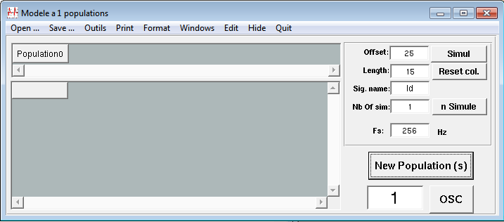

Figure 36: Simulation software. The main window giving access to the principal functionalities implemented to simulate thalamo-cortical activity.

*Managing the population parameters: the population manager object.* The interface illustrated in Figure 37 is accessible via the “Population#” button generated each time we instantiate a population in the main window. It allows editing the underlying parameters such as amplitude and rise and decay times of PSP of excitatory and inhibitory receptors (“Excitation/Inhibition” box), short-range connection strengths within and between sub-populations (“Connectivities” box), and input noise parameters, namely the mean and variance in cortical and subcortical modules (“Input Noise in CORTEX” and “Input Noise in THAL” boxes, respectively). The brainstem inputs to the *TC* cells and reticular nuclei module were also implemented in the “Input from Brainstem” box.

*Displaying the cortical and thalamic responses: the oscilloscope.* A dedicated object mimicking the functionalities of a classical “oscilloscope” was implemented and integrated in the thalamo-cortical software (accessible via the button “OSC” in the main interface). It displays the desired electrical activity of subpopulations in the thalamo-cortical loop. An example of the displayed signals is given in Figure 38. The local field activity is plotted in the top (‘EEG’ button), whereas in the middle, the LFP in *TC* cells as well as the firing rates of all the subpopulations are displayed. On the bottom, the power spectrum of the EEG output is plotted.

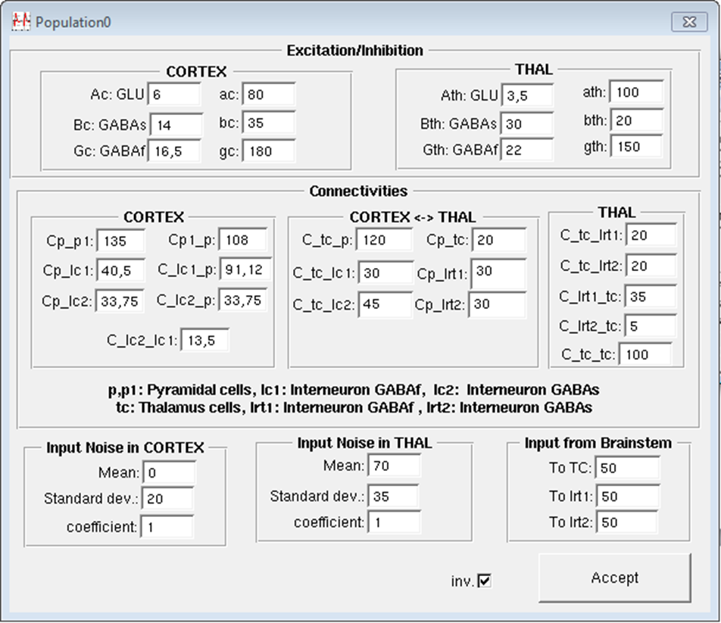

Figure 37: Simulation software. Graphical user interface giving access to edit the parameters associated with each population of neurons instantiated for the simulation purpose.

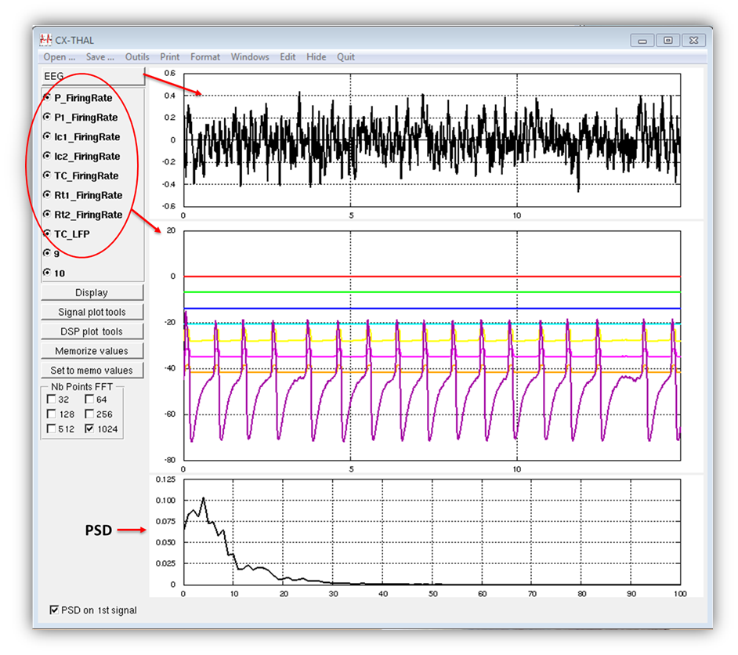

Figure 38: Simulation software. The oscilloscope object adapted to display the local field potential at the level of pyramidal cells (top), firing rates and local field potential at the level of all subpopulations and TC cells, respectively (middle), and the power spectrum of the first signal (bottom).

### Simulated electrophysiological signals

***a) Background activity***

The background activity was generated using the standard parameters listed in

Table 3.

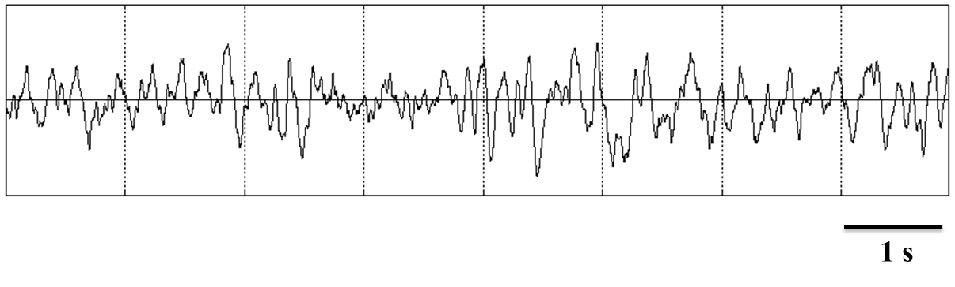

Figure 39: Simulated background activity.

***b) Alpha waves: awake/drowsiness***

|  |  |
| --- | --- |
| **A)** | **B)** |
| **C)** | |

Figure 40: A) Simulated (red) and real (black) alpha waves in human extracted from Atlas of Electroencephalography: EEG Awake and Sleep EEG Activation Procedures and Artifacts, Vol.1. B) The parameter values used to generate alpha waves in the thalamo-cortical model. C) The oscilloscope displaying EEG (top), firing rates (middle) and power spectrum density of EEG (bottom).

***c) Delta waves: slow waves sleep***

|  |  |
| --- | --- |
| N2 sleep stage | N3 delta sleep: Slow Waves Sleep |
| A1 | **A2** |
| B1 | **B2** |
| C1 | **C2** |
| D | |

Figure 41: Simulated local field potentials of N2 sleep stage (A1) and slow waves sleep (SWS)/delta waves (A2) are compared to real signals (D) illustrated from Hauri P. Current Concepts: The Sleep Disorders, 2nd Edition, Kalamazoo, MI: Upjohn Company; 1982, [link](http://sleepdisorders.sleepfoundation.org/chapter-1-normal-sleep/stages-of-human-sleep/), reproduced without permission. (B1 & B2) present firing rates of *TC* cells, inhibitory fast and slow TRN interneurons in N2 sleep stage and SWS, respectively. Notice the up (depolarized) and down (hyperpolarized) state. (C1 & C2) report graphical interfaces corresponding to the underlying parameters as well as zooms from figures (B1) and (B2) highlighting the delay of firing between *TC* cells and TRN interneurons. Notice that the more the sleep deepens, the more important the delay between *TC* cells and TRN interneurons firings is, and the more the latter are engaged, which corresponds to the real signals in (D) (blue and green). To switch from N2 sleep stage to SWS, two key parameters were tuned: the thalamic excitatory gain that was increased from 4.1 to 5 mV and the time constant of slow GABAergic TRN interneurons $1/a_{Th}$ that was increased from 0.05 to 0.0833 seconds.

## Conclusion

Developing a computational model for EEG in consciousness is a tremendously ambitious and challenging objective. Fortunately, we will not start from scratch. In this chapter, we explained how to exploit the computational models, already elaborated in our team in previous projects, as a starting point and toward the envisioned model to be developed in order to fulfill the requirements of LUMINOUS. We started by identifying the pros and cons of the existing computational models. Then we sketched a “roadmap” where we proposed new solutions to add new features and functionalities in line with LUMINOUS objectives. An important work was devoted i) to review the literature about brain connectivity (horizontal and vertical) and ii) to make, from this review, assumptions regarding some essential physiological mechanisms to be “ideally” included in the model. Here the word “ideally” denotes the fact that we have not yet translated these mechanisms into equations and implemented them in the model. This is part of the work to be performed in the coming months. We also tackled the implementation software that will be used to simulate the resulting electrophysiological data. In our “roadmap”, we outlined the two following main steps. After implementation and validation, the TC model presented in section 3.5 will be adapted to fit to the basic structure suggested in section 3.2.3 for one cortical population. The adapted model will be implemented and evaluated regarding the generation of global alpha and local gamma oscillations. Once this first step is validated, the TC model will be merged with the cortico-cortical model described in section 2.3.2, leading up to the envisioned “full” model in Figure 25. The full model will be validated by simulating realistic EEGs (as compared with actual recordings) upon plausible modifications of the cortico-cortical and thalamo-cortical connectivity depicted in sections 3.2.1, 3.2.2 and 3.2.3.

# Toward novel metrics of consciousness: model-based evaluation of scale-free approaches

## General context

In LUMINOUS project, we also aim at developing novel metrics of consciousness (see D1.1 *Consciousness: models, metrics & intervention in the electric brain*). To this aim, the availability of the envisioned computational model will be a tremendous asset. Indeed, most of these metrics are computed from EEG signals recorded in normal subjects or in patients, for various states of consciousness. They can therefore be also computed from simulated EEG signals.

Thus, we expect that the model can be used to learn about the various metrics, and ultimately evaluate their performance in term of measuring the state of consciousness or detecting transitions between states, possibly induced by NIBS. This idea is illustrated in Figure 42. On the one hand, we will have a brain model from which we will be able to generate simulated EEG signals, for different consciousness states and under control or stimulation condition. Of course, simulated signals are expected to reproduce the essential features of actual EEGs, recorded under similar condition. On the other hand, we have a number of candidate metrics (PCI, KAC, …) that can be readily applied to these simulated signals. Through the combination of model parameters, signals and metrics we expect:

To bridge between the values provided by metrics and the neurophysiologically-relevant parameters and mechanisms implemented in the model.

To interpret changes in metrics values in term of underlying mechanisms.

To compare the performance of metrics on simulated signals that will serve as benchmarks.

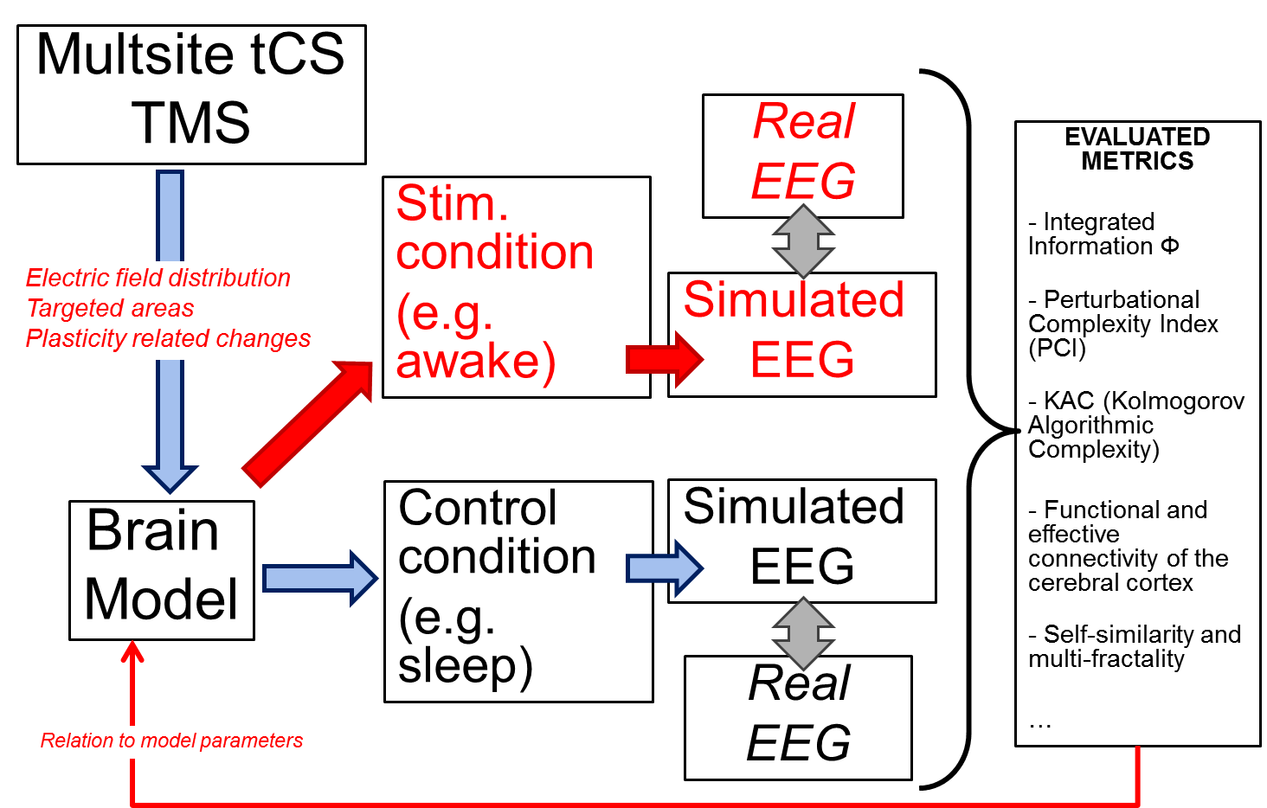

Figure 42: General approach to model-based evaluation of consciousness metrics.

## Application to scale-free approaches

In this section, we illustrate the above-described approach on three metrics provided by so-called “scale-free” signal processing techniques. We simulated local field potentials from a simple neural mass model (mesoscopic level, similar to models envisioned in LUMINOUS) and computed the three metrics (based on the Hurst exponents) on simulated signals. Based on this combination (model/signal processing), we determined some specific conditions for which we could establish an insightful relationship between i) the values provided by considered metrics and ii) model parameters directly related to excitation/inhibition in the underlying neuronal population comprising both pyramidal cell and interneurons.

### Background on scale-free approaches and rationale for LUMINOUS

Scale-free approaches refer to the signal processing techniques that analyze the temporal neural activity across different time scales. Unlike classical methods that focus on studying the oscillatory patterns present in the signal, these methods are rather interested in the arrhythmic aspect of neural activity that was shown scale-free [[115](#_ENREF_115)] (see Figure 43) . This scale-invariance means that the statistical properties of the signal do not change if the latter is rescaled and/or dilated. It is also characterized by a power spectrum displaying a power-law behavior (1/*f* β spectrum) in the infraslow domain (0.1-1.5 Hz).

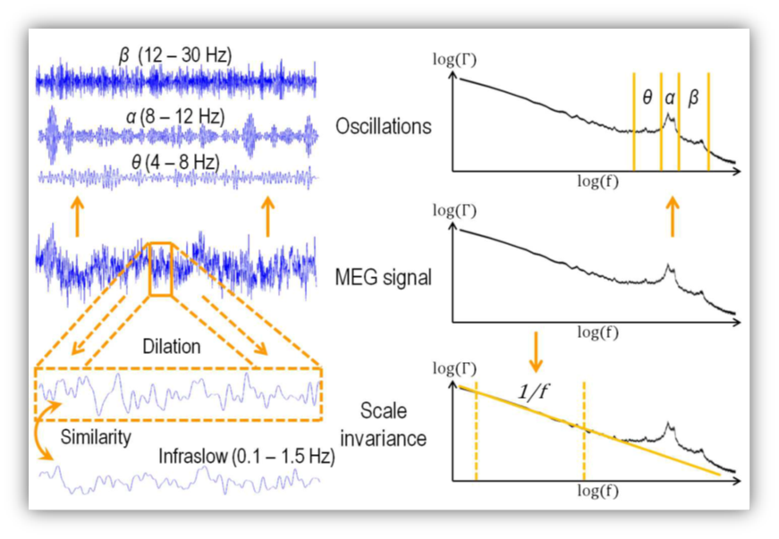

Figure 43: Rhythmic vs. arrhythmic neural activity. MEG signal is presented in time (middle left) and frequency (middle right) domains. The oscillatory patterns present in the signal are presented in time (top left) and frequency (top right) domains. The infraslow activity was shown scale-free (bottom left) which entails the presence of a power-law in the power spectrum (1/*fβ* spectrum) (bottom right) (adapted from [[116](#_ENREF_116)] without permission).

In Deliverable D1.1 (*Consciousness: models, metrics & intervention in the electric brain*), scale-free methods were suggested as potential consciousness metrics. The suggestion was motivated by several recent researches that consider the brain as a self-organized critical system and thereby neurophysiological changes as critical transitions across different phases [[115](#_ENREF_115), [117](#_ENREF_117), [118](#_ENREF_118)]. Deemed as criticality hallmarks, power-laws alteration are thus liable to reflect these neurophysiological changes. This conjecture was testified in the framework of sleep stages [[119-121](#_ENREF_119)], task performance [[122-124](#_ENREF_122)] and awareness [[125](#_ENREF_125), [126](#_ENREF_126)], wherein the value of the power-law exponent was proven dependent on the excitability state. Moreover, authors in [[127](#_ENREF_127)] argued that arrhythmic infraslow activity is an optimal neural substrate to curry, across wide cortical areas, the information integration necessary for conscious awareness. This hypothesis is justified by the slow time scale of this activity, which allows the synchronization across long distance, and the long-range subcortical and corticocortical connections that terminate preferentially in superficial layers and thus contribute to the infraslow activities. In [[128-131](#_ENREF_128)], the link between scale-invariance and brain plasticity and adaptation was tackled. Interestingly, scale-free attributes were shown modulated in evoked activity during performed tasks (visual and audiovisual tasks) after trainings [[128](#_ENREF_128), [132](#_ENREF_132)], which means that these methods can also detect the long-lasting modulation of electrical activity by tCs.

In the context of LUMINOUS project, two basic types of scale-free attributes are explored: *self-similarity* and *multifractality*. The former is evoked when the signal is characterized by one value of power-law exponent  In practice,  is measured via the computation of *Hurst exponent H* ( = 2*H*-1). The *multifractality* scheme is a generalization of *self-similarity* to the case when several exponents are present in the signal. We no longer talk about one exponent *H*; instead, a local measure of this exponent, denoted *h* (*Hölder exponent*), is defined and a *multifractality spectrum* *D* (named also *Hausdorff dimension*) is thus used to describe the fluctuations of *h* in the analyzed signal. In general, *D* is characterized by its width *M* and asymmetry. Notice that a self-similar signal is described by a spectrum *D* of width *M* = 0 (see Figure 44).

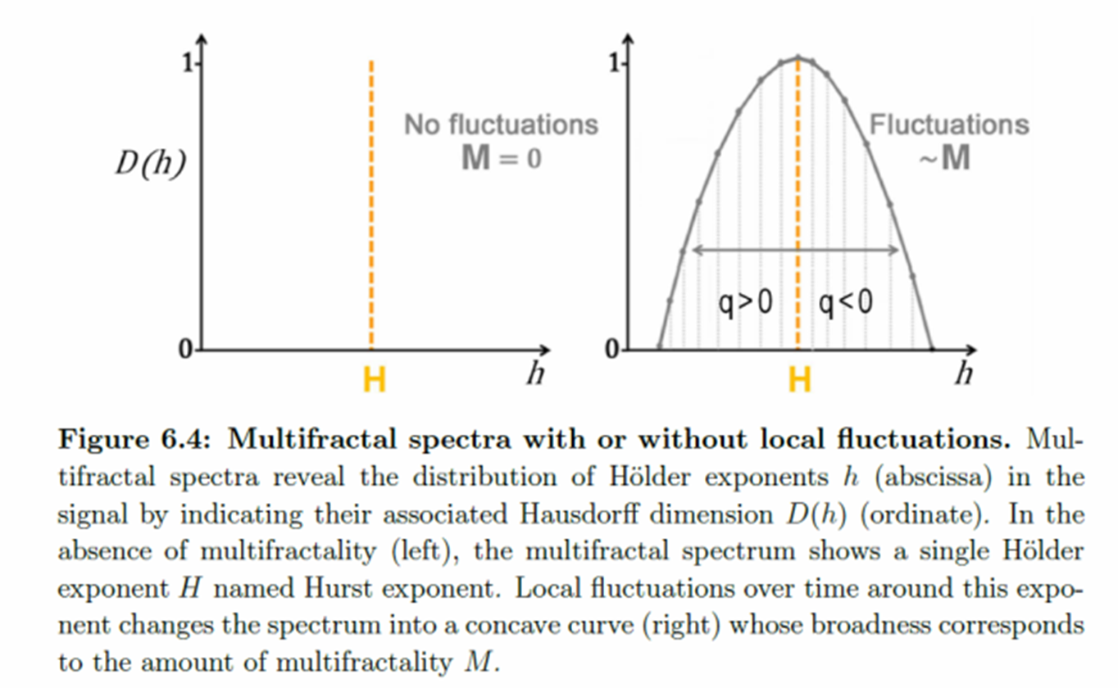

Figure 44: Self-similarity vs. Multifractality. The multifractality spectrum *D* describes the distribution of Hölder exponent *h* in the signal (right). Its maximum coincides with the Hurst exponent *H*. In the self-similarity scheme (left), *D* is reduced to one value that corresponds to the Hurst exponent *H* (adapted from [[116](#_ENREF_116)] without permission).

Two methods of scale-free metrics estimation were implemented starting from two existing toolboxes: 1) the wavelet leader based multifractal toolbox (WLBMF), and 2) the multifractal detrended fluctuation analysis (MFDFA). Based on wavelet leader transformations, WLBMF algorithm computes three quantities denoted *c1*, *c2* and *c3* which characterize the maximum (*H*), the width (*M*) and the asymmetry of *D*, respectively. MFDFA algorithm is based on the detrended fluctuation analysis and provides the values of *H* and *M*. As a preliminary work, these two toolboxes were tested on a simple cortical neural mass model simulating different excitability states. The objective was to find out if these metrics are able to detect the modulation of excitability. The neural mass model and the subtly-designed scenarios of simulation are described in the next section.

### A simple neural mass model of local field potentials

We used a simple generic model composed of two synaptically coupled subsets: pyramidal cells (PC) and local GABAergic interneurons (IN) (see Figure 45, first column). This model simply corresponds to the cortical module of the thalamo-cortical model, introduced in section 3.5.2. By tuning the parameters of the transfer functions of both subsets (gains and time constants), we modulate the excitability level of the system. Four excitability states were simulated going from “Low” to “High” states, where the former denotes the dynamical system being far from the bifurcation limit whereas the latter corresponds to the opposite case (see Figure 45, second column). The parameters of the subpopulations were tuned according to activity maps obtained in [[133](#_ENREF_133)]. Parameter values used in generating the different excitability states are reported in Table 4.

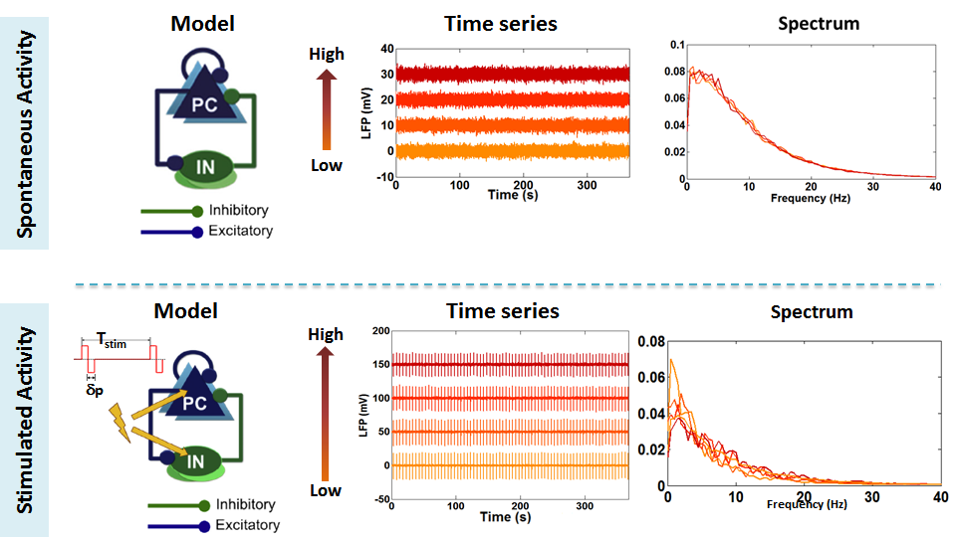

Figure 45: Spontaneous vs Stimulated activities. A generic neural mass model composed of pyramidal cells (PC) and inhibitory interneurons (IN) was implemented and used in passive and active paradigms (1st column). Local field potentials of 10 minute duration each were generated in four excitability states (“Low”, “Intermediate1”, “Intermediate 2”, and “High”). The underlying temporal and spectral presentations were seemingly equivalent (2nd & 3rd columns).

Two paradigms, passive and active, were adopted in these exploratory tests. In the passive paradigm, spontaneous electrical activity was used as inputs into the scale-free algorithms, whereas in the active paradigm, the dynamical system was probed by periodically applying a biphasic current pulse characterized by a stimulation period *T*stim and a pulse width p. In both paradigms, a sliding window *w* is applied to analyze the signals, where an estimate of the metrics was produced per window. Notice that the temporal and spectral representations of electrical activities in the different excitability levels are practically identical and indistinguishable (see Figure 45, second & third columns). This observation entails that classical analysis methods are blind to such information, and it would be, therefore, very interesting to find out alternative metrics able to capture it, hence the testing of scale-free metrics.

|  |  |  |  |  |
| --- | --- | --- | --- | --- |
|  | Low | Intermediate 1 | Intermediate 2 | High |
| $$A_{c}$$ | 2.5 mV | 3.125 mV | 3.75 mV | 4.375 mV |
| $$B_{c}$$ | 50 mV | 42.5 mV | 35 mV | 27.5 mV |
| $$G_{c}$$ | 15 mV | | | |
| $${1/a}_{c}$$ | 1/100 s | | | |
| $${1/b}_{c}$$ | 1/50 s | | | |
| $${1/g}_{c}$$ | 1/150 s | | | |
| $$C_{P,P'}$$ | 135 | | | |
| $$C_{P',P}$$ | 108 | | | |
| $$C_{I_{1}^{c},P}$$ | 13.5 | | | |
| $$C_{I_{2}^{c},P}$$ | 33.75 | | | |
| $$C_{{P,I}_{1}^{c}}$$ | 40.5 | | | |
| $$C_{{P,I}_{2}^{c}}$$ | 33.75 | | | |
| $$C_{I_{2}^{c},I_{1}^{c}}$$ | 108 | | | |

Table 4: Model parameters and values used to produce LFPs in four excitability states

### Preliminary results: assessment of cortical excitability

In the active paradigm, several values of stimulation periods *T*stim were tested (the pulse width was fixed to p = 1 ms). Moreover, several values of the sliding window length *w* were investigated in both paradigms. However, for a sake of concision, we reported only results obtained for *T*stim = 5 s, with sliding window lengths *w* = 20 s and 40 s as illustrated in Figure 46 and Figure 47.

The first striking result when using WLBMF method (Figure 46) consisted in the variability of metrics behavior between the two paradigms. While in the passive scheme the three metrics seemed insensitive to excitability level, they showed a consistent behavior in the active scheme where *c1* decreased with excitability and *c2* and *c3* slightly increased. This observation leads to the conjecture that we should probe/stimulate the dynamical system in order to extract information relevant to the proposed metrics. The second interesting result was the behavior of the three metrics in the active case where we noticed that *c1* was more sensitive to excitability changes than *c2* and *c3*. Notice that the more the system progressed toward bifurcation, the more *c2* and *c3* increased to zero, which means that the signals tend to be more self-similar and symmetric.

Results obtained using MFDFA were in agreement with those of WLBMF (Figure 46Figure 47). The active paradigm was more revealing where the Hurst exponent *H* decreased with excitability. Nevertheless, the metric *M* was less sensitive and showed no evolution in both paradigms. Further investigations should be conducted to grasp the physiological interpretation of these preliminary results. Yet, they are very promising and suggest that scale-free metrics combined with tCs can reveal subtle excitability changes, invisible to classical metrics.

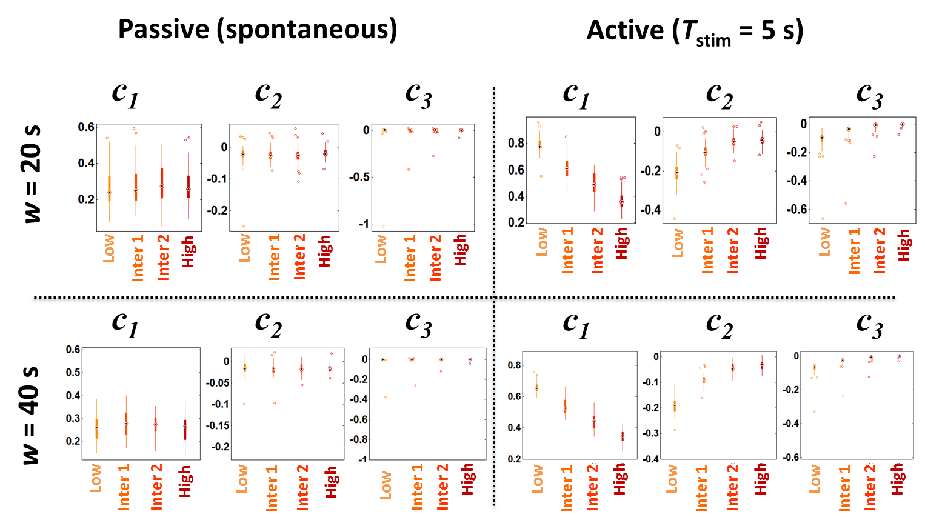

Figure 46: Boxplots of scale-free metrics *c1*, *c2* and *c3*, computed by WLBMF algorithm in the passive and active (*T*stim= 5 s) paradigms and for sliding windows of 20 and 40 seconds.

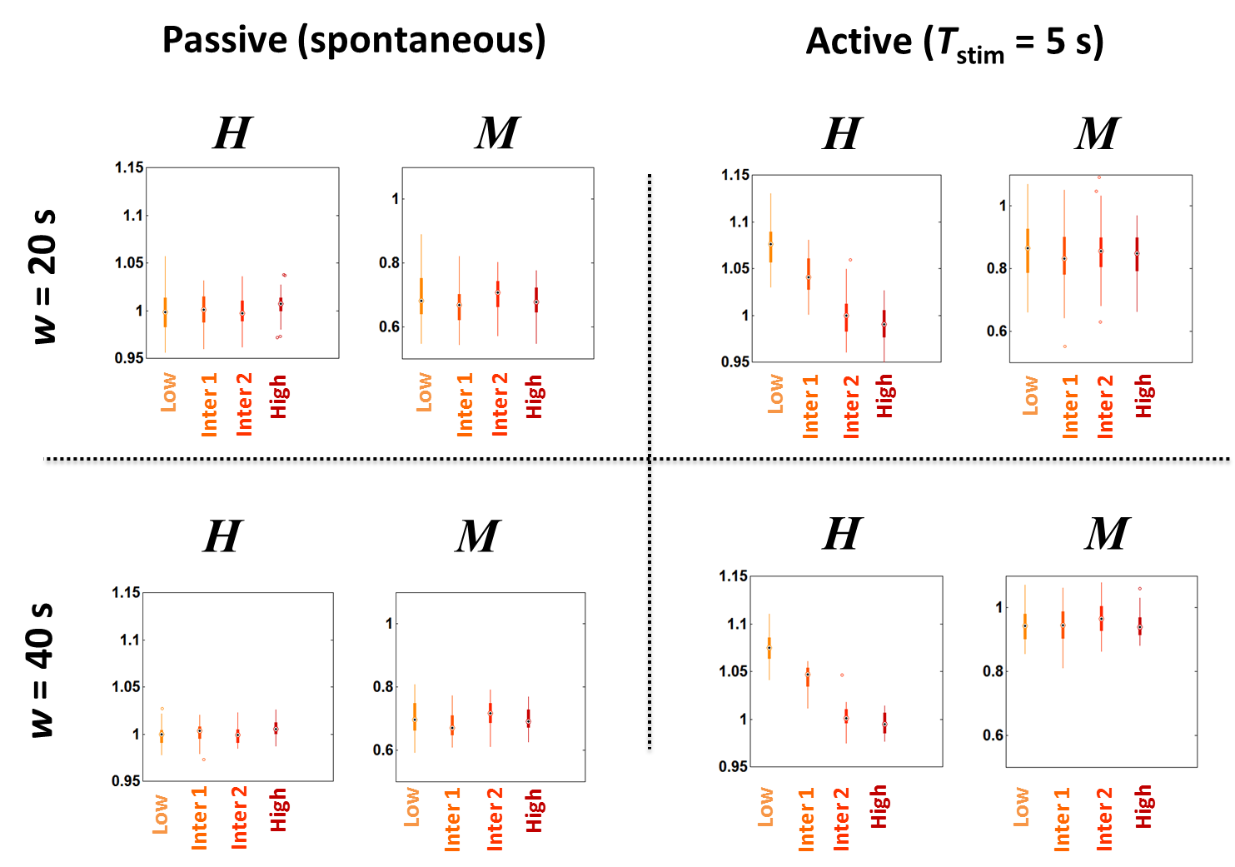

Figure 47 : Boxplots of scale-free metrics *H* and *M*, computed by MFDFA algorithm in the passive and active (*T*stim= 5 s) paradigms and for sliding windows of 20 and 40 seconds.

# Conclusion and perspectives

In this deliverable D1.3 (issue 1, month 12), we have reported the progress that has been accomplished on a computational model for EEG in consciousness studies.

The development of such a model is a tremendous challenge. Fortunately, it will benefit from the background, the results and the know-how acquired during a previous European project called HIVE (Hyper Interaction Viability Experiments, FP7-FET Open – 222079, 2008-13) that was coordinated by STARLAB and in which INSERM partner has led WP1 dedicated to biophysical and biological models of the brain under tCS conditions.

This available background explains why the first section (section 2: A computational model of EEG accounting for tCS effects: background from the “HIVE” project) provides a synthetic review on the main aspects and results obtained in the HIVE project. We preferred writing this summary instead of just referring to papers in order to i) gather the essential elements of modeling in the present document and ii) facilitate the reading of reviewers and colleagues. In addition, this section was intended to point at the limitations of models developed in HIVE and therefore the work to be done to obtain a model that can be useful for consciousness studies, which is one ambitious goal of the LUMINOUS project.

From section 3 (Computational modeling of EEG for consciousness studies), we describe the work accomplished over the period spanning from April 2016 to February 2017.

Starting from the main advantages and current limitations of the existing model and considering the theoretical models of consciousness reported in D1.1, we performed a comprehensive literature review about the neurophysiological mechanisms that should be “ideally” integrated in the envisioned computational modeling of EEG for consciousness studies.

From this review on key aspects of “horizontal” and “vertical” connectivity, thalamo-cortical loops and corresponding EEG rhythms, we defined a “modeling roadmap” we would like to follow over the next two years in order to reach the general objectives of LUMINOUS.

We then provided an update on recent (at M12) modeling advances regarding the cortical response to TMS and the Perturbational Complexity Index (PCI), based on the experimental work performed by UMIL (Milano, Italy). In brief, we have developed a model of local brain tissue activity, in response to brief (< 100 ms) pulses of stimulation, such as those used to calculate the PCI. Interestingly, preliminary results (M12) show that a neural field model composed of 10 populations, connected through a biologically plausible distribution of time delays, can capture the basic properties of TMS-evoked responses in humans. We then computed the PCI values for two states of consciousness and showed that they are consistent with PCI values measured for similar conditions.

This work will be pursued. The perspective is to obtain very realistic simulated responses and use the modeling results to physiologically explain the behavior of metrics and develop new ones.

We also provided an update regarding the progress we made on the thalamo-cortical model and the simulation of EEG in two different states of consciousness, i.e. wakefulness and sleep conditions. The key role of the thalamo-cortical (TC) circuitry as a neural correlate of consciousness has been reported in most theories of consciousness, including the Dynamic Core Hypothesis (DCH) and the Integrated Information Theory (IIT) (see D1.1). We have described the developed model, including a cortical module, a thalamic module, and a reticular module. The model was implemented in a user-friendly environment. At this stage, preliminary results indicate that it can simulate background activity, alpha waves and some rhythms associated with sleep (k-complexes and SWS).

This investigation will be pursued. The perspective is to integrate this thalamo-cortical model into the global model of EEG that will also account for non-invasive brain stimulation (NIBS) effects in humans.

Finally, one important objective of LUMINOUS is to develop novel metrics of consciousness. In section 4, we provided a first illustrative example of the approach we can follow to evaluate metrics of consciousness based on physiologically-relevant models of EEG. At this stage (M12), we simulated local field potentials from a simple neural mass model (mesoscopic level, similar to models envisioned in LUMINOUS) and computed various metrics based on the Hurst exponents on simulated signals.

From this combination (model/signal processing), we could determine some specific conditions for which an insightful relationship can be derived regarding i) the values provided by considered metrics and ii) model parameters directly related to cortical excitability. This work will be pursued. The perspective is to get similar results in the thalamo-cortical model first, and then in the global model of EEG.

**APPENDIX**

1. Schematic diagrams of the different subpopulations in the thalamo-cortical loop model

* *Pyramidal cells (P& P’):*

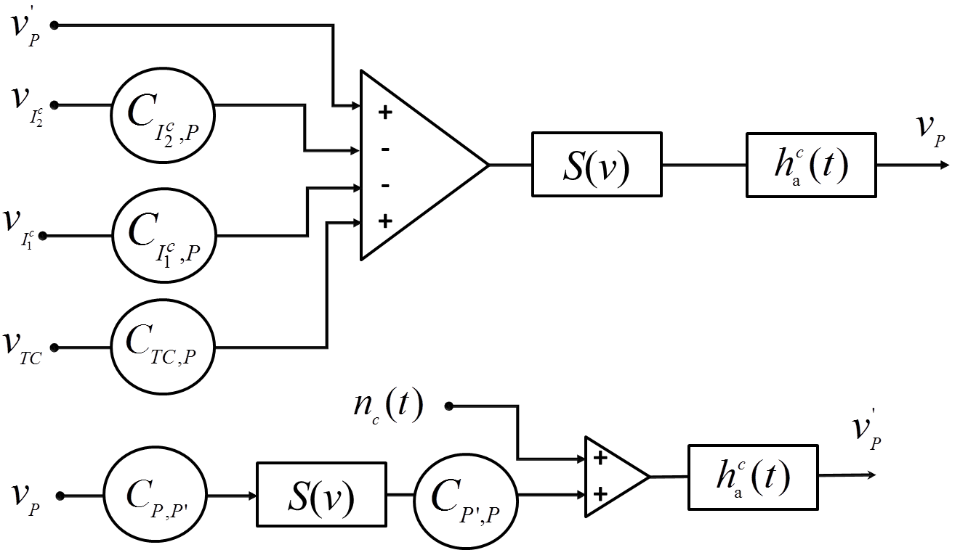

Figure 48: Schematic diagram of pyramidal cells P and P’ sub-block where $h_{a}^{c}\left(t\right)$ is the impulse response of the input transfer function in the cortical module for the AMPAergic transmissions.

${\ddot{v}}_{p}= A_{c}a_{c}S\left(v_{p}^{'}+C_{TC,P}v_{TC}-C_{I_{1}^{c},P}v_{I_{1}^{c}}-C_{I_{2}^{c},P}v_{I_{2}^{c}}\right)-2a_{c}{\dot{v}}_{p }-a_{c}^{2} v_{p}$**(1)**

${\ddot{v}}_{P}^{'}= A_{c}a_{c}\left[n_{c}(t)+C_{P',P}S\left(C_{P,P'}v_{P}\right)\right]-2a_{c}{\dot{v}}_{P}^{'}-a_{c}^{2} v_{p}^{'}$**(2)**

* *Cortical inhibitory interneurons $I_{1}^{c}$ and $I_{2}^{c}$:*

**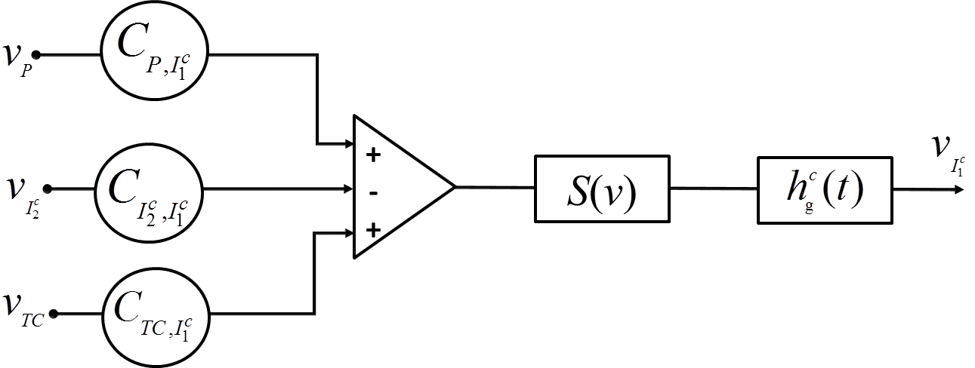**

Figure 49: Schematic diagram of inhibitory GABA fast cortical interneurons $I_{1}^{c}$ sub-block where $h_{g}^{c}\left(t\right)$ is the impulse response of the input transfer function in the cortical module for the fast GABAergic transmissions.

${\ddot{v}}_{I_{1}^{c}}= G_{c}g_{c}S\left(C_{TC,I_{1}^{c}}v_{TC}+C_{P,I_{1}^{c}}v_{P}-C_{I_{2}^{c},I_{1}^{c}}v_{I_{2}^{c}}\right)-2g_{c}{\dot{v}}_{I_{1}^{c} }-g_{c}^{2} v_{I_{1}^{c}}$**(3)**

**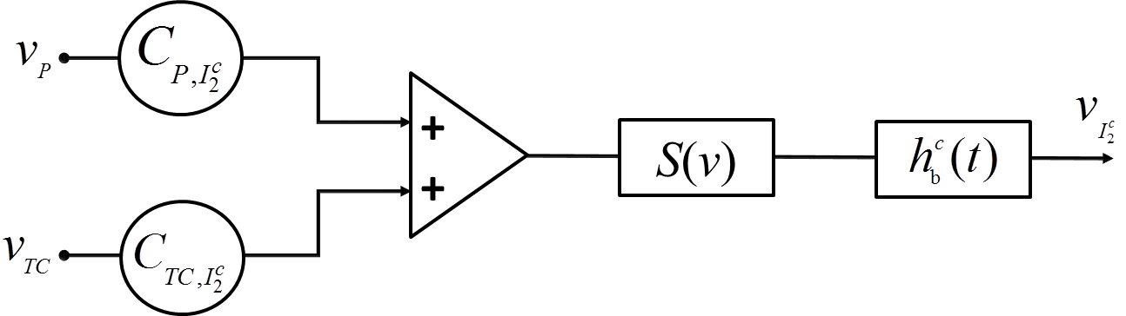**

Figure 50: Schematic diagram of inhibitory GABA slow cortical interneurons $I_{2}^{c}$ sub-block where $h_{b}^{c}\left(t\right)$ is the impulse response of the input transfer function in the cortical module for the slow GABAergic transmissions.

${\ddot{v}}_{I_{2}^{c}}= B_{c}b_{c}S\left(C_{TC,I_{2}^{c}}v_{TC}+C_{P,I_{2}^{c}}v_{P}\right)-2b_{c}{\dot{v}}_{I_{2}^{c} }-b_{c}^{2} v_{I_{2}^{c}}$**(4)**

* *Thalamic cells (TC):*

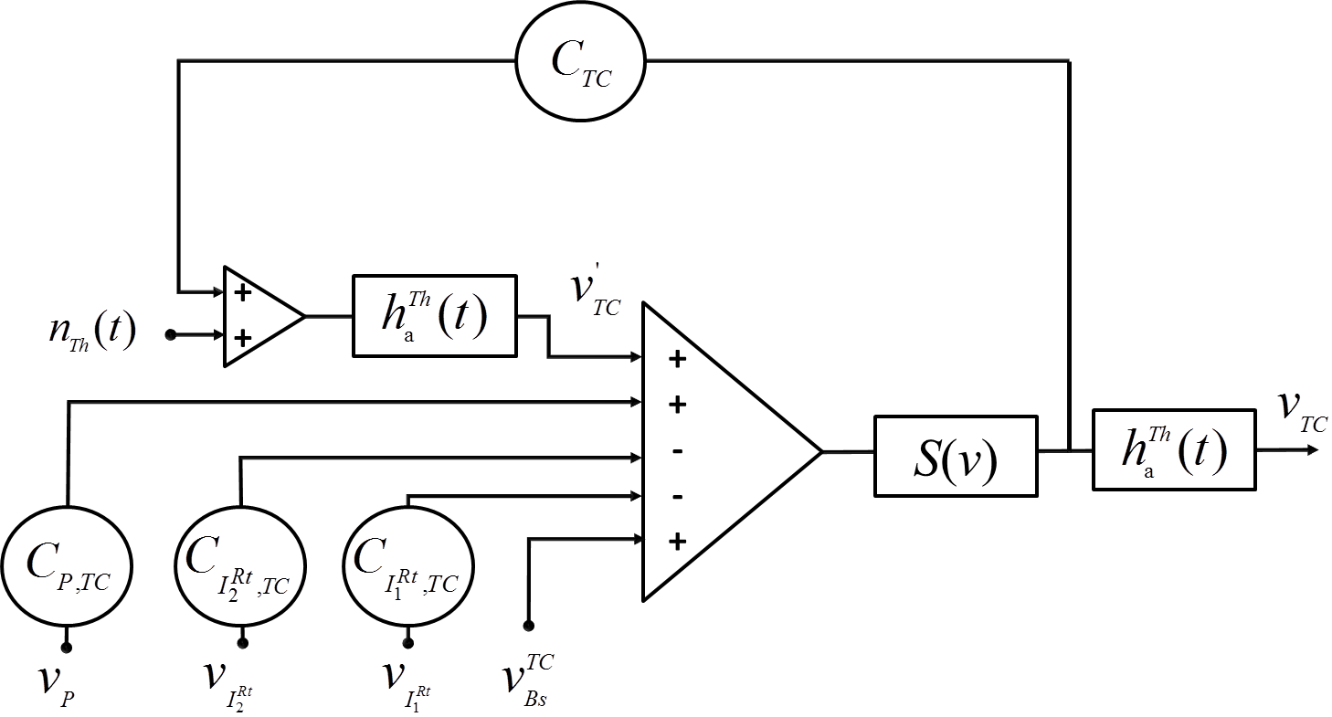

Figure 51: Schematic diagram of thalamic cells TC sub-block where $h_{a}^{Th}\left(t\right)$ is the impulse response of the input transfer function in the thalamic module for the AMPAergic transmissions.

${\ddot{v}}_{TC}= A_{Th}a_{Th}S\left(v_{TC}^{'}+C_{P,TC}v_{P}-C_{I_{1}^{Rt},TC}v_{I_{1}^{Rt}}-C_{I_{2}^{Rt},TC}v_{I_{2}^{Rt}}+v_{Bs}^{TC}\right)-2a_{Th}{\dot{v}}_{TC }-a_{Th}^{2} v_{TC}$**(5)**

$${\ddot{v}}_{TC}^{'}= A_{Th}a_{Th}\left[n_{Th}\left(t\right)+C_{TC} S\left(v_{TC}^{'}+C_{P,TC}v_{P}-C_{I_{1}^{Rt},TC}v_{I_{1}^{Rt}}-C_{I_{2}^{Rt},TC}v_{I_{2}^{Rt}}+v_{Bs}^{TC}\right)\right]-2a_{Th}{\dot{v}}_{TC}^{'}-a_{Th}^{2} v_{TC}^{'}$$**(6)**

* *TRN inhibitory interneurons ${ I}_{1}^{Rt}$ and $I_{2}^{Rt}$:*

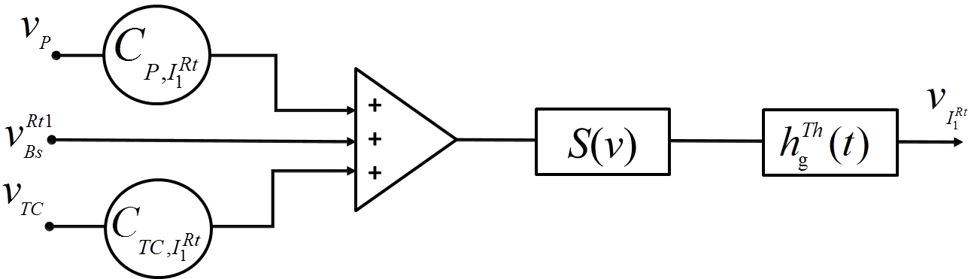

Figure 52: Schematic diagram of inhibitory GABA fast reticular thalamic nuclei interneurons $I_{1}^{Rt}$ sub-block where $h_{g}^{Th}\left(t\right)$ is the impulse response of the input transfer function in the reticular nuclei module for the fast GABAergic transmissions.

${\ddot{v}}_{I_{1}^{Rt}}= G_{Th}g_{Th}S\left(C_{TC,I_{1}^{Rt}}v_{TC}+C_{P,I_{1}^{Rt}}v_{P}+v_{Bs}^{Rt1}\right)-2g_{Th}{\dot{v}}_{I_{1}^{Rt} }-g_{Th}^{2} v_{I_{1}^{Rt}}$**(7)**

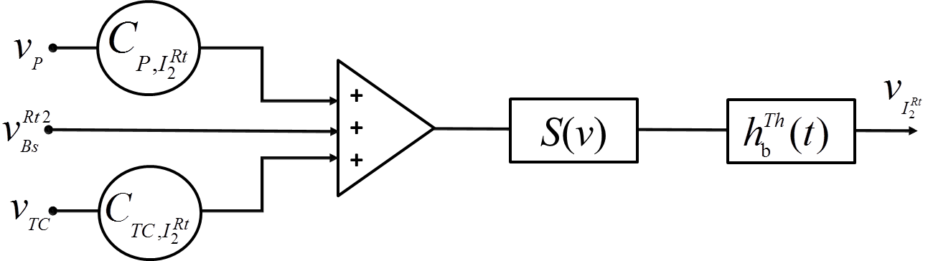

Figure 53: Schematic diagram of inhibitory GABA slow reticular thalamic nuclei interneurons $I_{2}^{Rt}$ sub-block where $h_{b}^{Th}\left(t\right)$ is the impulse response of the input transfer function in the reticular nuclei module for the slow GABAergic transmissions.

${\ddot{v}}_{I_{2}^{Rt}}= B_{Th}b_{Th}S\left(C_{TC,I_{2}^{Rt}}v_{TC}+C_{P,I_{2}^{Rt}}v_{P}+v_{Bs}^{Rt2}\right)-2b_{Th}{\dot{v}}_{I_{2}^{Rt} }-b_{Th}^{2} v_{I_{2}^{Rt}}$**(8)**

# References

[1] F. Wendling, I. Merlet, G. Birot, and B. Molaee-Ardekani, "D1.3 - Models for impact of current on neocortical tissue and brain neurodynamics. HIVE (Hyper Interaction Viability Experiments) project. <http://www.hive-eu.org/>. EC - FP7 - FET OPEN - 222079," 2011.

[2] C. J. Wilson HR, "A mathematical theory of the functional dynamics of cortical and thalamic nervous tissue," *Kybernetik,* vol. 13, pp. 55-80, 1973 1973.

[3] W. J. Freeman, "Models of the dynamics of neural populations," *Electroencephalogr Clin Neurophysiol Suppl,* pp. 9-18, 1978.

[4] F. H. Lopes da Silva, A. van Rotterdam, P. Barts, E. van Heusden, and W. Burr, "Models of neuronal populations: the basic mechanisms of rhythmicity," *Prog Brain Res,* vol. 45, pp. 281-308, 1976.

[5] F. H. Lopes da Silva, A. Hoeks, H. Smits, and L. H. Zetterberg, "Model of brain rhythmic activity. The alpha-rhythm of the thalamus," *Kybernetik,* vol. 15, pp. 27-37, May 31 1974.

[6] Z. G. Jansen BH, Brandt ME., "A neurophysiologically-based mathematical model of flash visual evoked potentials.," *Biol Cybern.,* vol. 68, pp. 275-283, 1993.

[7] R. V. Jansen BH, "Electroencephalogram and visual evoked potential generation in a mathematical model of coupled cortical columns.," *Biol Cybern.,* vol. 73, pp. 357-366, 1995.

[8] F. Wendling, F. Bartolomei, J. J. Bellanger, and P. Chauvel, "Epileptic fast activity can be explained by a model of impaired GABAergic dendritic inhibition," *Eur J Neurosci,* vol. 15, pp. 1499-508, May 2002.

[9] P. Suffczynski, S. Kalitzin, and F. H. Lopes Da Silva, "Dynamics of non-convulsive epileptic phenomena modeled by a bistable neuronal network," *Neuroscience,* vol. 126, pp. 467-84, 2004.

[10] I. Bojak and D. T. Liley, "Modeling the effects of anesthesia on the electroencephalogram," *Phys Rev E Stat Nonlin Soft Matter Phys,* vol. 71, p. 041902, Apr 2005.

[11] F. Wendling and P. Chauvel, "Transition to ictal activity in Temporal Lobe Epilepsy: insights from macroscopic models, in " *« Computational Neuroscience in Epilepsy », Edited by Drs. Ivan Soltesz and Kevin Staley, Elsevier.,* 2008.

[12] F. L. Kidd and J. T. Isaac, "Developmental and activity-dependent regulation of kainate receptors at thalamocortical synapses," *Nature,* vol. 400, pp. 569-73, Aug 5 1999.

[13] J. A. White, M. I. Banks, R. A. Pearce, and N. J. Kopell, "Networks of interneurons with fast and slow gamma-aminobutyric acid type A (GABAA) kinetics provide substrate for mixed gamma-theta rhythm," *Proc Natl Acad Sci U S A,* vol. 97, pp. 8128-33, Jul 5 2000.

[14] R. A. Deisz, "The GABA(B) receptor antagonist CGP 55845A reduces presynaptic GABA(B) actions in neocortical neurons of the rat in vitro," *Neuroscience,* vol. 93, pp. 1241-9, 1999.

[15] M. P. Jackson, A. Rahman, B. Lafon, G. Kronberg, D. Ling, L. C. Parra, and M. Bikson, "Animal models of transcranial direct current stimulation: Methods and mechanisms," *Clin Neurophysiol,* vol. 127, pp. 3425-3454, Nov 2016.

[16] M. Bikson, M. Inoue, H. Akiyama, J. K. Deans, J. E. Fox, H. Miyakawa, and J. G. Jefferys, "Effects of uniform extracellular DC electric fields on excitability in rat hippocampal slices in vitro," *J Physiol,* vol. 557, pp. 175-90, May 15 2004.

[17] B. Molaee-Ardekani, J. Marquez-Ruiz, I. Merlet, R. Leal-Campanario, A. Gruart, R. Sanchez-Campusano, G. Birot, G. Ruffini, J. M. Delgado-Garcia, and F. Wendling, "Effects of transcranial Direct Current Stimulation (tDCS) on cortical activity: a computational modeling study," *Brain Stimul,* vol. 6, pp. 25-39, Jan 2013.

[18] J. Marquez-Ruiz, R. Leal-Campanario, R. Sanchez-Campusano, B. Molaee-Ardekani, F. Wendling, P. C. Miranda, G. Ruffini, A. Gruart, and J. M. Delgado-Garcia, "Transcranial direct-current stimulation modulates synaptic mechanisms involved in associative learning in behaving rabbits," *Proc Natl Acad Sci U S A,* vol. 109, pp. 6710-5, Apr 24 2012.

[19] M. S. Hamalainen and J. Sarvas, "Realistic conductivity geometry model of the human head for interpretation of neuromagnetic data," *IEEE Trans Biomed Eng,* vol. 36, pp. 165-71, Feb 1989.

[20] D. Cosandier-Rimele, I. Merlet, J. M. Badier, P. Chauvel, and F. Wendling, "The neuronal sources of EEG: modeling of simultaneous scalp and intracerebral recordings in epilepsy," *Neuroimage,* vol. 42, pp. 135-46, Aug 01 2008.

[21] P. Somogyi, G. Tamas, R. Lujan, and E. H. Buhl, "Salient features of synaptic organisation in the cerebral cortex," *Brain Res Brain Res Rev,* vol. 26, pp. 113-35, May 1998.

[22] O. Sporns, G. Tononi, and R. Kotter, "The human connectome: A structural description of the human brain," *PLoS Comput Biol,* vol. 1, p. e42, Sep 2005.

[23] P. Hagmann, M. Kurant, X. Gigandet, P. Thiran, V. J. Wedeen, R. Meuli, and J. P. Thiran, "Mapping human whole-brain structural networks with diffusion MRI," *PLoS One,* vol. 2, p. e597, 2007.

[24] P. Hagmann, L. Cammoun, X. Gigandet, R. Meuli, C. J. Honey, V. J. Wedeen, and O. Sporns, "Mapping the structural core of human cerebral cortex," *PLoS Biol,* vol. 6, p. e159, Jul 01 2008.

[25] I. Merlet, G. Birot, R. Salvador, B. Molaee-Ardekani, A. Mekonnen, A. Soria-Frish, G. Ruffini, P. C. Miranda, and F. Wendling, "From oscillatory transcranial current stimulation to scalp EEG changes: a biophysical and physiological modeling study," *PLoS One,* vol. 8, p. e57330, 2013.

[26] B. Dogdas, D. W. Shattuck, and R. M. Leahy, "Segmentation of skull and scalp in 3-D human MRI using mathematical morphology," *Hum Brain Mapp,* vol. 26, pp. 273-85, Dec 2005.

[27] D. W. Shattuck and R. M. Leahy, "Automated graph-based analysis and correction of cortical volume topology," *IEEE Trans Med Imaging,* vol. 20, pp. 1167-77, Nov 2001.

[28] D. W. Shattuck and R. M. Leahy, "BrainSuite: an automated cortical surface identification tool," *Med Image Anal,* vol. 6, pp. 129-42, Jun 2002.

[29] D. W. Shattuck, S. R. Sandor-Leahy, K. A. Schaper, D. A. Rottenberg, and R. M. Leahy, "Magnetic resonance image tissue classification using a partial volume model," *Neuroimage,* vol. 13, pp. 856-76, May 2001.

[30] S. B. Baumann, D. R. Wozny, S. K. Kelly, and F. M. Meno, "The electrical conductivity of human cerebrospinal fluid at body temperature," *IEEE Trans Biomed Eng,* vol. 44, pp. 220-3, Mar 1997.

[31] S. I. Goncalves, J. C. de Munck, J. P. Verbunt, F. Bijma, R. M. Heethaar, and F. Lopes da Silva, "In vivo measurement of the brain and skull resistivities using an EIT-based method and realistic models for the head," *IEEE Trans Biomed Eng,* vol. 50, pp. 754-67, Jun 2003.

[32] D. Cosandier-Rimele, J. M. Badier, P. Chauvel, and F. Wendling, "A physiologically plausible spatio-temporal model for EEG signals recorded with intracerebral electrodes in human partial epilepsy," *IEEE Trans Biomed Eng,* vol. 54, pp. 380-8, Mar 2007.

[33] J. Touboul, F. Wendling, P. Chauvel, and O. Faugeras, "Neural mass activity, bifurcations, and epilepsy," *Neural Comput,* vol. 23, pp. 3232-86, Dec 2011.

[34] F. Wendling, J. J. Bellanger, F. Bartolomei, and P. Chauvel, "Relevance of nonlinear lumped-parameter models in the analysis of depth-EEG epileptic signals," *Biol Cybern,* vol. 83, pp. 367-78, Oct 2000.

[35] M. Goodfellow, K. Schindler, and G. Baier, "Intermittent spike-wave dynamics in a heterogeneous, spatially extended neural mass model," *Neuroimage,* vol. 55, pp. 920-32, Apr 01 2011.

[36] M. Steriade, "Grouping of brain rhythms in corticothalamic systems," *Neuroscience,* vol. 137, pp. 1087-106, 2006.

[37] M. Schurmann, T. Demiralp, E. Basar, and C. Basar Eroglu, "Electroencephalogram alpha (8-15 Hz) responses to visual stimuli in cat cortex, thalamus, and hippocampus: a distributed alpha network?," *Neurosci Lett,* vol. 292, pp. 175-8, Oct 13 2000.

[38] J. G. Jefferys, "Influence of electric fields on the excitability of granule cells in guinea-pig hippocampal slices," *J Physiol,* vol. 319, pp. 143-52, 1981.

[39] T. Zaehle, S. Rach, and C. S. Herrmann, "Transcranial alternating current stimulation enhances individual alpha activity in human EEG," *PLoS One,* vol. 5, p. e13766, Nov 01 2010.

[40] M. Steriade, P. Gloor, R. R. Llinas, F. H. Lopes de Silva, and M. M. Mesulam, "Report of IFCN Committee on Basic Mechanisms. Basic mechanisms of cerebral rhythmic activities," *Electroencephalogr Clin Neurophysiol,* vol. 76, pp. 481-508, Dec 1990.

[41] S. A. Knock, A. R. McIntosh, O. Sporns, R. Kotter, P. Hagmann, and V. K. Jirsa, "The effects of physiologically plausible connectivity structure on local and global dynamics in large scale brain models," *J Neurosci Methods,* vol. 183, pp. 86-94, Sep 30 2009.

[42] E. Fino, A. M. Packer, and R. Yuste, "The logic of inhibitory connectivity in the neocortex," *Neuroscientist,* vol. 19, pp. 228-37, Jun 2013.

[43] R. J. Douglas and K. A. Martin, "Neuronal circuits of the neocortex," *Annu Rev Neurosci,* vol. 27, pp. 419-51, 2004.

[44] J. C. Wester and C. J. McBain, "Behavioral state-dependent modulation of distinct interneuron subtypes and consequences for circuit function," *Curr Opin Neurobiol,* vol. 29, pp. 118-25, Dec 2014.

[45] J. Watts and A. M. Thomson, "Excitatory and inhibitory connections show selectivity in the neocortex," *J Physiol,* vol. 562, pp. 89-97, Jan 01 2005.

[46] S. H. Jin and C. K. Chung, "Messages from the brain connectivity regarding neural correlates of consciousness," *Exp Neurobiol,* vol. 21, pp. 113-22, Sep 2012.

[47] F. Ferrarelli, M. Massimini, S. Sarasso, A. Casali, B. A. Riedner, G. Angelini, G. Tononi, and R. A. Pearce, "Breakdown in cortical effective connectivity during midazolam-induced loss of consciousness," *Proceedings of the National Academy of Sciences,* vol. 107, pp. 2681-2686, 2010.

[48] F. Gomez, C. Phillips, A. Soddu, M. Boly, P. Boveroux, A. Vanhaudenhuyse, M. A. Bruno, O. Gosseries, V. Bonhomme, S. Laureys, and Q. Noirhomme, "Changes in effective connectivity by propofol sedation," *PLoS One,* vol. 8, p. e71370, 2013.

[49] A. G. Hudetz, "General anesthesia and human brain connectivity," *Brain Connect,* vol. 2, pp. 291-302, 2012.

[50] J. S. Crone, M. Schurz, Y. Holler, J. Bergmann, M. Monti, E. Schmid, E. Trinka, and M. Kronbichler, "Impaired consciousness is linked to changes in effective connectivity of the posterior cingulate cortex within the default mode network," *Neuroimage,* vol. 110, pp. 101-9, Apr 15 2015.

[51] G. Varotto, P. Fazio, D. Rossi Sebastiano, D. Duran, L. D'Incerti, E. Parati, D. Sattin, M. Leonardi, S. Franceschetti, and F. Panzica, "Altered resting state effective connectivity in long-standing vegetative state patients: an EEG study," *Clin Neurophysiol,* vol. 125, pp. 63-8, Jan 2014.

[52] M. Rosanova, O. Gosseries, S. Casarotto, M. Boly, A. G. Casali, M. A. Bruno, M. Mariotti, P. Boveroux, G. Tononi, S. Laureys, and M. Massimini, "Recovery of cortical effective connectivity and recovery of consciousness in vegetative patients," *Brain,* vol. 135, pp. 1308-1320, 2012.

[53] M. Steriade, I. Timofeev, and F. Grenier, "Natural waking and sleep states: a view from inside neocortical neurons," *J Neurophysiol,* vol. 85, pp. 1969-85, May 2001.

[54] G. Tononi and O. Sporns, "Measuring information integration," *BMC Neurosci,* vol. 4, p. 31, Dec 02 2003.

[55] S. K. Esser, S. Hill, and G. Tononi, "Breakdown of Effective Connectivity During Slow Wave Sleep: Investigating the Mechanism Underlying a Cortical Gate Using Large-Scale Modeling," *J Neurophysiol,* vol. 102, pp. 2096-2111, 2009.

[56] M. Massimini, F. Ferrarelli, M. J. Murphy, R. Huber, B. A. Riedner, S. Casarotto, and G. Tononi, "Cortical reactivity and effective connectivity during REM sleep in humans," *Cognitive Neuroscience,* vol. 1, pp. 176-183, 2010.

[57] P. Fries, "Rhythms for Cognition: Communication through Coherence," *Neuron,* vol. 88, pp. 220-35, Oct 07 2015.

[58] T. Womelsdorf, T. A. Valiante, N. T. Sahin, K. J. Miller, and P. Tiesinga, "Dynamic circuit motifs underlying rhythmic gain control, gating and integration," *Nat Neurosci,* vol. 17, pp. 1031-9, Aug 2014.

[59] M. M. Karnani, M. Agetsuma, and R. Yuste, "A blanket of inhibition: functional inferences from dense inhibitory connectivity," *Curr Opin Neurobiol,* vol. 26, pp. 96-102, Jun 2014.

[60] J. S. Isaacson and M. Scanziani, "How inhibition shapes cortical activity," *Neuron,* vol. 72, pp. 231-43, Oct 20 2011.

[61] H. Adesnik and M. Scanziani, "Lateral competition for cortical space by layer-specific horizontal circuits," *Nature,* vol. 464, pp. 1155-60, Apr 22 2010.

[62] K. D. Harris and T. D. Mrsic-Flogel, "Cortical connectivity and sensory coding," *Nature,* vol. 503, pp. 51-8, Nov 07 2013.

[63] H. J. Pi, B. Hangya, D. Kvitsiani, J. I. Sanders, Z. J. Huang, and A. Kepecs, "Cortical interneurons that specialize in disinhibitory control," *Nature,* vol. 503, pp. 521-4, Nov 28 2013.

[64] M. M. Karnani, J. Jackson, I. Ayzenshtat, A. Hamzehei Sichani, K. Manoocheri, S. Kim, and R. Yuste, "Opening Holes in the Blanket of Inhibition: Localized Lateral Disinhibition by VIP Interneurons," *J Neurosci,* vol. 36, pp. 3471-80, Mar 23 2016.

[65] C. K. Pfeffer, M. Xue, M. He, Z. J. Huang, and M. Scanziani, "Inhibition of inhibition in visual cortex: the logic of connections between molecularly distinct interneurons," *Nat Neurosci,* vol. 16, pp. 1068-76, Aug 2013.

[66] G. Tononi, "An information integration theory of consciousness," *BMC Neurosci,* vol. 5, p. 42, Nov 02 2004.

[67] G. Tononi, "Consciousness as integrated information: a provisional manifesto," *Biol Bull,* vol. 215, pp. 216-42, Dec 2008.

[68] G. Tononi and M. Massimini, "Why does consciousness fade in early sleep?," *Ann N Y Acad Sci,* vol. 1129, pp. 330-4, 2008.

[69] K. J. Friston, "Functional and effective connectivity: a review," *Brain Connect,* vol. 1, pp. 13-36, 2011.

[70] Y. B. Saalmann, "Intralaminar and medial thalamic influence on cortical synchrony, information transmission and cognition," *Front Syst Neurosci,* vol. 8, p. 83, 2014.

[71] J. R. Hale, T. P. White, S. D. Mayhew, R. S. Wilson, D. T. Rollings, S. Khalsa, T. N. Arvanitis, and A. P. Bagshaw, "Altered thalamocortical and intra-thalamic functional connectivity during light sleep compared with wake," *Neuroimage,* vol. 125, pp. 657-67, Jan 15 2016.

[72] S. P. Kim, E. Hwang, J. H. Kang, S. Kim, and J. H. Choi, "Changes in the thalamocortical connectivity during anesthesia-induced transitions in consciousness," *Neuroreport,* vol. 23, pp. 294-8, Mar 28 2012.

[73] K. Usami, R. Matsumoto, K. Kobayashi, T. Hitomi, A. Shimotake, T. Kikuchi, M. Matsuhashi, T. Kunieda, N. Mikuni, S. Miyamoto, H. Fukuyama, R. Takahashi, and A. Ikeda, "Sleep modulates cortical connectivity and excitability in humans: Direct evidence from neural activity induced by single-pulse electrical stimulation," *Hum Brain Mapp,* vol. 36, pp. 4714-29, Nov 2015.

[74] L. D. Lewis, J. Voigts, F. J. Flores, L. I. Schmitt, M. A. Wilson, M. M. Halassa, and E. N. Brown, "Thalamic reticular nucleus induces fast and local modulation of arousal state," *Elife,* vol. 4, p. e08760, Oct 13 2015.

[75] F. Mina, P. Benquet, A. Pasnicu, A. Biraben, and F. Wendling, "Modulation of epileptic activity by deep brain stimulation: a model-based study of frequency-dependent effects," *Front Comput Neurosci,* vol. 7, p. 94, 2013.

[76] A. T. Lee, S. M. Gee, D. Vogt, T. Patel, J. L. Rubenstein, and V. S. Sohal, "Pyramidal neurons in prefrontal cortex receive subtype-specific forms of excitation and inhibition," *Neuron,* vol. 81, pp. 61-8, Jan 8 2014.

[77] T. Akam and D. M. Kullmann, "Oscillatory multiplexing of population codes for selective communication in the mammalian brain," *Nat Rev Neurosci,* vol. 15, pp. 111-22, Feb 2014.

[78] A. Opitz, A. Falchier, C. G. Yan, E. M. Yeagle, G. S. Linn, P. Megevand, A. Thielscher, A. R. Deborah, M. P. Milham, A. D. Mehta, and C. E. Schroeder, "Spatiotemporal structure of intracranial electric fields induced by transcranial electric stimulation in humans and nonhuman primates," *Sci Rep,* vol. 6, p. 31236, Aug 18 2016.

[79] R. Plonsey and D. B. Heppner, "Considerations of Quasi-Stationarity in Electrophysiological Systems," *B Math Biophys,* vol. 29, pp. 657-&, 1967.

[80] C. R. Johnson, "Computational and numerical methods for bioelectric field problems," *Crit Rev Biomed Eng,* vol. 25, pp. 1-81, 1997.

[81] G. B. Saturnino, A. Antunes, and A. Thielscher, "On the importance of electrode parameters for shaping electric field patterns generated by tDCS," *NeuroImage,* vol. 120, pp. 25-35, Jul 2 2015.

[82] C. Gabriel, S. Gabriel, and E. Corthout, "The dielectric properties of biological tissues: I. Literature survey," *Phys Med Biol,* vol. 41, pp. 2231-49, 1996.

[83] R. Salvador, F. Ramirez, M. V'yacheslavovna, and P. C. Miranda, "Effects of tissue dielectric properties on the electric field induced in tDCS: a sensitivity analysis," in *34th Annual International Conference of the IEEE Engineering in Medicine and Biology Society (EMBC)*, San Diego, 2012, pp. 787-790.

[84] L. Santos, M. Martinho, R. Salvador, C. Wenger, S. R. Fernandes, O. Ripolles, G. Ruffini, and P. C. Miranda, "Evaluation of the electric field in the brain during transcranial direct current stimulation: A sensitivity analysis," *Conf Proc IEEE Eng Med Biol Soc,* vol. 2016, pp. 1778-1781, Aug 2016.

[85] C. H. Wolters, A. Anwander, X. Tricoche, D. Weinstein, M. A. Koch, and R. S. Macleod, "Influence of tissue conductivity anisotropy on EEG/MEG field and return current computation in a realistic head model: A simulation and visualization study using high-resolution finite element modeling," *NeuroImage,* vol. 30, pp. 813-826, Apr 15 2006.

[86] H. S. Suh, W. H. Lee, and T. S. Kim, "Influence of anisotropic conductivity in the skull and white matter on transcranial direct current stimulation via an anatomically realistic finite element head model," *Phys Med Biol,* vol. 57, pp. 6961-80, Nov 7 2012.

[87] G. Ruffini, M. D. Fox, O. Ripolles, P. C. Miranda, and A. Pascual-Leone, "Optimization of multifocal transcranial current stimulation for weighted cortical pattern targeting from realistic modeling of electric fields," *NeuroImage,* vol. 89, pp. 216-225, Apr 1 2014.

[88] P. C. Miranda, A. Mekonnen, R. Salvador, and G. Ruffini, "The electric field in the cortex during transcranial current stimulation," *NeuroImage,* vol. 70, pp. 48-58, Apr 15 2013.

[89] M. Bortoletto, C. Rodella, R. Salvador, P. C. Miranda, and C. Miniussi, "Reduced Current Spread by Concentric Electrodes in Transcranial Electrical Stimulation (tES)," *Brain Stimul,* Mar 9 2016.

[90] T. Radman, R. L. Ramos, J. C. Brumberg, and M. Bikson, "Role of cortical cell type and morphology in subthreshold and suprathreshold uniform electric field stimulation in vitro," *Brain Stimul,* vol. 2, pp. 215-228, Oct 2009.

[91] A. G. Casali, O. Gosseries, M. Rosanova, M. Boly, S. Sarasso, K. R. Casali, S. Casarotto, M. A. Bruno, S. Laureys, G. Tononi, and M. Massimini, "A theoretically based index of consciousness independent of sensory processing and behavior," *Sci Transl Med,* vol. 5, p. 198ra105, Aug 14 2013.

[92] F. Wendling, F. Bartolomei, F. Mina, C. Huneau, and P. Benquet, "Interictal spikes, fast ripples and seizures in partial epilepsies--combining multi-level computational models with experimental data," *Eur J Neurosci,* vol. 36, pp. 2164-77, Jul 2012.

[93] A. Hutt and L. Zhang, "Distributed nonlocal feedback delays may destabilize fronts in neural fields, distributed transmission delays do not," *J Math Neurosci,* vol. 3, p. 9, Jul 30 2013.

[94] S. Campbell, "Time delays in neural systems," *In Handbook of Brain Connectivity, R. McIntosh and V.K. Jirsa, editors. Springer-Verlag,* 2007.

[95] S. Rossi, M. Hallett, P. M. Rossini, A. Pascual-Leone, and T. M. S. C. G. Safety of, "Safety, ethical considerations, and application guidelines for the use of transcranial magnetic stimulation in clinical practice and research," *Clin Neurophysiol,* vol. 120, pp. 2008-39, Dec 2009.

[96] Y. D. Van Der Werf and T. Paus, "The neural response to transcranial magnetic stimulation of the human motor cortex. I. Intracortical and cortico-cortical contributions," *Exp Brain Res,* vol. 175, pp. 231-45, Nov 2006.

[97] M. Rosanova, A. Casali, V. Bellina, F. Resta, M. Mariotti, and M. Massimini, "Natural frequencies of human corticothalamic circuits," *J Neurosci,* vol. 29, pp. 7679-85, Jun 17 2009.

[98] L. M. Ward, "The thalamus: gateway to the mind," *Wiley Interdiscip Rev Cogn Sci,* vol. 4, pp. 609-22, Nov 2013.

[99] S. Laureys, M. Boly, and P. Maquet, "Tracking the recovery of consciousness from coma," *J Clin Invest,* vol. 116, pp. 1823-5, Jul 2006.

[100] F. David, J. T. Schmiedt, H. L. Taylor, G. Orban, G. Di Giovanni, V. N. Uebele, J. J. Renger, R. C. Lambert, N. Leresche, and V. Crunelli, "Essential thalamic contribution to slow waves of natural sleep," *J Neurosci,* vol. 33, pp. 19599-610, Dec 11 2013.

[101] V. Crunelli and S. W. Hughes, "The slow (<1 Hz) rhythm of non-REM sleep: a dialogue between three cardinal oscillators," *Nat Neurosci,* vol. 13, pp. 9-17, 01//print 2010.

[102] V. Crunelli, F. David, M. L. Lorincz, and S. W. Hughes, "The thalamocortical network as a single slow wave-generating unit," *Curr Opin Neurobiol,* vol. 31, pp. 72-80, Apr 2015.

[103] R. C. Sotero, N. J. Trujillo-Barreto, Y. Iturria-Medina, F. Carbonell, and J. C. Jimenez, "Realistically Coupled Neural Mass Models Can Generate EEG Rhythms," *Neural Comput.,* vol. 19, pp. 478-512, 2007.

[104] B. S. Bhattacharya, D. Coyle, and L. P. Maguire, "A thalamo–cortico–thalamic neural mass model to study alpha rhythms in Alzheimer’s disease," *Neural Networks,* vol. 24, pp. 631-645, 8// 2011.

[105] B. Sen Bhattacharya, Y. Cakir, N. Serap-Sengor, L. Maguire, and D. Coyle, "Model-based bifurcation and power spectral analyses of thalamocortical alpha rhythm slowing in Alzheimer's Disease," *Neurocomputing,* vol. 115, pp. 11-22, 9/4/ 2013.

[106] J. A. Roberts and P. A. Robinson, "Corticothalamic dynamics: Structure of parameter space, spectra, instabilities, and reduced model," *Physical Review E,* vol. 85, p. 011910, 01/12/ 2012.

[107] F. Cona, M. Lacanna, and M. Ursino, "A thalamo-cortical neural mass model for the simulation of brain rhythms during sleep," *J Comput Neurosci,* vol. 37, pp. 125-48, Aug 2014.

[108] F. Mina, P. Benquet, A. Pasnicu, A. Biraben, and F. Wendling, "Modulation of epileptic activity by deep brain stimulation: a model-based study of frequency-dependent effects," *Frontiers in Computational Neuroscience,* vol. 7, 2013-July-16 2013.

[109] J. A. Roberts and P. A. Robinson, "Modeling absence seizure dynamics: Implications for basic mechanisms and measurement of thalamocortical and corticothalamic latencies," *Journal of Theoretical Biology,* vol. 253, pp. 189-201, 7/7/ 2008.

[110] F. H. Lopes da Silva, "Event-related neural activities: what about phase?," in *Progress in Brain Research*. vol. Volume 159, N. Christa and K. Wolfgang, Eds., ed: Elsevier, 2006, pp. 3-17.

[111] V. Crunelli, D. W. Cope, and J. R. Terry, "Transition to absence seizures and the role of GABA(A) receptors," *Epilepsy Research,* vol. 97, pp. 283-289, 2011.

[112] L. M. Ward, "The thalamic dynamic core theory of conscious experience," *Conscious Cogn,* vol. 20, pp. 464-86, Jun 2011.

[113] B. T. McCormick DA, "Sleep and arousal: thalamocortical mechanisms," *Annu Rev Neurosci,* vol. 20, pp. 185-215, 1997.

[114] B.-K. Min, "A thalamic reticular networking model of consciousness," *Theoretical Biology & Medical Modelling,* vol. 7, pp. 10-10, 2010.

[115] J. Hesse and T. Gross, "Self-organized criticality as a fundamental property of neural systems," *Frontiers in Systems Neuroscience,* vol. 8, p. 166, 2014.

[116] N. Zilber, "ERF and scale-free analyses of source-reconstructed MEG brain signals during a multisensory learning paradigm," Université Paris Sud - Paris XI, 2014.

[117] J. J. Torres and J. Marro, "Brain Performance versus Phase Transitions," *Scientific Reports,* vol. 5, p. 12216, 07/20/online 2015.

[118] A. A. Fingelkurts, A. A. Fingelkurts, and C. F. H. Neves, "Consciousness as a phenomenon in the operational architectonics of brain organization: Criticality and self-organization considerations," *Chaos, Solitons & Fractals,* vol. 55, pp. 13-31, 10// 2013.

[119] B. J. He, J. M. Zempel, A. Z. Snyder, and M. E. Raichle, "The temporal structures and functional significance of scale-free brain activity," *Neuron,* vol. 66, pp. 353-369, 2010.

[120] B. Weiss, Z. Clemens, R. Bodizs, Z. Vago, and P. Halasz, "Spatio-temporal analysis of monofractal and multifractal properties of the human sleep EEG," *J Neurosci Methods,* vol. 185, pp. 116-24, Dec 15 2009.

[121] S. Leistedt, M. Dumont, N. Coumans, J. P. Lanquart, F. Jurysta, and P. Linkowski, "The modifications of the long-range temporal correlations of the sleep EEG due to major depressive episode disappear with the status of remission," *Neuroscience,* vol. 148, pp. 782-93, Sep 7 2007.

[122] S. Monto, S. Palva, J. Voipio, and J. M. Palva, "Very slow EEG fluctuations predict the dynamics of stimulus detection and oscillation amplitudes in humans," *J Neurosci,* vol. 28, pp. 8268-72, Aug 13 2008.

[123] M. Buiatti, D. Papo, P. M. Baudonniere, and C. van Vreeswijk, "Feedback modulates the temporal scale-free dynamics of brain electrical activity in a hypothesis testing task," *Neuroscience,* vol. 146, pp. 1400-12, May 25 2007.

[124] A. M. Wink, E. Bullmore, A. Barnes, F. Bernard, and J. Suckling, "Monofractal and multifractal dynamics of low frequency endogenous brain oscillations in functional MRI," *Hum Brain Mapp,* vol. 29, pp. 791-801, Jul 2008.

[125] E. Tagliazucchi, D. R. Chialvo, M. Siniatchkin, E. Amico, J.-F. Brichant, V. Bonhomme, Q. Noirhomme, H. Laufs, and S. Laureys, "Large-scale signatures of unconsciousness are consistent with a departure from critical dynamics," *Journal of The Royal Society Interface,* vol. 13, 2016-01-27 00:05:44 2016.

[126] E. Tagliazucchi, F. von Wegner, A. Morzelewski, V. Brodbeck, K. Jahnke, and H. Laufs, "Breakdown of long-range temporal dependence in default mode and attention networks during deep sleep," *Proc Natl Acad Sci U S A,* vol. 110, pp. 15419-24, Sep 17 2013.

[127] B. J. He and M. E. Raichle, "The fMRI signal, slow cortical potential and consciousness," *Trends Cogn Sci,* vol. 13, pp. 302-9, Jul 2009.

[128] N. Zilber, P. Ciuciu, P. Abry, and V. Van Wassenhove, "Learning-induced modulation of scale-free properties of brain activity measured with MEG," in *10th IEEE International Symposium on Biomedical Imaging*, San Francisco, United States, 2013, pp. 998-1001.

[129] L. de Arcangelis and H. J. Herrmann, "Learning as a phenomenon occurring in a critical state," *Proceedings of the National Academy of Sciences,* vol. 107, pp. 3977-3981, March 2, 2010 2010.

[130] P. J. Drew and L. F. Abbott, "Models and Properties of Power-Law Adaptation in Neural Systems," *Journal of Neurophysiology,* vol. 96, pp. 826-833, 2006.

[131] L. de Arcangelis, C. Perrone-Capano, and H. J. Herrmann, "Self-Organized Criticality Model for Brain Plasticity," *Physical Review Letters,* vol. 96, p. 028107, 01/19/ 2006.

[132] N. Zilber, P. Ciuciu, P. Abry, and V. Van Wassenhove, "MODULATION OF SCALE-FREE PROPERTIES OF BRAIN ACTIVITY IN MEG," in *IEEE International Symposium on Biomedical Imaging*, Barcelone, Spain, 2012, pp. 1531--1534.

[133] F. Wendling, F. Bartolomei, J. J. Bellanger, and P. Chauvel, "Epileptic fast activity can be explained by a model of impaired GABAergic dendritic inhibition," *European Journal of Neuroscience,* vol. 15, pp. 1499-1508, 2002.